Software Requirements Specification
IELTSPath ([CODE]) - Report 3

Project Name | IELTSPath
Vision & Scope Ref | Vision & Scope Document v[X.X]
RTW Ref | IELTSPath_RTW.xlsx (Requirements Traceability Workbook)
SRS Version | v1.0.0
Date Created | [DD/MM/YYYY]
Last Updated | [DD/MM/YYYY]
Author(s) | [Name / Role]
Reviewer(s) | [Name / Role]
Status | Draft / In Review / Approved

How to Use This Template
Template conventions
This template defines the structure and writing rules for an SRS that uses three
complementary specification methods:
• Scenario / Narrative — Part 2: real-world business flows
• Feature Description — Part 3: precise system behaviour
• Non-Functional Requirements — Part 6: quality constraints
• Data Requirements — Part 4: entities, constraints, state transitions

Colour coding in this template:
BLUE box = Guidance — explains what to write in this section
GREEN box = Sample placeholder — shows format of example content
PURPLE box = Diagram placeholder — where to insert a diagram
GRAY box = Excel reference — content maintained in RTW.xlsx
RED box = Negative AC (Acceptance Criteria) guidance
AMBER box = Boundary Value guidance

Fields shown as [Italic gray text] are fill-in placeholders — replace with real content.
Delete all blue Guidance boxes before distributing the completed SRS.

Companion files to create alongside this SRS:
• Vision & Scope Document (use the V&S Template)
• [ProjectName]_RTW.xlsx (use the RTW Template)

Document Change History
Guidance
Record every version change here. After the first approved baseline, add a row for
every subsequent change. Include the section affected, not just a generic description.

Version | Date | Changes | Author
v0.9 | 20/09/2026 | Draft for team review: Part 0 and Part 1 (system objective, technical scope, system context diagram, system roles, glossary, feature traceability bridge). | [Author]
v0.9.1 | 04/10/2026 | Part 2 — Scenario / Narrative: scenarios SC-01 to SC-08 with activity and sequence diagrams (sources in part2-diagrams/) and the Scenario List. | [Author]
v0.9.2 | 05/10/2026 | Part 3 — Feature Description: FT-01 to FT-23 with system behaviour, business rule IDs, acceptance criteria (AC/NAC) and boundary values, plus the Feature List; Part 1.5 status updated; Part 5 business rule list BR-01 to BR-30. | [Author]
v0.9.3 | 05/10/2026 | Part 3: FT-03, FT-16, FT-20, FT-22 and FT-23 extended and FT-24 Mock & placement test added to cover the feature tree; FT-03 aligned with SC-01. Part 1.5, SC-05 and the Scenario List link FT-24; Part 5 adds BR-31 to BR-33. | [Author]
v0.9.4 | 05/10/2026 | Part 3 split into one feature per feature-tree leaf: FT-01 to FT-54 (previous FT-01 to FT-24 renumbered). Part 1.4 glossary, Part 1.5 bridge, Part 2 scenario headers and Scenario List renumbered; SC-01 mentions the placement test; Part 5 adds BR-34. | [Author]
v0.9.5 | 05/10/2026 | Use case diagram extended with 14 use cases and the Administrator generalization of Content Author and Examiner (part2-diagrams/IELTSPath_UseCaseDiagram.drawio.xml); Part 1.3 diagram description, Part 2 Related UC rows and Part 3 Related UC aligned with it; FT-14 also linked to SC-05. | [Author]
v0.9.6 | 05/10/2026 | Part 1.3: Use Case Diagram inserted in place of its placeholder (rendered from part2-diagrams/IELTSPath_UseCaseDiagram.drawio.xml; PNG export saved next to it); diagram layout tidied, Practise shadowing and Request AI grading placed in the Learning group. | [Author]
v0.9.7 | 05/10/2026 | Part 5: business rules BR-01 to BR-34 presented as a table with the features that apply each rule, replacing the RTW reference box and the guidance box. | [Author]
v0.9.8 | 05/10/2026 | Part 4.1: Core Entities & Relationships rewritten in the template layout: five conceptual ERD views in the style of the Part 2 diagrams (part4-diagrams/IELTSPath_ERD.drawio) and one entity table grouped by data owner; Part 4 guidance box removed. | [Author]
v0.9.9 | 05/10/2026 | Part 2: the eight scenario diagram sources merged into one draw.io file (part2-diagrams/IELTSPath_Scenarios.drawio, one page per scenario); figure source lines updated. | [Author]
v0.9.10 | 05/10/2026 | Part 4.2: data constraints DC-01 to DC-40 with affected entities, violation behaviour and the features or state transitions they support; guidance box removed. | [Author]
v0.9.11 | 05/10/2026 | Part 4.3: data retention and ownership policy for 14 data types (account closure by an Administrator, personal data deleted and learning records anonymised 30 days after closure, points and keys kept 5 years, tokens cleaned up after 30 days and DELETED content after 90 days); guidance box removed. | [Author]
v0.9.12 | 05/10/2026 | Part 4.4: state transition tables (valid and invalid transitions, QA notes) and state machine figures for Learning Goal, Activation Key, Topic Progress, Review Item, Writing Submission and Assessment Attempt with Result Version (part4-diagrams/IELTSPath_StateMachines.drawio); DC-01 entity list aligned; guidance box and placeholders removed. | [Author]
v0.9.13 | 05/10/2026 | Part 4.4: QA Notes boxes removed from the six state transition subsections (4.4.1 to 4.4.6). | [Author]
v0.9.14 | 05/10/2026 | Part 6: non-functional requirements from the current code and configuration: performance NFR-P01 to NFR-P05, scalability NFR-S01 to NFR-S04, availability and reliability NFR-A01 to NFR-A07, security NFR-SEC01 to NFR-SEC10, usability NFR-U01 and NFR-U02, maintainability NFR-M01 to NFR-M06, compliance NFR-C01 to NFR-C04; unmeasured targets and open values marked; guidance boxes removed. | [Author]
v0.9.15 | 05/10/2026 | Part 6 revised after review: every row states a measurable requirement and puts the current release in Notes (Notes column added to 6.1 and 6.7); MVP targets for response time, concurrent learners and uptime; service-call limits and retries, multi-instance services, outbox delivery, one error format and password length rewritten; new NFR-A08 backup and restore, NFR-A09 monitoring, NFR-SEC11 sign-in and reset rate limits, NFR-SEC12 no email disclosure, NFR-SEC13 LLM cost limit and NFR-C03 essay access and retention. | [Author]
v1.0.0 | [DD/MM/YYYY] | Initial SRS baseline | [Author]

Part 0 — Document Overview
Guidance — Part 0
Describe how this SRS fits into the broader documentation ecosystem.
List companion documents and what NOT to duplicate from each.
This section is read first — it sets expectations for scope and cross-references.

[Describe how this SRS complements the Vision & Scope Document and the RTW workbook.]

What is NOT in this SRS — see companion documents
[List the sections/content that live in V&S and RTW.xlsx, not here.]
Example: V&S Sections 1–5 (background, gap analysis, proposed solution, exclusions)
Example: RTW.xlsx Sheet 2–9 (UC List, Traceability, Permission Matrix, Data Dictionary,
BR Register, NFR Tracker, Open Issues, Change Log)

Part 1 — System Overview

1.1 System Objective & Business Context

Reference: IELTSPath Vision & Scope Document v1.0 — Sections 1, 2 and 3 (background, problem and proposed solution).
IELTSPath guides IELTS learners through a skill-by-skill sequence of topics — lessons, lesson-linked practice, targeted review of weak knowledge points and a final test per topic — and gives content authors, examiners and administrators the tools to manage curriculum, grading, access and users.

1.2 Technical Scope

Dimension | In Technical Scope | Notes
Modules | Nine business services behind one API Gateway:  • user — accounts, roles, profile, learning goals, activity and streak  • access — plans, subscriptions, activation keys, point wallet  • content — topics, knowledge points, question bank, packages, lessons, asset references  • learning — learning path, lesson progress, practice, review, mastery, topic-test assignment, Writing grading  • assessment — test attempts, grading, results  • library — vocabulary, videos, notes, flashcards, video progress  • game — single-player sessions and multiplayer rooms  • community — posts, comments, reactions, moderation  • notification — skeleton only  Platform modules: API Gateway, Config Server, Eureka service registry, shared security library. | Notification exposes no API yet. The web frontend is a separate project and is outside this technical scope.
Integrations | • LLM provider through an OpenAI-compatible API — grades Writing Task 1 and Task 2 essays.  • Media storage (cloud bucket) — serves passage images and Listening audio by URL.  • RabbitMQ message broker (internal) — assessment publishes AssessmentCompleted.v2, learning consumes it.  • Synchronous HTTP between services (internal) — learning → content, learning → access, assessment → content, library → content, game → library and content. | LLM: read-write (sends essay and task prompt, receives criterion scores and feedback).  Media storage: read-only; the system stores URLs or keys only. Bucket not chosen yet.  RabbitMQ: write (assessment), read (learning).
Tech Stack | Java 21, Spring Boot 3.5, Spring Cloud 2025.0 (Gateway on WebFlux, Config Server, Eureka); PostgreSQL 15 with Flyway migrations, one database per service; RabbitMQ 3.13; Spring WebSocket for real-time games; JWT (HMAC-SHA256) authentication; OpenAPI documentation via springdoc; Docker images run with Docker Compose. | Production hosting, CI/CD and secret management are not decided yet.
Data Boundary | User accounts, roles, profiles, learning goals and activity; plans, subscriptions, activation keys and point ledger; curriculum content (topics, knowledge points, questions, packages, lessons, asset references); vocabulary and video catalog; learners' notes, flashcards and video progress; test attempts, responses and results; learning progress, knowledge-point evidence, practice attempts, reviews, topic-test assignments and Writing submissions; game sessions and rooms; community posts and comments. | Not owned: media files (held in external storage), the LLM model and its processing, payment data (no payment integration), frontend client state. Each service owns its own database and never reads another service's database.
Excluded (Tech) | Delegated to third parties: LLM inference; hosting of media files.  Not implemented in the current release: payment processing, email/SMS delivery, push and in-app notifications, OAuth sign-in, speech recording and Speaking scoring. | See V&S Section 4 (Limitations & Exclusions).

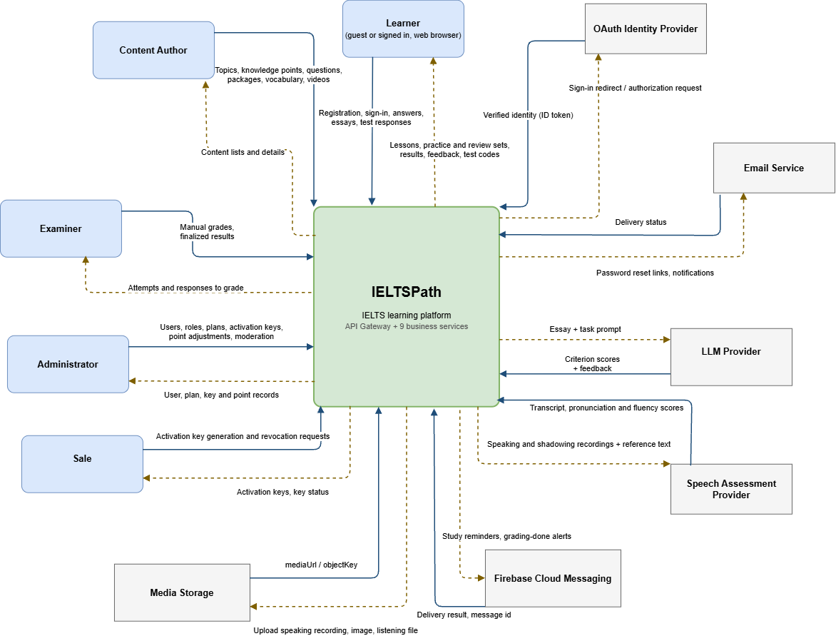

1.3 System Roles

Human actors of the System Context Diagram (Section 1.2) and their access level:
Role | Access Level | Primary Feature Areas
Learner — Guest (not signed in) | Public (unauthenticated) | Register; sign in with a password or through the OAuth identity provider; refresh the session; request a password reset link by email and complete the reset.
Learner — Signed in | Public (authenticated), role CUSTOMER | Learning path, lessons, lesson practice and review sets, topic final tests with test codes, results and feedback; Writing essays graded by the LLM provider; Speaking and shadowing recordings scored by the speech assessment provider; own subscription, points and activation keys; notes, flashcards, vocabulary and videos; games; community; profile, learning goals, activity and streak; study reminders and grading-done alerts by push notification or email.
Content Author | Internal | Create and maintain topics, knowledge points, questions, content packages, vocabulary and videos; upload passage images and Listening audio to media storage; view content lists and details.
Examiner | Internal | Receive attempts and responses that need manual grading; enter manual grades and finalize results; read-only access to topics, Reading sections, vocabulary and videos.
Sale | Internal, role SALES_STAFF | Generate and revoke activation keys; view issued keys and their status.
Administrator | Internal | Users and roles, plans, activation keys, point adjustments and community moderation; view user, plan, key and point records; all Content Author and Examiner capabilities.
Internal services (system) | API only | Service-to-service endpoints under /internal and the AssessmentCompleted.v2 event; not reachable through the API Gateway.

External systems of the System Context Diagram. They hold no sign-in role and exchange only the data below with IELTSPath:
External System | Sends to IELTSPath (solid arrow) | Receives from IELTSPath (dashed arrow)
OAuth Identity Provider | Verified identity (ID token). | Sign-in redirect / authorization request.
Email Service | Delivery status. | Password reset links and notifications.
LLM Provider | Criterion scores and feedback for each essay. | Essay text and the task prompt (Writing Task 1 and Task 2).
Speech Assessment Provider | Transcript, pronunciation and fluency scores. | Speaking and shadowing recordings with the reference text.
Firebase Cloud Messaging | Delivery result and message id. | Study reminders and grading-done alerts.
Media Storage | mediaUrl / objectKey of the stored file; the system keeps only the URL or key. | Speaking recordings, passage images and Listening files to upload.

Permission Matrix → IELTSPath_RTW.xlsx Sheet 4
Detailed Role x Feature x Action permission matrix (F/E/R/O/— per action).
Update RTW.xlsx Sheet 4 when roles or feature access rules change.

Use Case List → IELTSPath_RTW.xlsx Sheet 2
Full Use Case List with: UC ID, Name, Primary Actor, Secondary Actor(s),
Pre/Postcondition, Related FT-xx, Related SC-xx, Priority, Status.
To add/update/deprecate a UC: edit RTW.xlsx Sheet 2 directly.
Then update the Use Case Diagram below.

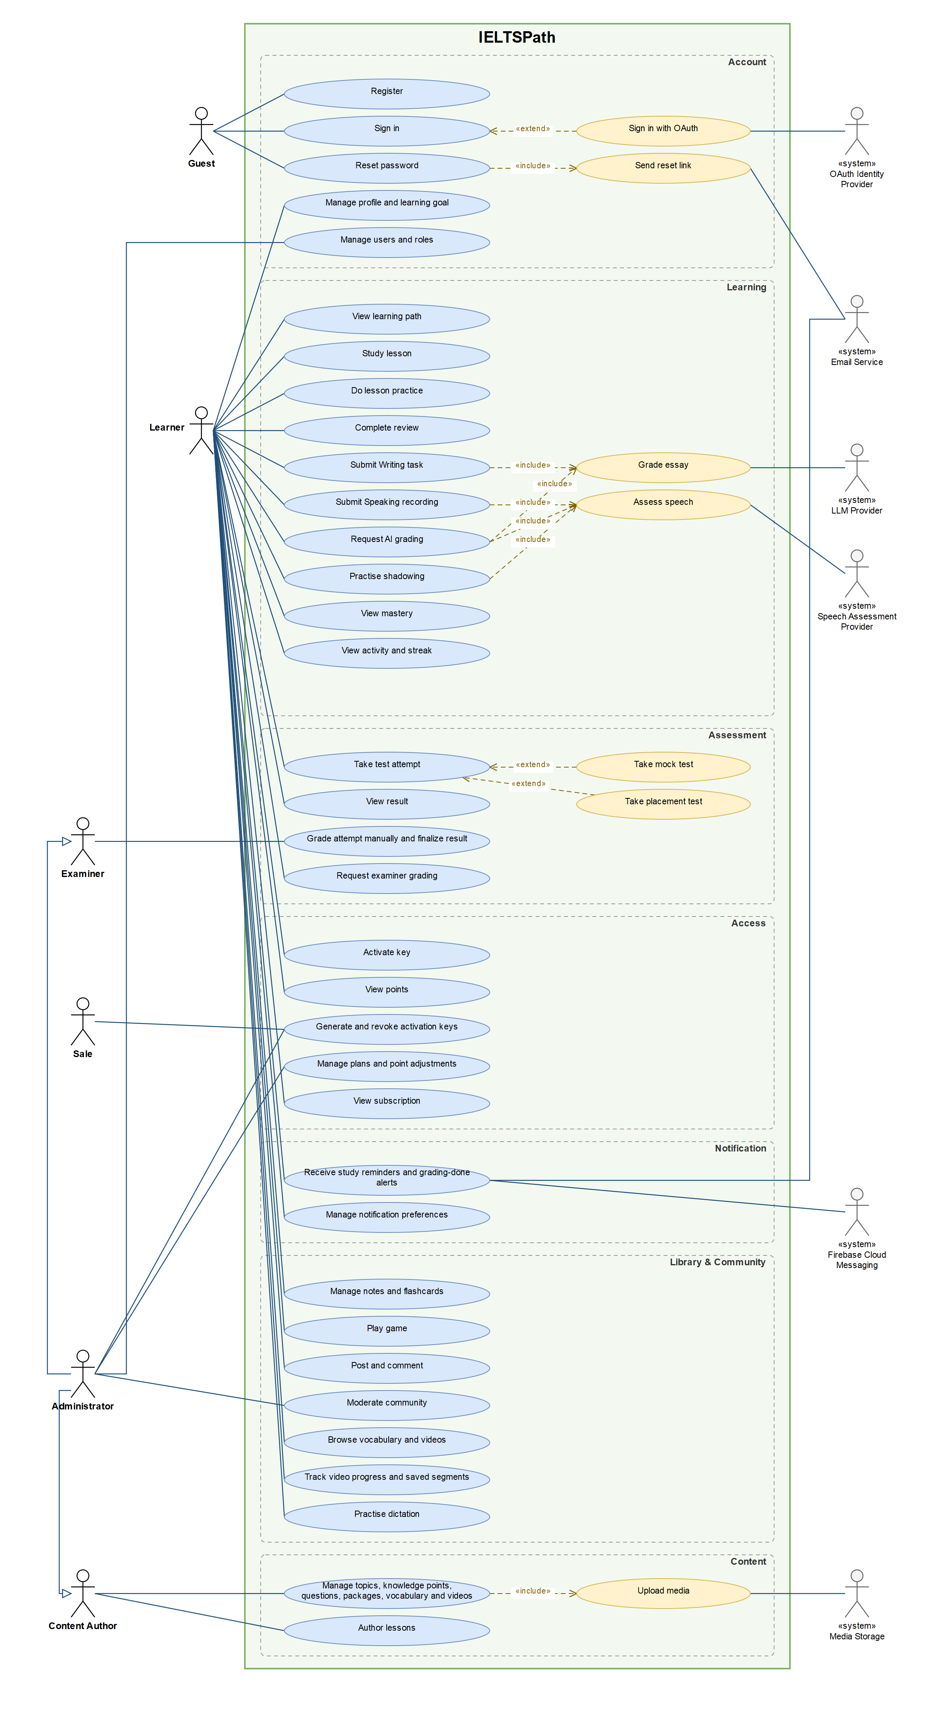
Figure 1.3 — Use Case Diagram (System Overview): actors, use cases by group, «include» / «extend» and the Administrator generalization
Source: part2-diagrams/IELTSPath_UseCaseDiagram.drawio.xml

1.4 Glossary

Term | Definition | Used in
Skill | One of the IELTS skills: Reading, Listening, Writing, Speaking. Each topic belongs to exactly one skill, and each skill has its own learning sequence. | FT-15, FT-20, FT-21, FT-28
Topic | The main unit of the learning path. It contains ordered lessons and, except for Writing topics, one final test. | FT-15, FT-20, FT-29
Lesson / Lesson block | An ordered unit inside a topic made of blocks: theory text, assets (passage, audio) and auto-graded exercises. | FT-19, FT-21, FT-22
Knowledge Point (KP) | The smallest unit of skill the system measures, for example True/False/Not Given questions. Questions and theory blocks are tagged with KPs. | FT-15, FT-16, FT-26, FT-28
Pass mark | The 70% correct threshold for passing a lesson block, a practice set, a review set and a topic final test. | FT-22, FT-27, FT-28, FT-29
Evidence | A recorded result for one KP from a lesson's first submission, a practice set, a review set or a final test. Mastery is computed from evidence. | FT-22, FT-26, FT-27, FT-28, FT-29
Mastery | A score from 0 to 1 per KP, computed from evidence each time it is read (formula ported from DeepTutor v1.6.9). | FT-26, FT-28
Practice set | A content package of type PRACTICE_SET linked to one lesson; the learner takes it after the lesson. | FT-17, FT-27
Revealed package | A practice package whose answers the learner has seen, in practice or in a review. It is never assigned to that learner again as a review set. | FT-27, FT-28
Review (review ladder) | A remediation item for one weak KP: a review set with hints, then theory with up to 3 quick-check questions, then a second set. It is skipped after two failed sets or when no unrevealed set remains. | FT-28
Quick-check | Up to 3 short questions in the theory stage of a review. They record no evidence. | FT-28
Topic final test | A content package of type TOPIC_TEST taken in the assessment module. It opens when every lesson of the topic has passed practice. | FT-29, FT-30
Test assignment | A single-use test code issued to one learner for one topic final test; available tests rotate between attempts. | FT-29
Attempt | One sitting of a test package in the assessment module, with saved responses, a submission and a result. | FT-30, FT-31, FT-32
AssessmentCompleted.v2 | The event the assessment module publishes when a result is final. The learning module consumes it to record evidence and pass the topic. | FT-29, FT-31, FT-32
Band | The IELTS score scale from 0 to 9 in steps of 0.5; used for learning goals and Writing grading. | FT-09, FT-25, FT-34
Point | A learner balance used to pay for AI grading of Writing tasks. Each grading debits points. | FT-12, FT-25
Plan / Entitlement | A plan grants feature keys to a learner. Content that requires a feature key is Premium content. | FT-10, FT-13
Activation key | A code generated for a key product; a learner redeems it to activate a plan. | FT-11
requestId | A client-generated id sent with each submission. Resending the same requestId returns the original result without grading or charging again. | FT-22, FT-25, FT-27, FT-28
AC-xx | Acceptance Criterion — a positive, testable condition for feature completion | All FT-xx
NAC-xx | Negative Acceptance Criterion — failure/rejection/boundary-breach test condition | All FT-xx
BV-xx | Boundary Value note — defines valid/invalid ranges for a specific constraint | All FT-xx
BR-xx | Business Rule ID — full definition in RTW.xlsx Sheet 6 | All FT-xx

1.5 Feature Traceability Bridge (V&S → SRS)

Full traceability matrix → IELTSPath_RTW.xlsx Sheet 3
Maintained in: RTW.xlsx Sheet 3: Feature Traceability Matrix

V&S Feature (FE-xx) | Feature Name in V&S | Maps to SRS (FT-xx) | Status
FE-01 | Account & Identity | FT-01 Account registration  FT-02 Password sign-in  FT-03 Session refresh & sign-out  FT-04 Password recovery by email  FT-05 OAuth sign-in  FT-06 Account & learner profile  FT-07 Role-based authorization  FT-08 User administration | Specified (draft parts in FT-04, FT-05)
FE-02 | Learning Goal | FT-09 Learning goal | Specified (draft parts in FT-09)
FE-03 | Access, Premium & Point | FT-10 Plans & subscriptions  FT-11 Activation keys  FT-12 Point wallet  FT-13 Premium content access  FT-14 Examiner grading credits  FT-25 Writing task grading | Specified (draft parts in FT-11, FT-13, FT-14)
FE-04 | Curriculum & Content Administration | FT-15 Topics & knowledge points  FT-16 Question bank  FT-17 Content packages & publishing  FT-18 Media assets  FT-19 Lesson authoring | Specified (draft parts in FT-17, FT-18, FT-19)
FE-05 | Learning Path & Lessons | FT-20 Skill-based learning path  FT-21 Lesson access gates & delivery  FT-22 Exercise grading & evidence  FT-23 Hints for wrong answers  FT-24 Listening audio & transcripts  FT-25 Writing task grading  FT-26 Knowledge-point mastery  FT-27 Lesson practice  FT-28 Review ladder  FT-29 Topic final test assignment & completion  FT-39 Speaking assessment | Specified (draft parts in FT-39)
FE-06 | Assessment | FT-14 Examiner grading credits  FT-30 Test attempts & responses  FT-31 Auto-grading & results  FT-32 Examiner grading  FT-33 AI grading jobs  FT-34 Mock test  FT-35 Placement test | Specified (draft parts in FT-14, FT-33, FT-34, FT-35)
FE-07 | Vocabulary & Video | FT-36 Vocabulary catalog  FT-37 Video catalog  FT-38 Video progress & saved segments  FT-39 Speaking assessment  FT-40 Shadowing practice  FT-41 Dictation practice | Specified (draft parts in FT-39, FT-40, FT-41)
FE-08 | Personal Library | FT-42 Notes  FT-43 Flashcards & decks | Specified
FE-09 | Learning Activity & Streak | FT-44 Learning activity log  FT-45 Study streak | Specified (draft parts in FT-44, FT-45)
FE-10 | Game Learning | FT-46 Single-player game sessions  FT-47 Multiplayer game rooms  FT-48 Matchmaking | Specified (draft parts in FT-48)
FE-11 | Quiz & Leaderboard | — (not in the current release) | Pending
FE-12 | Community | FT-49 Posts, comments & reactions  FT-50 Community moderation | Specified
FE-13 | Notification | FT-51 Notification preferences & devices  FT-52 Grading-done alerts  FT-53 Study reminders  FT-54 In-app notifications & delivery retry | Draft

Part 2 — Scenario / Narrative
The eight scenarios below describe the main business flows of the current release, from joining IELTSPath to passing a topic, and the staff flows that support them. Every feature FT-01 to FT-54 is linked to at least one scenario (see the Scenario List). Related UC entries use the use case names of the Use Case Diagram in Section 1.3; their UC IDs are assigned in IELTSPath_RTW.xlsx Sheet 2.
The diagram sources are kept in part2-diagrams/IELTSPath_Scenarios.drawio next to this SRS (draw.io format, one page per scenario), with a PNG export of each diagram. Red nodes in the activity diagrams mark exception paths.

SC-01 — Join IELTSPath and set a learning goal
Business Flow | Register an account, set a learning goal and see the skill-based learning path
Primary Actor | Learner — Guest (signed in as a Learner once registered)
Pre-condition | No IELTSPath account exists for the learner's email address.
Post-condition | An active account with role CUSTOMER exists and the learner is signed in; the learner has exactly one ACTIVE learning goal; the learning path shows one topic in progress per skill.
Related Feature | FE-01, FE-02, FE-06 → FT-01, FT-02, FT-03, FT-04, FT-05, FT-06, FT-07, FT-09, FT-35
Related UC | Register; Sign in; Sign in with OAuth; Reset password; Manage profile and learning goal; Take placement test

Narrative:
Minh Anh is a third-year university student who needs IELTS band 6.5 to graduate and plans to sit the Academic test in four months. On a Sunday evening at home, Minh Anh opens IELTSPath on a laptop and registers with an email address, a password of at least 6 characters and a full name. IELTSPath creates the account with the learner role (CUSTOMER), and Minh Anh then signs in with the same email and password.
Next, Minh Anh sets a learning goal: target band 6.5, an exam date in mid-February and 60 minutes of study per day. IELTSPath keeps this as the learner's single active goal; changing it later updates that goal instead of adding a second one. Minh Anh then opens the learning path. Each skill has its own ordered list of topics; the first topic of every skill is in progress and the later ones are locked. In this release the goal is kept for the learner's own tracking and does not change the order of topics. Before starting, Minh Anh can also take a one-time placement test to estimate a starting level.
Key Exception / Alternate Flows:
• Email already registered: IELTSPath rejects the registration and creates nothing — Minh Anh is told the email is in use and can sign in, or choose Forgot password.
• Forgotten password: Minh Anh chooses Forgot password and enters the email; IELTSPath creates a single-use reset link valid for 15 minutes, to be sent by email (email delivery is not built in the current release) — Minh Anh sets a new password through the link and signs in again; an expired or already used link is rejected.
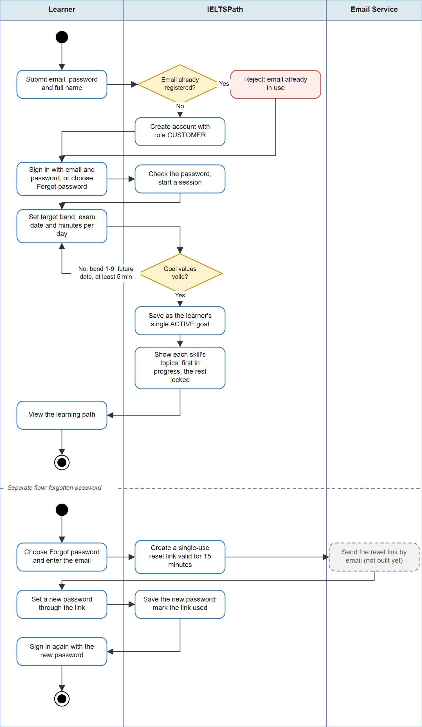
Figure SC-01 — Activity Diagram: Join IELTSPath and set a learning goal
Source: part2-diagrams/IELTSPath_Scenarios.drawio, page 1

SC-02 — Study a lesson on the skill path
Business Flow | Study the next lesson of a topic and pass its exercise blocks
Primary Actor | Learner — Signed in (CUSTOMER)
Pre-condition | The topic is in progress for its skill; every earlier lesson of the topic is completed; the learner has no pending review in the same skill.
Post-condition | Every auto-graded exercise block of the lesson has passed with at least 70%; evidence from the first submission of each block is recorded per knowledge point; the next lesson and the practice set of this lesson are unlocked.
Related Feature | FE-05, FE-09 → FT-20, FT-21, FT-22, FT-23, FT-26, FT-44, FT-45
Related UC | View learning path; Study lesson; View mastery; View activity and streak

Narrative:
Tuấn works in an office and studies on a phone during the 40-minute bus ride home. Tuấn opens the Reading path, where the topic on main ideas is in progress, and continues with its third lesson. IELTSPath presents the lesson in order: a short theory section, a reading passage and two exercise blocks. The questions come without answers or explanations.
Tuấn answers the first block and submits it. Five of eight answers are correct (62.5%), below the 70% pass mark, so the block is not passed. IELTSPath marks which answers were wrong and reveals the author's hint for each of those questions, but still no correct answers. Tuấn reads the hints, tries again and gets seven of eight (87.5%). The block passes and IELTSPath now shows the correct answer and explanation for every question. Only the first submission of each block counts as evidence for Tuấn's knowledge-point mastery, so retrying does not inflate it.
After the second block also passes, the lesson is complete. IELTSPath unlocks the next lesson and the practice set of this lesson, updates Tuấn's mastery per knowledge point and counts the day toward Tuấn's study streak.
Key Exception / Alternate Flows:
• Pending review in the same skill: IELTSPath refuses to open or grade Reading lessons until the review is done or skipped — Tuấn can still study Listening or Writing in the meantime.
• Connection drops after submitting: the app resends the same submission and IELTSPath returns the original result — the block is not graded or counted twice.
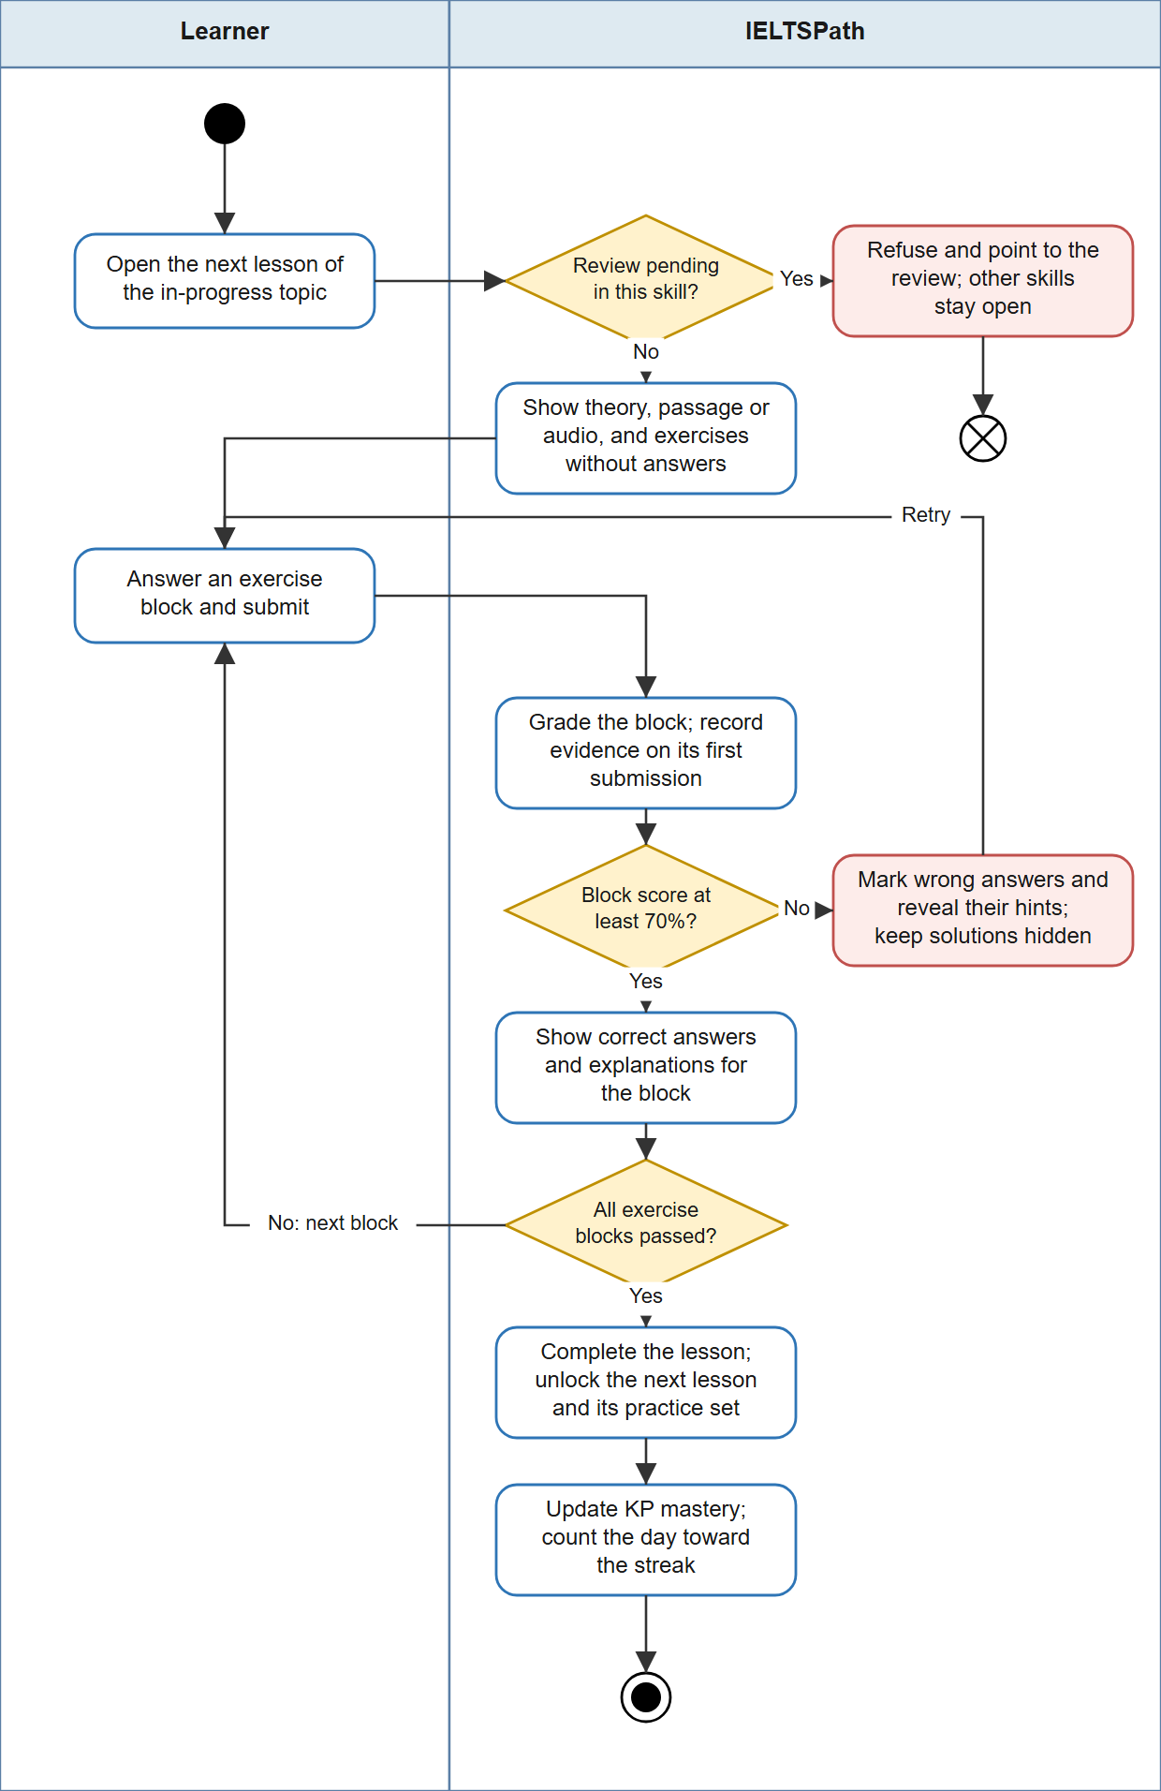
Figure SC-02 — Activity Diagram: Study a lesson on the skill path
Source: part2-diagrams/IELTSPath_Scenarios.drawio, page 2

SC-03 — Practise after a lesson and recover through review
Business Flow | Take the practice set of a lesson and repair weak knowledge points through the review ladder
Primary Actor | Learner — Signed in (CUSTOMER)
Pre-condition | The lesson is completed; the lesson has at least one published practice set the learner has not seen; no review is pending in the same skill.
Post-condition | Practice is cleared for the lesson, either by a first submission of at least 70% or by finishing the reviews that the set created (DONE or SKIPPED); every submitted set is marked as revealed for this learner and is never given to the learner again as a review set.
Related Feature | FE-05 → FT-26, FT-27, FT-28
Related UC | Do lesson practice; Complete review

Narrative:
Lan finishes the Reading lesson on Matching Headings on a Saturday morning and starts its practice set on a tablet. Lan submits the set and scores 60%. IELTSPath shows every correct answer and explanation straight away and marks the set as revealed for Lan. Because this first submission is below 70%, IELTSPath opens a review for each knowledge point Lan scored below 70% on — here, recognising paraphrase — as long as another unseen set remains for it. Until the review ends, Lan cannot continue Reading lessons, Reading practice or the Reading final test; Listening and Writing stay open.
The review gives Lan a fresh set on the same knowledge point, with hints. Lan scores 50%, so the review moves to theory: IELTSPath shows the theory for that knowledge point and up to three quick-check questions, which do not count as evidence. After the quick check, Lan receives another unseen set and scores 75%. The review is DONE, Reading is unblocked and practice for the lesson is cleared.
Key Exception / Alternate Flows:
• Second review set also fails: IELTSPath ends the review as SKIPPED after two failed sets — Lan is not held in a loop; Reading unblocks and practice for the lesson still clears.
• No unseen set left for the knowledge point: IELTSPath skips the review at once instead of reusing a set Lan has already seen.
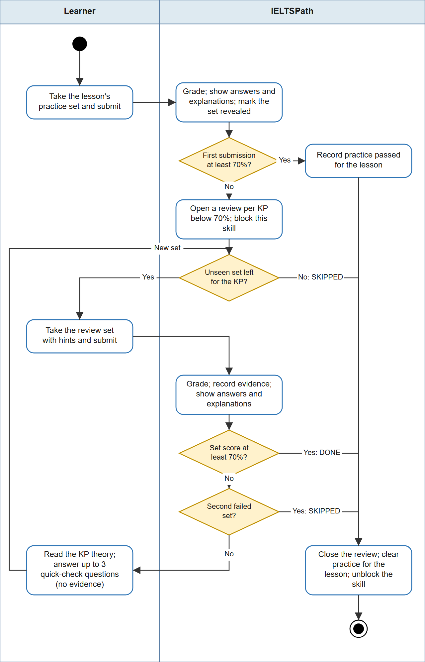
Figure SC-03 — Activity Diagram: Practise after a lesson and recover through review
Source: part2-diagrams/IELTSPath_Scenarios.drawio, page 3

SC-04 — Get a Writing essay graded by AI
Business Flow | Submit a Writing Task 2 essay in a lesson and receive an estimated band with feedback per criterion
Primary Actor | Learner — Signed in (CUSTOMER)
Pre-condition | The Writing lesson is open to the learner; the point balance is at least 3; the learner has used fewer than 10 gradings today; the LLM provider is reachable.
Post-condition | The essay is stored as GRADED with four criterion bands, an overall band and feedback; exactly 3 points are debited once; evidence is recorded for the knowledge points of the question; the sample answer is shown if the essay reached the pass band.
Related Feature | FE-03, FE-05 → FT-12, FT-25
Related UC | Submit Writing task; Grade essay (LLM Provider); View points

Narrative:
Hà is aiming for band 7 and practises Writing in the evening at home on a laptop. In the Writing topic on opinion essays, Hà reaches the essay block of the lesson, writes about 280 words in response to the Task 2 prompt and submits it. IELTSPath checks the length (50 to 1,000 words) and sends the essay with the task prompt to the LLM provider. Within about 20 to 45 seconds Hà receives a band and feedback for each of the four criteria — Task Response, Coherence and Cohesion, Lexical Resource, and Grammatical Range and Accuracy — with strengths and points to improve.
IELTSPath computes the overall band itself as the mean of the four criterion bands rounded to the nearest half band, and treats the essay as passed when the overall band reaches the pass band of the block. Only after a successful grading does it debit 3 points from Hà's wallet, and the points history shows the charge. Hà's essay reached the pass band, so the sample answer is now shown. The band is presented as an estimate, not an official IELTS score. Essay blocks never hold back lesson completion: a learner without points can still finish every Writing lesson, and a Writing topic, which has no final test, is passed when all its lessons are complete.
Key Exception / Alternate Flows:
• Balance below 3 points, or 10 gradings already used today: IELTSPath rejects the essay before grading and charges nothing — Hà can top up with a points key (SC-06) or try again the next day (Vietnam time).
• LLM provider fails, times out or returns an invalid result: the submission is marked failed and no points are charged — Hà resends it later and IELTSPath grades the essay text stored with the first attempt.
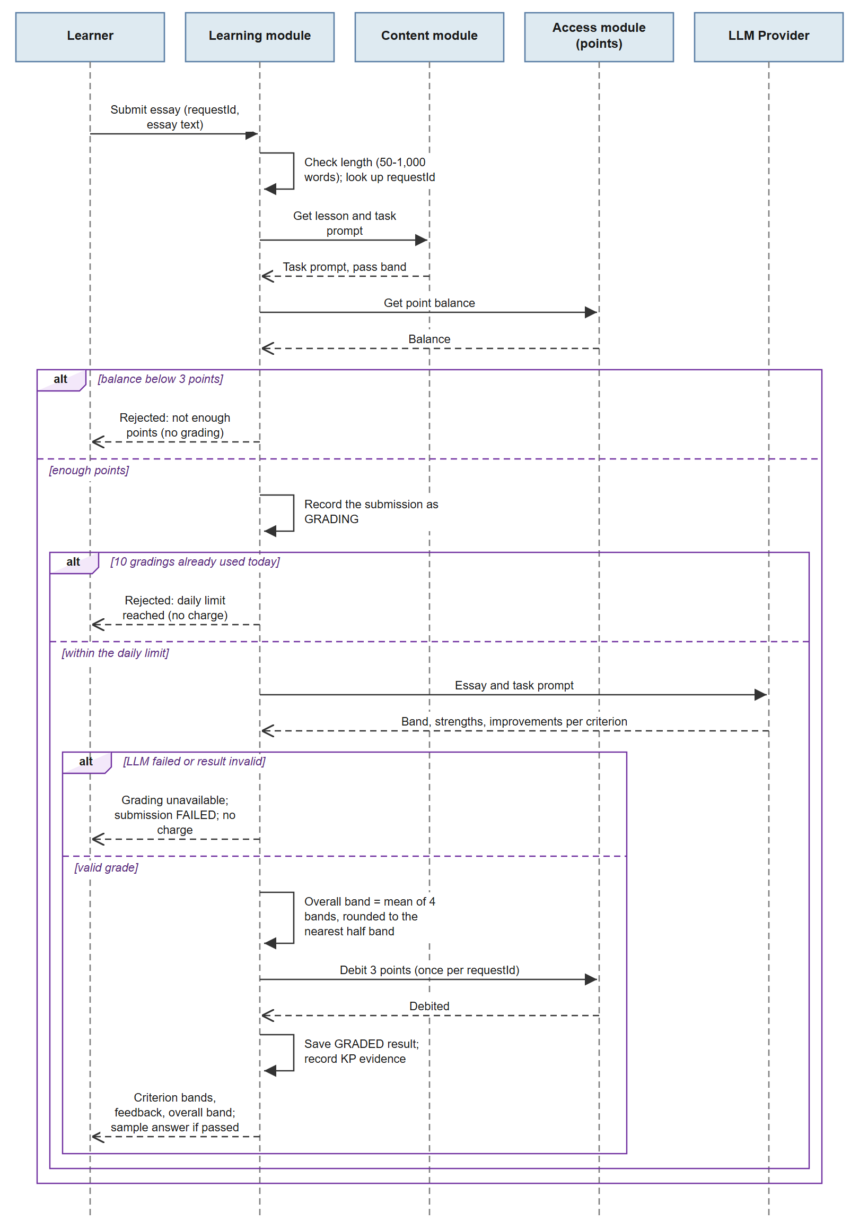
Figure SC-04 — Sequence Diagram: Get a Writing essay graded by AI
Source: part2-diagrams/IELTSPath_Scenarios.drawio, page 4

SC-05 — Take the topic final test and unlock the next topic
Business Flow | Request a test code, sit the topic final test and pass the topic
Primary Actor | Learner — Signed in (CUSTOMER); Examiner (secondary)
Pre-condition | The topic is in progress and has a final test; every lesson of the topic is completed and has cleared practice; no review is pending in the skill of the topic.
Post-condition | The test code is consumed; the attempt has a final result; evidence is recorded per knowledge point; with a score of at least 70% the topic is PASSED and the next topic of the same skill is in progress.
Related Feature | FE-03, FE-05, FE-06, FE-13 → FT-14, FT-24, FT-26, FT-29, FT-30, FT-31, FT-32, FT-33, FT-34, FT-51, FT-52, FT-53, FT-54
Related UC | Take test attempt; View result; Take mock test; Request examiner grading; Request AI grading; Grade attempt manually and finalize result; Receive study reminders and grading-done alerts; Manage notification preferences

Narrative:
Quang has cleared practice for all four lessons of the first Listening topic. On Saturday morning, at a desk with headphones, Quang asks for the final test of the topic. IELTSPath checks that every lesson is complete and practice-cleared and that no Listening review is pending, then issues a single-use test code for one of the tests of the topic. Quang starts the attempt, the answers are saved along the way, and Quang submits.
IELTSPath grades the objective questions automatically and passes the final result to Quang's learning progress. Quang scores 78%: the test code is consumed, the result is recorded as evidence for each knowledge point, the topic becomes PASSED and the next Listening topic opens. Quang then reviews the result: the score, which answers were right or wrong and, because the score reached 70%, the correct answers, explanations and transcripts. Before the real exam, Quang can also sit a full four-skill mock test, which IELTSPath grades and turns into an estimated band for each skill and overall.
Key Exception / Alternate Flows:
• Score below 70%: the code is still consumed and the topic stays in progress; correct answers stay hidden and reviews open for weak knowledge points (mastery below 0.6) — when Quang asks again, IELTSPath issues a code for a different test of the topic while unused tests remain.
• Responses that cannot be graded automatically: the result waits for an Examiner, who enters the grades and finalizes it; Quang receives a grading-done alert — the topic is then passed or not by the same 70% rule.
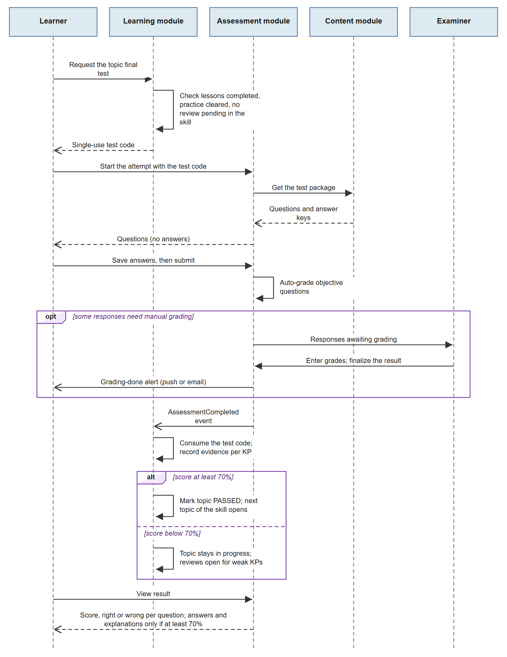
Figure SC-05 — Sequence Diagram: Take the topic final test and unlock the next topic
Source: part2-diagrams/IELTSPath_Scenarios.drawio, page 5

SC-06 — Unlock Premium or points with an activation key
Business Flow | Issue activation keys and redeem one for Premium days or points
Primary Actor | Learner — Signed in (CUSTOMER); Sale (secondary)
Pre-condition | A key product exists (for example Premium 30 days, or a pack of points); a Sale staff member has generated a key for it that is ACTIVE and not expired.
Post-condition | The key is REDEEMED exactly once; for a Premium product the subscription of the learner is created or extended by the days of the product; for a points product the wallet is credited and the points history shows the credit.
Related Feature | FE-03, FE-06 → FT-10, FT-11, FT-12, FT-13, FT-14
Related UC | Generate and revoke activation keys; Activate key; View points; View subscription

Narrative:
Vy studies at a partner English centre that sells IELTSPath Premium as part of its course. Đức, a Sale staff member, generates a batch of keys for the product "Premium 30 days" with an expiry date. IELTSPath shows each key to Đức once and afterwards keeps only a short hint of it. Đức hands one key to Vy on the first day of class; a key that is lost before use can be revoked, but a redeemed key cannot.
That evening Vy enters the key in IELTSPath. IELTSPath checks that the key is active and not expired, marks it redeemed so it can never be used again, and starts a 30-day Premium subscription for Vy — or adds the 30 days to the current subscription if Vy already has one. Vy sees the new end date. A key for a points product works the same way, except that IELTSPath adds the points to Vy's wallet and records the credit in the points history.
Key Exception / Alternate Flows:
• Key already redeemed, revoked or expired: IELTSPath rejects it and changes nothing — Vy asks the centre for a new key.
• The same activation is sent twice, for example on a slow network: IELTSPath recognises the repeat — the key is redeemed and the benefit granted only once.
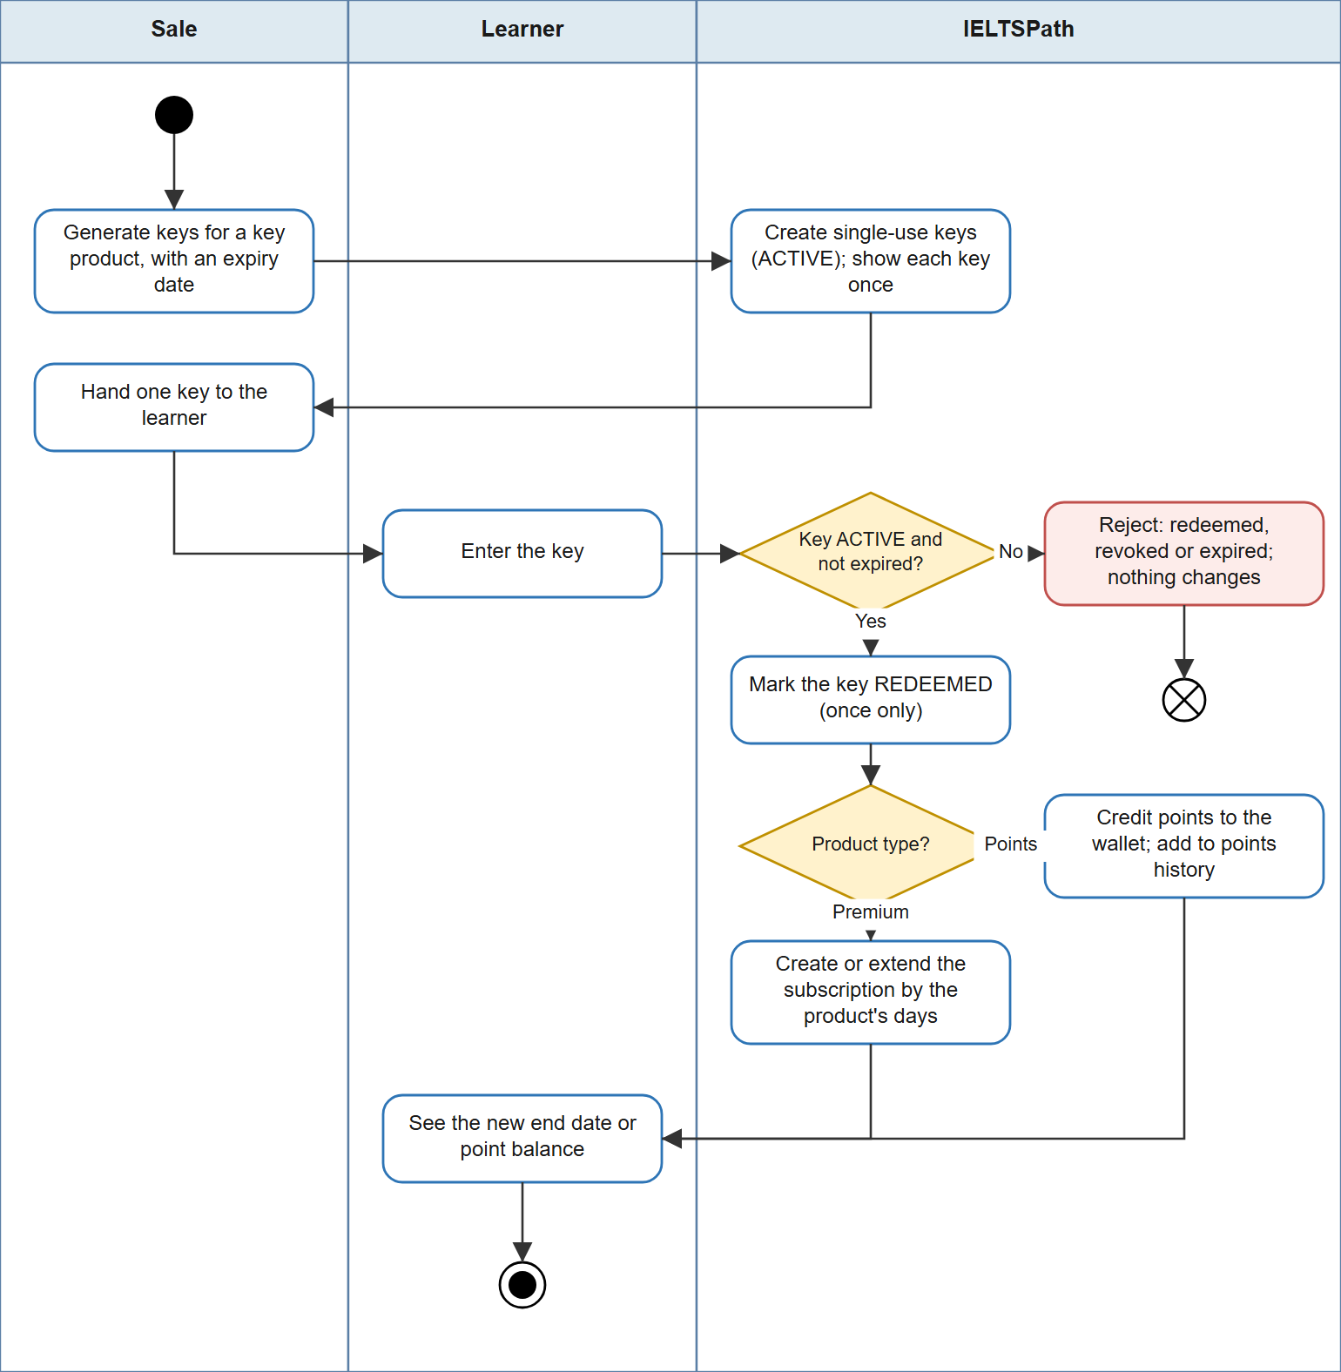
Figure SC-06 — Activity Diagram: Unlock Premium or points with an activation key
Source: part2-diagrams/IELTSPath_Scenarios.drawio, page 6

SC-07 — Prepare a new topic for learners
Business Flow | Grant authoring access, build the question bank and packages of a topic, and publish them
Primary Actor | Content Author; Administrator (secondary)
Pre-condition | The author has an IELTSPath account; the lessons of the topic are planned.
Post-condition | The topic belongs to one skill and has knowledge points, questions and published packages (a practice set for each lesson and one final test); media files sit in Media Storage and the system keeps only their URL or key.
Related Feature | FE-01, FE-04 → FT-07, FT-08, FT-15, FT-16, FT-17, FT-18, FT-19
Related UC | Manage users and roles; Manage topics, knowledge points, questions, packages, vocabulary and videos; Author lessons; Upload media (Media Storage)

Narrative:
Phương, the Administrator, grants Hùng the CONTENT_AUTHOR role so that Hùng can work on the curriculum. Hùng is preparing a new Listening topic on map labelling. Working from the office on a desktop, Hùng creates the topic under the Listening skill, adds its knowledge points and writes the questions. Each question has a stem, the correct answer, an explanation, an optional hint, a purpose (learning or exam) and the knowledge points it tests. Hùng uploads the audio recordings and map images; IELTSPath stores the files in Media Storage and keeps only their address.
Hùng then groups the questions into packages: a practice set for each lesson and one final test for the topic. IELTSPath checks that each question belongs to only one package and saves the package versions as drafts. When Hùng publishes them, the topic and its packages become available to learners in the Listening sequence. Later edits create new versions, so a learner who has already started a set keeps the version they began.
Key Exception / Alternate Flows:
• A question already belongs to another package or lesson: IELTSPath rejects adding it — Hùng creates a separate question instead.
• Changing the skill of a topic that already has lessons: IELTSPath rejects the change — the topic stays in its skill.
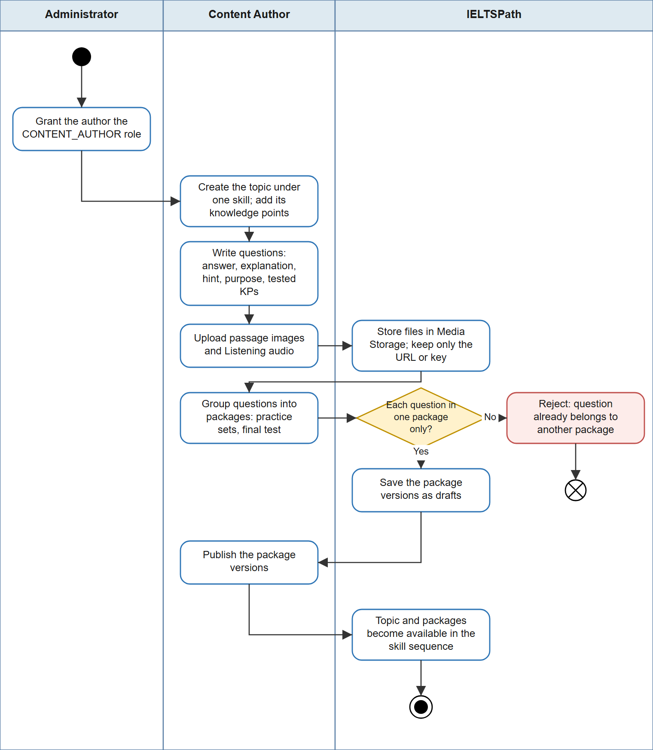
Figure SC-07 — Activity Diagram: Prepare a new topic for learners
Source: part2-diagrams/IELTSPath_Scenarios.drawio, page 7

SC-08 — Self-study vocabulary and share in the community
Business Flow | Use videos, flashcards, shadowing and games for self-study, then share a tip in the community
Primary Actor | Learner — Signed in (CUSTOMER); Administrator (secondary)
Pre-condition | Published videos and vocabulary exist in the library; the learner is signed in.
Post-condition | Video progress, saved segments and flashcards are stored in the personal library of the learner; shadowing scores and a completed game session are recorded; the community post is visible unless an Administrator hides it.
Related Feature | FE-05, FE-07, FE-08, FE-10, FE-12 → FT-36, FT-37, FT-38, FT-39, FT-40, FT-41, FT-42, FT-43, FT-46, FT-47, FT-48, FT-49, FT-50
Related UC | Browse vocabulary and videos; Track video progress and saved segments; Manage notes and flashcards; Submit Speaking recording; Practise shadowing; Practise dictation; Assess speech (Speech Assessment Provider); Play game; Post and comment; Moderate community

Narrative:
Khoa likes to study vocabulary on Sunday afternoons. Khoa watches a short video about city life, saves a segment with useful phrases and adds four new words to a flashcard deck, together with a practice question Khoa got wrong earlier. IELTSPath keeps the video progress, the saved segment and the cards in Khoa's personal library. Khoa then records a shadowing attempt of the saved segment; IELTSPath sends the recording and its reference text to the speech assessment provider and shows Khoa the transcript with pronunciation and fluency scores.
To finish, Khoa plays a ten-question word-meaning game, earning one point for each correct answer, and posts a tip about learning collocations in the community, where other learners comment and react.
Key Exception / Alternate Flows:
• Khoa leaves the game before the last question: IELTSPath ends the session as abandoned — it does not count as completed.
• A post breaks the community rules: the Administrator hides it — it no longer appears in the feed.
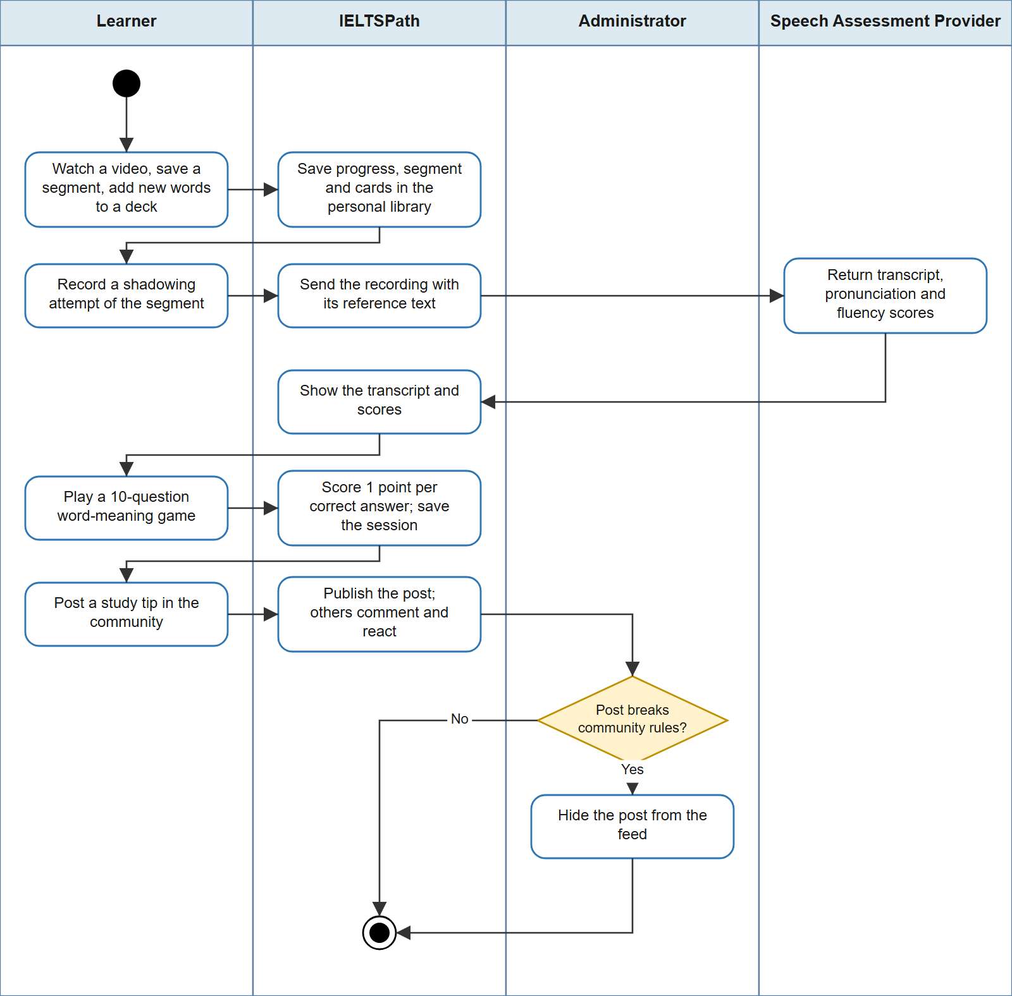
Figure SC-08 — Activity Diagram: Self-study vocabulary and share in the community
Source: part2-diagrams/IELTSPath_Scenarios.drawio, page 8

Scenario List
ID | Scenario Name | Primary Actor | Maps to Feature(s) | Priority
SC-01 | Join IELTSPath and set a learning goal | Learner — Guest | FT-01, FT-02, FT-03, FT-04, FT-05, FT-06, FT-07, FT-09, FT-35 | High
SC-02 | Study a lesson on the skill path | Learner | FT-20, FT-21, FT-22, FT-23, FT-26, FT-44, FT-45 | High
SC-03 | Practise after a lesson and recover through review | Learner | FT-26, FT-27, FT-28 | High
SC-04 | Get a Writing essay graded by AI | Learner | FT-12, FT-25 | High
SC-05 | Take the topic final test and unlock the next topic | Learner (Examiner) | FT-14, FT-24, FT-26, FT-29, FT-30, FT-31, FT-32, FT-33, FT-34, FT-51, FT-52, FT-53, FT-54 | High
SC-06 | Unlock Premium or points with an activation key | Learner (Sale) | FT-10, FT-11, FT-12, FT-13, FT-14 | Medium
SC-07 | Prepare a new topic for learners | Content Author (Administrator) | FT-07, FT-08, FT-15, FT-16, FT-17, FT-18, FT-19 | Medium
SC-08 | Self-study vocabulary and share in the community | Learner (Administrator) | FT-36, FT-37, FT-38, FT-39, FT-40, FT-41, FT-42, FT-43, FT-46, FT-47, FT-48, FT-49, FT-50 | Low

Part 3 — Feature Description
The features below specify what IELTSPath does for each SRS feature FT-01 to FT-54 named in the Feature Traceability Bridge (Section 1.5) and the Scenario List (Part 2); there is one feature for each leaf of the IELTSPath feature tree in the current scope. Each feature lists its business rules by ID only; the one-line rule list is in Part 5 and the full rule text in IELTSPath_RTW.xlsx Sheet 6.
Acceptance criteria are numbered per feature and are cited as FT-xx/AC-yy, FT-xx/NAC-yy and FT-xx/BV-yy. HTTP status codes are those returned through the API Gateway; where a service also returns a machine-readable error code, the code is given in capitals (for example 409 REQUEST_CONFLICT).
Status Specified means the behaviour is implemented in the current release and was checked against it. Status Draft means the behaviour is required but not yet built; each Draft feature states what the current release already provides, and values marked [TBC] still need a team decision.

FT-01 — Account registration
Source Feature (V&S) | FE-01
Related Scenario | SC-01
Related UC | Register (UC IDs in RTW.xlsx Sheet 2)
Summary | The system lets a guest create a learner account, so the guest can sign in and start learning.

System Behaviour:
When a guest submits a registration with email, password, full name and an optional phone number, the system checks the email format, a password of 6 to 72 characters and a non-blank full name, and rejects an email that another account already uses. It then creates an ACTIVE account with exactly one role, CUSTOMER, and stores the password only as a BCrypt hash.
Public registration never grants any other role; staff roles are assigned only by an Administrator (FT-08).

Applicable Business Rules:
BR-01, BR-02 → See Part 5 and IELTSPath_RTW.xlsx Sheet 6 for full definitions.

Positive Acceptance Criteria (AC):
AC-01: When a guest registers with an unused email, a password of 6 to 72 characters and a full name, the system returns HTTP 201 and creates exactly one ACTIVE account whose only role is CUSTOMER.
AC-02: After registration, no response or log contains the raw password; the account stores only its hash.

Negative Acceptance Criteria (NAC) — FT-01
NAC-01: Registration with an email that already belongs to an account → HTTP 409; no account is created.
NAC-02: Registration that requests a role other than CUSTOMER → HTTP 400; no account is created.
NAC-03: Registration with an invalid email, a blank full name or a password outside 6–72 characters (BV-01) → HTTP 400 with the failing fields listed; nothing is stored.

Boundary Value Notes (BV) — FT-01
BV-01 Password length:
Valid: 6 to 72 characters
Invalid: 5, 73
Test points: 5 (reject), 6 (accept), 72 (accept), 73 (reject)

FT-02 — Password sign-in
Source Feature (V&S) | FE-01
Related Scenario | SC-01
Related UC | Sign in (UC IDs in RTW.xlsx Sheet 2)
Summary | The system signs in a registered user with email (or username) and password and issues the tokens that identify the user on every later request.

System Behaviour:
When a user signs in with an email (or username) and a password, the system accepts the request only if the account exists, is ACTIVE and the password matches. It issues an access token valid for 3,600 seconds that carries the user id and roles, and a refresh token valid for 604,800 seconds (7 days) that is stored only as a hash. When cookie mode is enabled, both tokens are also returned as HttpOnly cookies.
Every sign-in failure returns the same message, so the response never reveals whether an email is registered. The API Gateway validates the access token on every protected request and forwards only a gateway-signed internal token, so identity headers sent by a client are ignored.

Applicable Business Rules:
BR-04, BR-06 → See Part 5 and IELTSPath_RTW.xlsx Sheet 6 for full definitions.

Positive Acceptance Criteria (AC):
AC-01: When an ACTIVE user signs in with the correct password, the system returns an access token that expires 3,600 seconds after issue and a refresh token that expires 604,800 seconds after issue.
AC-02: The access token's subject is the user id and its roles claim lists exactly the user's roles.

Negative Acceptance Criteria (NAC) — FT-02
NAC-01: Sign-in with a wrong password, an unknown email or an account in status INACTIVE, LOCKED or PENDING_VERIFY → HTTP 401 with the same message in every case; no token is issued.
NAC-02: Sign-in with a blank password → HTTP 400; no token is issued.
NAC-03: A protected request without a valid access token, including one that only sends X-User-* headers → HTTP 401; the request does not reach the business service.

Boundary Value Notes (BV) — FT-02
BV-01 Access token lifetime:
Valid: up to 3,600 seconds after issue
Invalid: later than 3,600 seconds
Test points: 3,599 s (accepted), 3,601 s (HTTP 401)

FT-03 — Session refresh & sign-out
Source Feature (V&S) | FE-01
Related Scenario | SC-01
Related UC | Sign in (UC IDs in RTW.xlsx Sheet 2)
Summary | The system keeps a signed-in session alive by exchanging a refresh token for a new token pair, and ends the session on sign-out.

System Behaviour:
Refresh tokens are random strings that the system stores only as hashes, each with an expiry and a revocation time. A refresh token is usable only while it is not revoked and not expired.
When the client presents a refresh token, the system revokes it in one atomic step and, only if that step succeeds and the account is still ACTIVE, issues a new access token and a new refresh token. A used token therefore cannot be used again even before its 7 days end, and two simultaneous refreshes with the same token yield one new pair only.
Sign-out revokes the presented refresh token and clears the auth cookies. Each sign-in starts a separate session, so signing out on one device leaves the user's other devices signed in.

Applicable Business Rules:
BR-04 → See Part 5 and IELTSPath_RTW.xlsx Sheet 6 for full definitions.

Positive Acceptance Criteria (AC):
AC-01: When a valid refresh token is presented, the system returns a new access token and a new refresh token, and a second request with the first refresh token returns HTTP 401 even though its 7-day lifetime has not ended.
AC-02: After sign-out, the refresh token presented at sign-out returns HTTP 401 on refresh.
AC-03: When a user is signed in on two devices and signs out on one, the other device can still refresh its session.

Negative Acceptance Criteria (NAC) — FT-03
NAC-01: Refresh with a token that is used, revoked, expired or unknown → HTTP 401; no new token is issued.
NAC-02: Two refresh requests with the same token at the same moment → exactly one returns a new pair; the other returns HTTP 401.
NAC-03: Refresh for an account that is no longer ACTIVE → HTTP 401; no new token is issued.

Boundary Value Notes (BV) — FT-03
BV-01 Refresh token lifetime:
Valid: up to 604,800 seconds (7 days) after issue, once
Invalid: later than 7 days, or a second use
Test points: 7 days minus 1 minute (accepted), 7 days plus 1 minute (HTTP 401), second use within 1 minute (HTTP 401)

FT-04 — Password recovery by email
Source Feature (V&S) | FE-01
Related Scenario | SC-01
Related UC | Reset password <<include>> Send reset link (Email Service) (UC IDs in RTW.xlsx Sheet 2)
Summary | The system lets a user who forgot the password set a new one through a single-use link that expires after 15 minutes.

System Behaviour:
When a user requests a password reset with an email address, the system checks the email format and looks up the account. It generates a random reset token, stores only its hash with purpose PASSWORD_RESET and an expiry 15 minutes after creation, and hands the reset link to the Email Service.
When the user submits the token with a new password of at least 6 characters, the system accepts the token only if its hash exists, it has not been used and it has not expired. It marks the token used, replaces the password hash and records only the user id in the log. The old password stops working at once.
An Administrator can list a user's account action tokens with their expiry and revoke them. Current release: the token is created and the reset works, but no email is sent because the Email Service is not integrated yet.

Applicable Business Rules:
BR-02, BR-03 → See Part 5 and IELTSPath_RTW.xlsx Sheet 6 for full definitions.

Positive Acceptance Criteria (AC):
AC-01: When a registered email requests a reset, the system stores one PASSWORD_RESET token whose expiry is 15 minutes after creation and returns HTTP 200.
AC-02: When a valid token and a new password of at least 6 characters are submitted, the system returns HTTP 200, the new password signs in successfully and the old password returns HTTP 401.
AC-03: After a successful reset, the same token is rejected if it is submitted again.

Negative Acceptance Criteria (NAC) — FT-04
NAC-01: Reset request with an email that has no account → HTTP 404; no token is created.
NAC-02: Reset request with a blank or malformed email → HTTP 400; no token is created.
NAC-03: Reset with a token that is unknown, already used or older than 15 minutes → HTTP 400; the password does not change.
NAC-04: Reset with a new password shorter than 6 characters (BV-02) → HTTP 400; the token stays unused.

Boundary Value Notes (BV) — FT-04
BV-01 Reset token validity:
Valid: up to 15 minutes after creation, once
Invalid: after 15 minutes, or a second use
Test points: 14 min 59 s (accepted), 15 min 01 s (HTTP 400), second use (HTTP 400)
BV-02 New password length:
Valid: 6 characters or more
Invalid: 5 characters, blank
Test points: 5 (reject), 6 (accept), blank (reject)

FT-05 — OAuth sign-in
Source Feature (V&S) | FE-01
Related Scenario | SC-01
Related UC | Sign in <<extend>> Sign in with OAuth (OAuth Identity Provider) (UC IDs in RTW.xlsx Sheet 2)
Summary | The system lets a user sign in through the OAuth Identity Provider and manage the identities linked to the account.

System Behaviour:
When a guest chooses OAuth sign-in, the system redirects to the OAuth Identity Provider, verifies the returned ID token and signs in the account linked to that identity, issuing tokens as in FT-02. [TBC: whether a first OAuth sign-in creates a CUSTOMER account or links to an existing account with the same email].
A signed-in user lists the identities linked to the account and unlinks a provider; an Administrator can do the same for any user. Current release: listing and unlinking are implemented; the redirect, ID-token verification and linking are not built.

Applicable Business Rules:
BR-01, BR-04 → See Part 5 and IELTSPath_RTW.xlsx Sheet 6 for full definitions.

Positive Acceptance Criteria (AC):
AC-01: When a user unlinks a linked provider, the provider no longer appears in the user's list of linked identities.
AC-02: [TBC] When the provider returns a valid ID token for a linked identity, the system issues an access token and a refresh token.

Negative Acceptance Criteria (NAC) — FT-05
NAC-01: Unlinking a provider that is not linked to the account → HTTP 404; nothing changes.
NAC-02: [TBC] An invalid or expired ID token → HTTP 401; no account is created and no token is issued.

Boundary Value Notes (BV) — FT-05
No numeric boundary applies to this feature; its limits are covered by the AC and NAC above.

FT-06 — Account & learner profile
Source Feature (V&S) | FE-01
Related Scenario | SC-01
Related UC | Manage profile and learning goal (UC IDs in RTW.xlsx Sheet 2)
Summary | The system lets each user keep their account details and learner profile up to date.

System Behaviour:
A signed-in user reads and updates their own account: a non-blank full name and an optional phone number. The system rejects a phone number that already belongs to another account.
When a learner saves the profile, the system validates a non-blank display name of at most 100 characters, an avatar URL of at most 500 characters, a bio of at most 1,000 characters, a current band from 0.0 to 9.0, a timezone of at most 50 characters and a visibility of PUBLIC or PRIVATE, and stores the profile for the signed-in user only.

Applicable Business Rules:
BR-27 → See Part 5 and IELTSPath_RTW.xlsx Sheet 6 for full definitions.

Positive Acceptance Criteria (AC):
AC-01: When a user changes the full name on their account, the next read of the account returns the new name.
AC-02: When a learner saves a valid profile, a following read of the profile returns the saved values.

Negative Acceptance Criteria (NAC) — FT-06
NAC-01: Account update with a blank full name → HTTP 400; with a phone number that belongs to another account → HTTP 409; the account does not change.
NAC-02: Profile with a blank display name, a display name over 100 characters, a band outside 0.0–9.0 or a visibility other than PUBLIC or PRIVATE → HTTP 400; the stored profile does not change.

Boundary Value Notes (BV) — FT-06
BV-01 Profile display name length:
Valid: 1 to 100 characters
Invalid: blank, 101
Test points: blank (reject), 1 (accept), 100 (accept), 101 (reject)
BV-02 Profile current band:
Valid: 0.0 to 9.0
Invalid: -0.5, 9.5
Test points: -0.5 (reject), 0.0, 9.0 (accept), 9.5 (reject)
BV-03 Bio length:
Valid: 0 to 1,000 characters
Invalid: 1,001
Test points: 1,000 (accept), 1,001 (reject)

FT-07 — Role-based authorization
Source Feature (V&S) | FE-01
Related Scenario | SC-01, SC-07
Related UC | — (cross-cutting: applies to every use case) (UC IDs in RTW.xlsx Sheet 2)
Summary | The system allows every operation only to the canonical roles that need it, so each user can do exactly what the role permits.

System Behaviour:
The system recognises exactly five roles: ADMIN, CUSTOMER, CONTENT_AUTHOR, EXAMINER and SALES_STAFF. The API Gateway rejects tokens whose issuer is wrong, whose subject is not a UUID or whose roles fall outside this set, and then forwards a short-lived internal token signed by the Gateway.
Every service checks the role required by each operation: for example authoring needs ADMIN or CONTENT_AUTHOR, grading needs ADMIN or EXAMINER, and user administration needs ADMIN. Services identify the user only from the verified token, never from identity headers. Service-to-service endpoints under /internal are not reachable through the Gateway.

Applicable Business Rules:
BR-06 → See Part 5 and IELTSPath_RTW.xlsx Sheet 6 for full definitions.

Positive Acceptance Criteria (AC):
AC-01: When a user with role CONTENT_AUTHOR creates a topic, the request succeeds; the same request by a CUSTOMER returns HTTP 403.
AC-02: When a user holds two roles (for example EXAMINER and ADMIN), every operation allowed to either role succeeds.

Negative Acceptance Criteria (NAC) — FT-07
NAC-01: A token whose roles include a value outside the five canonical roles → HTTP 401 at the Gateway.
NAC-02: A request that carries X-User-* headers but no valid token → HTTP 401; the headers are ignored.
NAC-03: A client call to any /internal path through the Gateway → rejected; the internal endpoint is not executed.

Boundary Value Notes (BV) — FT-07
No numeric boundary applies to this feature; its limits are covered by the AC and NAC above.

FT-08 — User administration
Source Feature (V&S) | FE-01
Related Scenario | SC-07
Related UC | Manage users and roles (UC IDs in RTW.xlsx Sheet 2)
Summary | The system lets an Administrator manage accounts, roles and account statuses.

System Behaviour:
An Administrator lists users, creates a user with any set of canonical roles, reads and updates a user's name and phone number, replaces a user's roles with a non-empty set, changes the account status to ACTIVE, INACTIVE, LOCKED or PENDING_VERIFY, and deletes the account. The Administrator can also read and change a user's profile and learning goals, unlink OAuth identities and revoke account action tokens.
A status other than ACTIVE takes effect on the next sign-in or refresh: both are rejected (FT-02, FT-03). Access tokens already issued stay valid until they expire, at most 3,600 seconds later. New roles appear in the next token issued.

Applicable Business Rules:
BR-06 → See Part 5 and IELTSPath_RTW.xlsx Sheet 6 for full definitions.

Positive Acceptance Criteria (AC):
AC-01: When an Administrator assigns the role CONTENT_AUTHOR to a learner, the next token issued to that user contains CONTENT_AUTHOR.
AC-02: When an Administrator sets a user's status to LOCKED, that user's next sign-in and next refresh return HTTP 401.
AC-03: When an Administrator creates a user with roles EXAMINER and ADMIN, the user signs in with both roles in the token.

Negative Acceptance Criteria (NAC) — FT-08
NAC-01: Any user-administration request by a non-ADMIN user → HTTP 403; nothing changes.
NAC-02: Role assignment with an empty set, or with a role name outside the five canonical roles → HTTP 400; the roles do not change.
NAC-03: Request for a user id that does not exist → HTTP 404.

Boundary Value Notes (BV) — FT-08
BV-01 Roles in an assignment:
Valid: 1 to 5 distinct canonical roles
Invalid: 0 roles, an unknown role
Test points: empty set (reject), {CUSTOMER} (accept), all five (accept), {LEARNER} (reject)

FT-09 — Learning goal
Source Feature (V&S) | FE-02
Related Scenario | SC-01
Related UC | Manage profile and learning goal (UC IDs in RTW.xlsx Sheet 2)
Summary | The system keeps exactly one active learning goal per learner, so the learner can track a target band, exam date and daily study time.

System Behaviour:
When a learner sets a learning goal with a target band from 1.0 to 9.0, an optional exam date that must be in the future and at least 5 study minutes per day, the system stores it as the learner's ACTIVE goal. When the learner later changes the target band, the exam date or the daily minutes, the system updates that ACTIVE goal instead of adding a second one, so the learner always has at most one ACTIVE goal.
The learner can change a goal's status: pause an ACTIVE goal, resume a PAUSED goal, mark it ACHIEVED or ABANDONED, and read the active goal and the goal history. The goal does not change the order of topics in the learning path (FT-20). Current release: a goal cannot be edited; saving a new goal while one is ACTIVE creates a second goal as ACTIVE and moves the previous one to PAUSED.

Applicable Business Rules:
BR-05 → See Part 5 and IELTSPath_RTW.xlsx Sheet 6 for full definitions.

Positive Acceptance Criteria (AC):
AC-01: When a learner without a goal sets one with target band 6.5, a future exam date and 60 minutes per day, the system returns the goal with status ACTIVE.
AC-02: When a learner with an ACTIVE goal changes the target band from 6.5 to 7.0, the system returns the same goal (same id) with target band 7.0, and the learner still has exactly one goal with status ACTIVE.
AC-03: When a learner pauses an ACTIVE goal and later resumes it, the goal status is PAUSED and then ACTIVE.

Negative Acceptance Criteria (NAC) — FT-09
NAC-01: Goal with target band below 1.0 or above 9.0, an exam date today or in the past, or fewer than 5 minutes per day (BV-01 to BV-03) → HTTP 400; no goal is created and the ACTIVE goal does not change.
NAC-02: Two goal requests for the same learner at the same moment → one succeeds and the other returns HTTP 409; the learner ends with exactly one ACTIVE goal.
NAC-03: Resuming a goal that is not PAUSED, pausing a goal that is not ACTIVE, or a status other than ACTIVE, PAUSED, ACHIEVED or ABANDONED → HTTP 400; the status does not change.

Boundary Value Notes (BV) — FT-09
BV-01 Goal target band:
Valid: 1.0 to 9.0
Invalid: 0.5, 9.5
Test points: 0.5 (reject), 1.0 (accept), 9.0 (accept), 9.5 (reject)
BV-02 Study minutes per day:
Valid: 5 or more
Invalid: 4, 0, empty
Test points: 4 (reject), 5 (accept), 0 (reject)
BV-03 Exam date:
Valid: any date after today
Invalid: today, yesterday
Test points: today (reject), tomorrow (accept); empty is accepted

FT-10 — Plans & subscriptions
Source Feature (V&S) | FE-03
Related Scenario | SC-06
Related UC | Manage plans and point adjustments; View subscription; Activate key (UC IDs in RTW.xlsx Sheet 2)
Summary | The system lets an Administrator define plans and key products and gives each learner a subscription that records which plan is active and until when.

System Behaviour:
An Administrator creates plans (code and name) and key products. A key product has a code, a name and a type: POINTS with a points amount greater than 0, or PREMIUM with a number of Premium days greater than 0, a link to a plan and at least 1 examiner grading credit (FT-14). Signed-in users can read the list of plans and key products.
A learner's subscription has status ACTIVE, EXPIRED or CANCELLED and an end time. It is created or extended by a Premium key (FT-11) or by an Administrator grant of 1 day or more. Extending adds the days to the current end time if it is still in the future, otherwise to the current time. The learner reads their own subscription.

Applicable Business Rules:
BR-08 → See Part 5 and IELTSPath_RTW.xlsx Sheet 6 for full definitions.

Positive Acceptance Criteria (AC):
AC-01: When an Administrator grants 30 days to a learner without a subscription, the learner has an ACTIVE subscription ending 30 days later.
AC-02: When a learner whose subscription ends on 10/11/2026 receives 30 more days, the end moves to 10/12/2026.
AC-03: When a signed-in user reads the plan list, every plan created by the Administrator is returned.

Negative Acceptance Criteria (NAC) — FT-10
NAC-01: Plan, key product or subscription grant by a non-ADMIN user → HTTP 403; nothing is created.
NAC-02: Key product of type POINTS with 0 points, or PREMIUM with 0 days or 0 credits → HTTP 400; nothing is created.
NAC-03: Subscription grant of 0 days or with negative credits → HTTP 400.

Boundary Value Notes (BV) — FT-10
BV-01 Subscription grant duration:
Valid: 1 day or more
Invalid: 0, negative
Test points: 0 (reject), 1 (accept)
BV-02 Points amount and Premium days of a key product:
Valid: 1 or more
Invalid: 0
Test points: 0 (reject), 1 (accept)

FT-11 — Activation keys
Source Feature (V&S) | FE-03
Related Scenario | SC-06
Related UC | Generate and revoke activation keys; Activate key (UC IDs in RTW.xlsx Sheet 2)
Summary | The system lets staff issue activation keys and lets a learner redeem a key once for Premium days or points.

System Behaviour:
When staff generate keys, the system creates 1 to 1,000 keys for one key product in one request, each with an optional expiry time and status ACTIVE. It returns every raw key once in that response and stores only a SHA-256 hash and a hint made of the last 4 characters. A key that is not yet redeemed can be revoked; a redeemed key cannot.
When a learner activates a key with an idempotency key, the system finds the key by its hash, requires status ACTIVE and an expiry time not yet passed, and marks it REDEEMED. A PREMIUM key creates or extends the subscription (FT-10) and adds its grading credits (FT-14); a POINTS key credits the wallet (FT-12). A repeat with the same idempotency key returns the first result and grants nothing again.
Current release: generation and revocation are limited to ADMIN (SALES_STAFF access is pending), and staff cannot yet list the keys they issued.

Applicable Business Rules:
BR-07, BR-08, BR-30 → See Part 5 and IELTSPath_RTW.xlsx Sheet 6 for full definitions.

Positive Acceptance Criteria (AC):
AC-01: When staff generate 50 keys for product "Premium 30 days", the system returns 50 distinct raw keys with status ACTIVE and stores only their 50 hashes and 4-character hints.
AC-02: When a learner without a subscription redeems an ACTIVE PREMIUM 30-day key, the key becomes REDEEMED and the learner has an ACTIVE subscription ending 30 days after activation.
AC-03: When the same activation request is sent twice with the same idempotency key, the second response equals the first and the benefit is granted once.

Negative Acceptance Criteria (NAC) — FT-11
NAC-01: Activation of a key that is REDEEMED, REVOKED or past its expiry time → HTTP 400; no subscription or wallet change.
NAC-02: Activation of a key that does not exist → HTTP 404; activation with a blank key or idempotency key → HTTP 400.
NAC-03: Key generation with a count of 0 or more than 1,000 (BV-01) → HTTP 400; no key is created.
NAC-04: Revoking a REDEEMED key → HTTP 400; key generation or revocation without the required role → HTTP 403.

Boundary Value Notes (BV) — FT-11
BV-01 Keys per generation request:
Valid: 1 to 1,000
Invalid: 0, 1,001
Test points: 0 (reject), 1 (accept), 1,000 (accept), 1,001 (reject)
BV-02 Key expiry:
Valid: activation before the expiry time; no expiry means no limit
Invalid: activation after the expiry time
Test points: expiry minus 1 s (accepted), expiry plus 1 s (HTTP 400)

FT-12 — Point wallet
Source Feature (V&S) | FE-03
Related Scenario | SC-04, SC-06
Related UC | View points; Manage plans and point adjustments (UC IDs in RTW.xlsx Sheet 2)
Summary | The system keeps one point balance per learner and a ledger entry for every change, so AI grading can be paid for and every charge can be traced.

System Behaviour:
The system creates a learner's wallet at the first credit. The balance is a whole number that never goes below 0. Every change writes a ledger entry with the amount, the balance after the change, the type (KEY_CREDIT, AI_GRADING_DEBIT, AI_GRADING_REFUND or ADMIN_ADJUSTMENT), a reference and an idempotency key. The learner reads the balance and the history.
Points are credited by POINTS keys (FT-11) and by Administrator adjustments that state a reason. Points are debited by other services for AI grading through an internal endpoint (FT-25): the debit uses the learner's own token, the user id in the request must equal the token subject, and the amount must be at least 1. An Administrator can refund a debit.
Every credit, debit and refund is idempotent by its idempotency key: repeating the same request returns the original ledger entry and changes the balance once, even when two identical requests arrive at the same time; reusing a key with a different user, amount or reference is rejected.

Applicable Business Rules:
BR-09, BR-10, BR-30 → See Part 5 and IELTSPath_RTW.xlsx Sheet 6 for full definitions.

Positive Acceptance Criteria (AC):
AC-01: When a learner redeems a POINTS key worth 30 points with a balance of 0, the balance becomes 30 and the history shows one KEY_CREDIT entry of 30.
AC-02: When the grading flow debits 3 points from a balance of 10, the balance becomes 7 and the history shows one AI_GRADING_DEBIT entry with balance after 7.
AC-03: When the same debit is sent twice with the same idempotency key, both responses return the same ledger entry and the balance drops by 3 once.

Negative Acceptance Criteria (NAC) — FT-12
NAC-01: Debit larger than the balance → HTTP 402; the balance and ledger do not change.
NAC-02: Debit whose user id differs from the token subject → HTTP 403; nothing changes.
NAC-03: Reuse of an idempotency key with a different amount, user or reference → HTTP 409; the original entry is unchanged.
NAC-04: Debit or refund amount of 0 or less, or an adjustment without a reason → HTTP 400; an adjustment by a non-ADMIN user → HTTP 403.

Boundary Value Notes (BV) — FT-12
BV-01 Debit amount:
Valid: 1 or more and not above the balance
Invalid: 0, balance + 1
Test points: 0 (HTTP 400), balance 3 debit 3 (accept, balance 0), balance 2 debit 3 (HTTP 402)

FT-13 — Premium content access
Source Feature (V&S) | FE-03
Related Scenario | SC-06
Related UC | View learning path; Study lesson (UC IDs in RTW.xlsx Sheet 2)
Summary | The system marks topics and practice sets that need a paid plan as PREMIUM and lets only learners whose subscription includes that plan open them.

System Behaviour:
Content attaches a required feature key to a Premium topic or practice set. The learning path returns each topic and practice set with access level FREE or PREMIUM, and lists free topics before Premium topics within each skill (FT-20).
When a learner opens a Premium lesson or practice set, the system allows it only if the learner's ACTIVE subscription includes the required feature key; otherwise it rejects the request and changes nothing. The access module reports a learner's entitlement (the feature keys of the active plan).
Current release: the PREMIUM label is shown but not enforced when a learner opens a lesson or practice set, and the entitlement read is available to ADMIN only.

Applicable Business Rules:
BR-16, BR-34 → See Part 5 and IELTSPath_RTW.xlsx Sheet 6 for full definitions.

Positive Acceptance Criteria (AC):
AC-01: When a topic has a required feature key, the learning path returns it with access level PREMIUM; a topic without one is FREE.
AC-02: [TBC] When a learner with an ACTIVE subscription that includes the feature key opens a Premium lesson, the lesson is returned.

Negative Acceptance Criteria (NAC) — FT-13
NAC-01: [TBC] A learner without such a subscription opens a Premium lesson or practice set → HTTP 403; nothing is recorded.
NAC-02: [TBC] A learner whose subscription has expired opens a Premium lesson → HTTP 403.

Boundary Value Notes (BV) — FT-13
BV-01 Subscription end time:
Valid: request before the end time
Invalid: request after the end time
Test points: end minus 1 s (allowed), end plus 1 s (rejected)

FT-14 — Examiner grading credits
Source Feature (V&S) | FE-03, FE-06
Related Scenario | SC-05, SC-06
Related UC | Request examiner grading; Activate key (UC IDs in RTW.xlsx Sheet 2)
Summary | The system lets a Premium plan include examiner grading credits and consumes one credit each time a learner sends an attempt for examiner grading.

System Behaviour:
A PREMIUM key product carries 1 or more credits, an Administrator can grant a subscription with 0 or more credits, and activating another Premium key adds its credits to the ACTIVE subscription.
When a learner sends an attempt for examiner grading, the system consumes 1 credit from the learner's ACTIVE subscription and returns the credits left; with no credit left or no ACTIVE subscription the request is rejected. Current release: credits are stored and can be consumed only by an Administrator; the learner flow that sends an attempt to an examiner is not built.

Applicable Business Rules:
BR-31 → See Part 5 and IELTSPath_RTW.xlsx Sheet 6 for full definitions.

Positive Acceptance Criteria (AC):
AC-01: When a learner redeems a Premium key with 2 credits, the subscription's credits increase by 2.
AC-02: When 1 credit is consumed from a subscription with 2 credits, the response returns 1 credit left.

Negative Acceptance Criteria (NAC) — FT-14
NAC-01: Consuming a credit with 0 credits left or without an ACTIVE subscription → HTTP 402; nothing is consumed and the attempt is not sent.
NAC-02: Consuming a credit without the required role → HTTP 403.

Boundary Value Notes (BV) — FT-14
BV-01 Grading credits:
Valid: 1 or more on a PREMIUM key product; 0 or more on a direct grant
Invalid: 0 on a key product, negative on a grant
Test points: key product with 0 (HTTP 400), with 1 (accept); credits left 1 (consume accepted, 0 left), 0 (HTTP 402)

FT-15 — Topics & knowledge points
Source Feature (V&S) | FE-04
Related Scenario | SC-07
Related UC | Manage topics, knowledge points, questions, packages, vocabulary and videos (UC IDs in RTW.xlsx Sheet 2)
Summary | The system lets Content Authors and Administrators define the topics of each skill and the knowledge points they teach.

System Behaviour:
A Content Author or Administrator creates and updates topics with a code of at most 100 characters, a name of at most 255, an optional skill (LISTENING, READING, WRITING or SPEAKING) and an optional band range from 0.0 to 9.0. An update that omits the skill keeps the current skill; once a topic has published lessons its skill cannot change.
Authors create knowledge points with a code of at most 100 characters and a name of at most 255. ADMIN, CONTENT_AUTHOR, CUSTOMER and EXAMINER can read topics; any signed-in user can list knowledge points.

Applicable Business Rules:
BR-12 → See Part 5 and IELTSPath_RTW.xlsx Sheet 6 for full definitions.

Positive Acceptance Criteria (AC):
AC-01: When an author creates a topic with skill LISTENING and code "MAP_LABELLING", the system stores it and returns it with skill LISTENING.
AC-02: When an author updates a topic's name without sending a skill, the topic keeps its skill.
AC-03: When an author creates a knowledge point, it appears in the knowledge point list.

Negative Acceptance Criteria (NAC) — FT-15
NAC-01: Changing the skill of a topic that has published lessons → HTTP 409 TOPIC_SKILL_LOCKED; the topic keeps its skill.
NAC-02: Creating or updating a topic or knowledge point as CUSTOMER, EXAMINER or SALES_STAFF → HTTP 403.
NAC-03: A code over 100 characters, a name over 255 or a band outside 0.0–9.0 → HTTP 400; nothing is stored.

Boundary Value Notes (BV) — FT-15
BV-01 Code length:
Valid: 1 to 100 characters
Invalid: 101
Test points: 100 (accept), 101 (HTTP 400)
BV-02 Topic band range:
Valid: 0.0 to 9.0
Invalid: -0.5, 9.5
Test points: -0.5 (reject), 0.0 (accept), 9.0 (accept), 9.5 (reject)

FT-16 — Question bank
Source Feature (V&S) | FE-04
Related Scenario | SC-07
Related UC | Manage topics, knowledge points, questions, packages, vocabulary and videos (UC IDs in RTW.xlsx Sheet 2)
Summary | The system keeps a versioned bank of questions, each with its answer, explanation, hint, purpose and the knowledge points it tests.

System Behaviour:
Questions are versioned. Each version holds the type (MULTIPLE_CHOICE, FILL_IN_BLANK, MATCHING, TRUE_FALSE_NOT_GIVEN, SHORT_ANSWER, ESSAY or SPEAKING), stem, options, answer specification, explanation, an optional hint of at most 500 characters, a difficulty and the knowledge points it tests. A question can be archived.
A question's purpose is set once at creation: LEARNING (lessons, practice sets and topic tests; the default) or EXAM (mock and placement tests). Adding a version keeps the purpose. Authors list the bank filtered by purpose and skill, with filtering done in the database. Only ADMIN and CONTENT_AUTHOR can read the bank, because it contains answers.

Applicable Business Rules:
BR-14 → See Part 5 and IELTSPath_RTW.xlsx Sheet 6 for full definitions.

Positive Acceptance Criteria (AC):
AC-01: When an author creates a question without a purpose, it is stored with purpose LEARNING.
AC-02: When an author adds version 2 to a question with purpose EXAM, version 2 keeps purpose EXAM.
AC-03: When an author lists the bank with purpose EXAM and skill READING, only EXAM Reading questions are returned.

Negative Acceptance Criteria (NAC) — FT-16
NAC-01: A purpose value other than LEARNING or EXAM → HTTP 400; nothing is stored.
NAC-02: Reading or writing the bank as CUSTOMER, EXAMINER or SALES_STAFF → HTTP 403.
NAC-03: A hint over 500 characters or a version number below 1 → HTTP 400.

Boundary Value Notes (BV) — FT-16
BV-01 Hint length:
Valid: 0 to 500 characters
Invalid: 501
Test points: 500 (accept), 501 (HTTP 400)
BV-02 Question version number:
Valid: 1 or more
Invalid: 0
Test points: 0 (reject), 1 (accept)

FT-17 — Content packages & publishing
Source Feature (V&S) | FE-04
Related Scenario | SC-07
Related UC | Manage topics, knowledge points, questions, packages, vocabulary and videos (UC IDs in RTW.xlsx Sheet 2)
Summary | The system groups questions into versioned packages and publishes them only when every question has a single owner and the right purpose.

System Behaviour:
Packages have a code of at most 100 characters, a title of at most 255 and a type: PRACTICE_SET (optionally linked to one lesson), TOPIC_TEST (attached to one topic), MOCK_TEST, PLACEMENT_TEST, QUIZ or LESSON. Package versions start as DRAFT, hold sections, and become PUBLISHED.
On publish the system locks the questions involved in id order and checks that each question has one owner only (a lesson or one practice set, topic test, mock test or placement test), that the purpose fits the package type, and that a linked practice set uses only questions of its lesson's skill. Any failure saves and publishes nothing. A learner who started an attempt keeps the version snapshotted at the start.
Current release: TOPIC_TEST packages cannot be created through the API and come from seed data only.

Applicable Business Rules:
BR-13, BR-14 → See Part 5 and IELTSPath_RTW.xlsx Sheet 6 for full definitions.

Positive Acceptance Criteria (AC):
AC-01: When an author publishes a practice set whose questions are not used anywhere else and match its lesson's skill and purpose LEARNING, the package version becomes PUBLISHED.
AC-02: When a new version of a package is published while a learner's attempt is open, the attempt keeps the questions it started with.

Negative Acceptance Criteria (NAC) — FT-17
NAC-01: Publishing with a question already owned by a lesson or another published package → HTTP 422 QUESTION_ALREADY_USED listing at most 10 conflicts; nothing is saved or published.
NAC-02: Publishing a mock or placement test with a LEARNING question, or a lesson package with an EXAM question → HTTP 422 QUESTION_PURPOSE_MISMATCH; nothing is saved.
NAC-03: Linking a practice set to a lesson that does not exist, or whose topic skill differs from a question's skill → HTTP 422 INVALID_PACKAGE_LESSON.
NAC-04: Any package operation by CUSTOMER, EXAMINER or SALES_STAFF → HTTP 403.

Boundary Value Notes (BV) — FT-17
BV-01 Package version number:
Valid: 1 or more
Invalid: 0
Test points: 0 (reject), 1 (accept)
BV-02 Conflicts listed on QUESTION_ALREADY_USED:
Valid: 1 to 10 listed
Above limit: only the first 10 are listed
Test points: 10 conflicts (10 listed), 11 conflicts (10 listed)

FT-18 — Media assets
Source Feature (V&S) | FE-04
Related Scenario | SC-07
Related UC | Manage topics, knowledge points, questions, packages, vocabulary and videos <<include>> Upload media (Media Storage) (UC IDs in RTW.xlsx Sheet 2)
Summary | The system stores references to passage images and Listening audio and builds the media URL that learners receive.

System Behaviour:
When an author uploads a passage image or a Listening audio file, the system stores the file in Media Storage and keeps only its reference. A reference is an https:// URL, an image data URI (PNG, JPEG or SVG) or an audio object key made of ASCII letters, digits, '.', '_', '-' and '/', not starting with '/' and never containing '..'.
Content is the only module that builds media URLs: it joins an audio key to the configured https media base URL and keeps a full https:// URL as it is. Assets can hold transcripts, so only ADMIN and CONTENT_AUTHOR read them directly; learners receive media through lessons and attempts. Current release: there is no upload; the team uploads files to the bucket outside the system and the author records the URL or key.

Applicable Business Rules:
BR-19 → See Part 5 and IELTSPath_RTW.xlsx Sheet 6 for full definitions.

Positive Acceptance Criteria (AC):
AC-01: When an audio asset has key "listening/demo/ls1.mp3" and the media base URL is set, the lesson returns a full https:// URL built from that key.
AC-02: When an asset has a full https:// URL, the lesson returns that URL unchanged.

Negative Acceptance Criteria (NAC) — FT-18
NAC-01: A reference with http://, a path containing ".." or an image type other than PNG, JPEG or SVG → INVALID_MEDIA_REFERENCE; the content is not served.
NAC-02: An audio key when no media base URL is configured → INVALID_MEDIA_REFERENCE; the lesson is not served.
NAC-03: Reading an asset as CUSTOMER or EXAMINER → HTTP 403.

Boundary Value Notes (BV) — FT-18
BV-01 Upload size:
Valid: up to [TBC] MB
Invalid: [TBC] MB + 1
Test points: [TBC]

FT-19 — Lesson authoring
Source Feature (V&S) | FE-04
Related Scenario | SC-07
Related UC | Author lessons (UC IDs in RTW.xlsx Sheet 2)
Summary | The system lets Content Authors build the ordered lessons of a topic from theory, assets, exercises and essay blocks, and publish them.

System Behaviour:
An author creates a lesson in a topic; the lesson inherits the topic's skill and every question and knowledge point of the lesson must belong to that skill. The author orders the lesson's blocks: theory text tagged with the knowledge points it teaches, assets (passage, audio), exercise blocks of questions, and essay blocks.
An essay block holds exactly one essay question; a Task 1 essay also needs chart facts of 1 to 2,000 characters and at least one image. A published lesson of a topic that has a final test must have at least one practice set (FT-17). Published lessons appear in the learning path (FT-20).
Current release: there is no lesson authoring function; lessons are added by seed data, and Content validates lesson blocks when they are read.

Applicable Business Rules:
BR-12, BR-13 → See Part 5 and IELTSPath_RTW.xlsx Sheet 6 for full definitions.

Positive Acceptance Criteria (AC):
AC-01: [TBC] When an author publishes a lesson with two exercise blocks in a Reading topic, the lesson appears in the topic's lesson list.
AC-02: [TBC] When an author reorders two blocks, the lesson returns the blocks in the new order.

Negative Acceptance Criteria (NAC) — FT-19
NAC-01: A Task 1 essay block without chart facts or without an image, or an essay block with more than one question → INVALID_LESSON_BLOCK; the lesson is not served.
NAC-02: [TBC] Adding a question of another skill to a lesson → rejected; the lesson does not change.

Boundary Value Notes (BV) — FT-19
BV-01 Task 1 chart facts:
Valid: 1 to 2,000 characters
Invalid: blank, 2,001
Test points: 2,000 (accept), 2,001 (reject)

FT-20 — Skill-based learning path
Source Feature (V&S) | FE-05
Related Scenario | SC-02
Related UC | View learning path (UC IDs in RTW.xlsx Sheet 2)
Summary | The system shows each learner one ordered sequence of topics per skill and derives which topic is passed, in progress or locked.

System Behaviour:
When a learner opens the learning path, the system reads the topic sequence from the content module once and groups the topics by skill (LISTENING, READING, WRITING, SPEAKING). Within a skill, topics follow the curriculum order, with free topics before Premium topics (FT-13). A topic removed from the curriculum leaves the path.
The system derives each topic's status at read time and per skill: PASSED when the learner has passed it, IN_PROGRESS for the first topic of the skill that is not passed, and LOCKED for every later topic of that skill. Passing a topic is permanent. For each topic the system returns the skill, whether it has a final test, the number of completed lessons and the access level.
For a topic, the system lists the lessons in order with each lesson's practice status and the topic's test status (NONE when the topic has no final test). The learning goal and band do not change the order.

Applicable Business Rules:
BR-15, BR-16 → See Part 5 and IELTSPath_RTW.xlsx Sheet 6 for full definitions.

Positive Acceptance Criteria (AC):
AC-01: When a new learner opens the path, every skill that has topics shows exactly one IN_PROGRESS topic (its first) and all later topics of that skill are LOCKED.
AC-02: When the learner passes the first Reading topic, the next read shows it PASSED and the second Reading topic IN_PROGRESS, while Listening and Writing statuses are unchanged.
AC-03: Within one skill, every FREE topic is listed before every PREMIUM topic.

Negative Acceptance Criteria (NAC) — FT-20
NAC-01: Request without a valid token → HTTP 401.
NAC-02: Content module unreachable or timing out → HTTP 503 CONTENT_UNAVAILABLE; any other content failure → HTTP 502 CONTENT_FAILURE; no progress record is changed.
NAC-03: Lesson list for a topic id that does not exist → HTTP 404 NOT_FOUND.

Boundary Value Notes (BV) — FT-20
BV-01 IN_PROGRESS topics per skill:
Valid: exactly 1 while the skill has an unpassed topic; 0 when all are passed
Invalid: 2 or more
Test points: 0 passed (first topic IN_PROGRESS), all but the last passed (last IN_PROGRESS), all passed (none IN_PROGRESS)

FT-21 — Lesson access gates & delivery
Source Feature (V&S) | FE-05
Related Scenario | SC-02
Related UC | Study lesson (UC IDs in RTW.xlsx Sheet 2)
Summary | The system opens lessons strictly in order and delivers each lesson's blocks without revealing answers.

System Behaviour:
When a learner opens, submits or completes a lesson, the system checks three gates in this order: no pending review in the lesson's skill (else REVIEW_REQUIRED with the blocking reviews), the topic is not LOCKED (else TOPIC_LOCKED), and every earlier lesson of the topic is completed (else LESSON_LOCKED).
The system returns the lesson's blocks in order: theory text, assets such as a passage or an audio file (FT-24), exercise blocks and essay blocks. Each question shows only its id, order, stem, options and hint key; answer specifications and knowledge-point mappings are never sent.
A lesson without exercise blocks is completed by an explicit complete action; a lesson with exercise blocks is completed when all of them pass (FT-22). Essay blocks never count toward completion. A topic without a final test is passed when all its lessons are completed.

Applicable Business Rules:
BR-17, BR-19 → See Part 5 and IELTSPath_RTW.xlsx Sheet 6 for full definitions.

Positive Acceptance Criteria (AC):
AC-01: When every earlier lesson of the topic is completed and no review of the skill is pending, the lesson is returned with its blocks in order and no answer specification.
AC-02: When a learner completes a lesson that has no exercise blocks, the next lesson opens.
AC-03: When the last lesson of a Writing topic (no final test) is completed, the topic becomes PASSED.

Negative Acceptance Criteria (NAC) — FT-21
NAC-01: Opening, submitting or completing a lesson while a review of the same skill is pending → HTTP 403 REVIEW_REQUIRED listing the reviews; nothing is graded or stored.
NAC-02: Opening a lesson of a LOCKED topic → HTTP 403 TOPIC_LOCKED; opening a lesson whose earlier lesson is not completed → HTTP 403 LESSON_LOCKED.
NAC-03: Using the complete action on a lesson that has exercise blocks → HTTP 409 LESSON_HAS_EXERCISES; unknown lesson → HTTP 404 NOT_FOUND.

Boundary Value Notes (BV) — FT-21
No numeric boundary applies to this feature; its limits are covered by the AC and NAC above.

FT-22 — Exercise grading & evidence
Source Feature (V&S) | FE-05
Related Scenario | SC-02
Related UC | Study lesson (UC IDs in RTW.xlsx Sheet 2)
Summary | The system grades each exercise block at once against a 70% pass mark and records knowledge-point evidence from the first submission only.

System Behaviour:
When the learner submits an exercise block with a request id and exactly one answer per question, the system grades every question and passes the block at 70% correct or more. Once the block passes, the response contains the correct answers and explanations; before that it shows only which answers were wrong (and hints, FT-23).
Only the learner's first submission of each block records knowledge-point evidence (FT-26); later submissions can pass the block but add no evidence. When every exercise block has passed, the lesson is completed and the next lesson and the lesson's practice sets open.
Each submission is stored with its request id. Resending the same request id for the same learner, lesson and block returns the stored response without grading again. Progress, evidence and the stored response are written in one transaction serialised per learner.

Applicable Business Rules:
BR-15, BR-18, BR-19, BR-30 → See Part 5 and IELTSPath_RTW.xlsx Sheet 6 for full definitions.

Positive Acceptance Criteria (AC):
AC-01: When a learner answers 7 of 10 questions correctly (70%), the block passes and the response contains the correct answer and explanation for all 10 questions.
AC-02: When a learner fails a block and then passes it, the mastery evidence contains only the outcomes of the first submission.
AC-03: When the last exercise block of a lesson passes, the next lesson opens and the lesson's practice sets can be started.
AC-04: When the same submission is resent with the same request id, the response equals the first response and no new evidence is written.

Negative Acceptance Criteria (NAC) — FT-22
NAC-01: Submission with a missing, duplicate or foreign question id → HTTP 422 INVALID_ANSWERS; a block with unsupported answer specifications → HTTP 422 UNGRADABLE_EXERCISE; nothing is stored.
NAC-02: A request id already used for another lesson or block → HTTP 409 REQUEST_CONFLICT; the earlier submission is unchanged.
NAC-03: Submitting an essay block as an exercise → HTTP 409 ESSAY_BLOCK.

Boundary Value Notes (BV) — FT-22
BV-01 Block pass mark:
Valid (pass): 70% correct or more
Invalid (fail): below 70%
Test points: 6/10 (fail), 7/10 (pass, boundary), 5/8 = 62.5% (fail), 6/8 = 75% (pass)
BV-02 Answers per submission:
Valid: exactly one answer per block question
Invalid: one missing, one extra, one repeated
Test points: N-1 answers (HTTP 422), N answers (accept), N+1 answers (HTTP 422)

FT-23 — Hints for wrong answers
Source Feature (V&S) | FE-05
Related Scenario | SC-02
Related UC | Study lesson (UC IDs in RTW.xlsx Sheet 2)
Summary | The system reveals the author's hint for a question the learner answered wrongly, while the block is not passed, so the learner can retry without seeing the answer.

System Behaviour:
While an exercise block is not passed, the system shows a hint for each question answered wrongly in any submission of that block, including a question later answered correctly in a block that still failed. A hint is shown only if the question has one and is a fill question, a True/False/Not Given question or a choice question with at least 3 options; two-choice questions and essays never get a hint.
Every question in a lesson read or submission result carries the hint key, null when hidden or unavailable. Once the block passes, every hint is null. Replaying a request id returns the hints of the original response.
Practice, review-set and quick-check questions carry their hints from the start; their results do not repeat them. Final assessments never show hints.

Applicable Business Rules:
BR-19 → See Part 5 and IELTSPath_RTW.xlsx Sheet 6 for full definitions.

Positive Acceptance Criteria (AC):
AC-01: When a learner answers an eligible question wrongly and the block fails, the response shows that question's hint.
AC-02: When the learner answers the same question correctly on the next try but the block still fails, the hint stays visible.
AC-03: When the block passes, every question's hint is null.

Negative Acceptance Criteria (NAC) — FT-23
NAC-01: A two-choice question or an essay answered wrongly → no hint is shown.
NAC-02: A question without an authored hint → hint is null.
NAC-03: A topic final test or other assessment attempt → no hint is ever returned.

Boundary Value Notes (BV) — FT-23
BV-01 Options of a choice question:
Valid (hint possible): 3 or more options
Invalid: 2 options
Test points: 2 options (no hint), 3 options (hint after a wrong answer)

FT-24 — Listening audio & transcripts
Source Feature (V&S) | FE-05
Related Scenario | SC-05
Related UC | Study lesson; Take test attempt (UC IDs in RTW.xlsx Sheet 2)
Summary | The system delivers Listening audio by URL and reveals the transcript only after the learner has earned it.

System Behaviour:
Audio assets in lessons, practice sets and test attempts carry the media URL built by Content (FT-18) and, in tests, the duration. The media host serves audio/mpeg and supports range requests for playback.
The transcript is hidden until the learner earns it: in a lesson after the lesson is completed; in practice and review sets right after the set is submitted; in a test only when the result reaches 70%. A test attempt's structure never contains a transcript, and the result event carries none.
Current release: the 8 seed audio files are not recorded or uploaded yet, so Listening runs with placeholder URLs.

Applicable Business Rules:
BR-19, BR-24 → See Part 5 and IELTSPath_RTW.xlsx Sheet 6 for full definitions.

Positive Acceptance Criteria (AC):
AC-01: When a Listening lesson is not yet completed, the lesson's audio asset has a media URL and no transcript; after completion the transcript is returned.
AC-02: When a Listening test result is 78%, the result view includes the section transcript.
AC-03: When a practice set with audio is submitted, the response includes the transcript.

Negative Acceptance Criteria (NAC) — FT-24
NAC-01: A Listening test result of 60% → no transcript in the result view.
NAC-02: A passing result whose sections have no transcript → an empty transcript list, not an error.

Boundary Value Notes (BV) — FT-24
BV-01 Transcript visibility in a test:
Shown: result 70% or more
Hidden: below 70%
Test points: 69% (hidden), 70% (shown)

FT-25 — Writing task grading
Source Feature (V&S) | FE-05, FE-03
Related Scenario | SC-04
Related UC | Submit Writing task <<include>> Grade essay (LLM Provider); View points (UC IDs in RTW.xlsx Sheet 2)
Summary | The system grades a Writing Task 1 or Task 2 essay through the LLM provider, returns four criterion bands, an overall band and feedback, and charges 3 points only after a successful grade.

System Behaviour:
When a learner submits an essay with a request id, the system accepts 50 to 1,000 words and at most 10,000 characters, checks that the learner's balance is at least 3 points, applies the lesson gates of FT-21 and counts the grading against a limit of 10 gradings per learner per calendar day in Vietnam time (Asia/Ho_Chi_Minh). It then sends the essay and the task prompt (with the chart facts for Task 1, never the image) to the LLM provider outside any database transaction. Each call is limited to 20 seconds and one malformed reply is retried once.
The system accepts exactly four criteria with bands from 0 to 9 in steps of 0.5: Task Achievement (Task 1) or Task Response (Task 2), Coherence and Cohesion, Lexical Resource, and Grammatical Range and Accuracy. It computes the overall band itself as the mean of the four bands rounded to the nearest half band, with .25 rounding up to .5 and .75 up to the next whole band. Feedback holds at most 3 strengths and 3 improvements of at most 300 characters each, at most 10 corrections quoting the essay exactly, and a summary of at most 600 characters.
After grading, the system stores the grade as PAYMENT_PENDING, debits 3 points once (FT-12) and then marks the submission GRADED and records Writing evidence (FT-26). The essay passes when the overall band reaches the block's pass band; the sample answer is shown once the block has passed. A learner reads only their own submissions, and the band is presented as an estimate. Essay blocks never block lesson completion.
Resending the same request id continues from the last completed step, so one essay is graded by the LLM at most once and charged once. If the LLM fails, times out or returns an invalid grade, the submission becomes FAILED and no points are charged; a grading in progress for more than 120 seconds no longer blocks a new attempt. The system never logs essays, prompts or LLM output, and learners never receive the chart facts or answer specification.

Applicable Business Rules:
BR-10, BR-11, BR-19, BR-30 → See Part 5 and IELTSPath_RTW.xlsx Sheet 6 for full definitions.

Positive Acceptance Criteria (AC):
AC-01: When a learner with 10 points submits a 280-word Task 2 essay and the LLM returns TR 6.5, CC 6.0, LR 6.5, GRA 6.0, the system returns status GRADED, overall band 6.5 (mean 6.25 rounded up) and the balance becomes 7.
AC-02: When the overall band reaches the block's pass band, the essay is marked passed and the essay block shows the sample answer.
AC-03: When the same request id is resent after a GRADED response, the system returns the same grade, calls the LLM 0 more times and the balance does not change again.
AC-04: When the LLM times out, the submission is FAILED, the balance is unchanged, and a resend with the same request id grades the essay text stored with the first attempt.

Negative Acceptance Criteria (NAC) — FT-25
NAC-01: Essay with fewer than 50 words → HTTP 422 ESSAY_TOO_SHORT; more than 1,000 words or 10,000 characters → HTTP 422 ESSAY_TOO_LONG; empty essay → HTTP 422 ESSAY_EMPTY; no LLM call and no charge.
NAC-02: Balance below 3 points → HTTP 402 INSUFFICIENT_POINTS before any LLM call; nothing is charged.
NAC-03: 11th grading of the day → HTTP 429 DAILY_LIMIT_REACHED; no LLM call and no charge.
NAC-04: LLM not configured or failing → HTTP 503 GRADING_UNAVAILABLE; points service unreachable → HTTP 503 PAYMENT_UNAVAILABLE; the learner is not charged twice when the request is retried.
NAC-05: A second essay for the same block while a grading is in progress → HTTP 409 GRADING_IN_PROGRESS; reading another learner's submission → HTTP 404.

Boundary Value Notes (BV) — FT-25
BV-01 Essay length in words:
Valid: 50 to 1,000
Invalid: 49, 1,001
Test points: 49 (reject), 50 (accept), 1,000 (accept), 1,001 (reject)
BV-02 Essay length in characters:
Valid: up to 10,000
Invalid: 10,001
Test points: 10,000 (accept), 10,001 (reject)
BV-03 Point balance before grading:
Valid: 3 or more
Invalid: 2
Test points: 2 (HTTP 402), 3 (accept, balance 0 after grading)
BV-04 Daily gradings (Asia/Ho_Chi_Minh):
Valid: 1st to 10th of the day
Invalid: 11th of the same day
Test points: 10th (accept), 11th (HTTP 429), 1st after 00:00 Vietnam time next day (accept)
BV-05 Overall band rounding:
Valid: mean of four bands rounded to the nearest 0.5
Invalid: any band not a multiple of 0.5
Test points: mean 6.125 → 6.0, 6.25 → 6.5, 6.625 → 6.5, 6.75 → 7.0

FT-26 — Knowledge-point mastery
Source Feature (V&S) | FE-05
Related Scenario | SC-02, SC-03, SC-05
Related UC | View mastery (UC IDs in RTW.xlsx Sheet 2)
Summary | The system computes a mastery score from 0 to 1 for every knowledge point from the learner's own evidence, so weak points can be found and repaired.

System Behaviour:
The system records one evidence outcome per knowledge point from: the first submission of each lesson exercise block, the first submission of an unrevealed practice set, each review set, each graded Writing essay and each final assessment result. Evidence belongs to the learner and is never shared between learners.
When the learner reads mastery, the system computes it at read time from the latest 5 outcomes of each knowledge point, in recording order, with recency weights 0.5, 0.7, 0.85, 0.95 and 1.0. With only 1 outcome mastery is capped at 0.5, with 2 outcomes at 0.8, and with none it is 0. The formula is ported from DeepTutor v1.6.9 (Apache-2.0). The response lists, for every knowledge point of the curriculum, its topic, skill, mastery and total evidence count.
When an assessment result arrives (FT-29, FT-34), the system opens a review for every knowledge point of the result whose mastery is below 0.6. When an examiner re-grades an attempt, the newer result version replaces the evidence of the older one; an equal or older version changes nothing.

Applicable Business Rules:
BR-18, BR-23, BR-25 → See Part 5 and IELTSPath_RTW.xlsx Sheet 6 for full definitions.

Positive Acceptance Criteria (AC):
AC-01: When a learner has no evidence for a knowledge point, mastery is 0 and the evidence count is 0.
AC-02: When a learner has exactly one fully correct outcome, mastery is 0.5; with two fully correct outcomes it is 0.8.
AC-03: When a learner has 6 outcomes, mastery uses only the latest 5 and the evidence count is 6.
AC-04: When a topic final test result gives a knowledge point mastery 0.55, a review is opened for it; at 0.60 none is opened.

Negative Acceptance Criteria (NAC) — FT-26
NAC-01: Mastery request without a valid token → HTTP 401.
NAC-02: Quick-check answers, repeated block submissions and submissions of a revealed practice set → no evidence is written and mastery does not change.
NAC-03: A result version equal to or older than the one already applied → ignored; evidence and mastery do not change.

Boundary Value Notes (BV) — FT-26
BV-01 Mastery range:
Valid: 0.0 to 1.0
Invalid: below 0, above 1
Test points: no evidence (0.0), all correct with 5 outcomes (1.0)
BV-02 Outcomes used:
Valid: latest 1 to 5
Ignored: the 6th oldest and earlier
Test points: 1 (cap 0.5), 2 (cap 0.8), 5, 6 (oldest dropped)
BV-03 Review threshold after an assessment:
Opens a review: mastery below 0.6
No review: 0.6 or more
Test points: 0.59 (review), 0.60 (no review)

FT-27 — Lesson practice
Source Feature (V&S) | FE-05
Related Scenario | SC-03
Related UC | Do lesson practice (UC IDs in RTW.xlsx Sheet 2)
Summary | The system gives each completed lesson its practice sets, grades a set once, always reveals the solutions and opens a review when the first submission shows a weak knowledge point.

System Behaviour:
For a lesson, the system lists its practice sets with the access level, the learner's attempt and clearance status and whether the set's answers were already revealed to the learner. A learner can start a practice attempt only after the lesson is completed and while no review of the same skill is pending; starting again returns the open attempt.
When the learner submits an attempt with a request id, the system grades every question once, returns the correct answers, explanations and any audio transcript, and marks the package as revealed for that learner. The first submission of a package not revealed before records practice evidence (FT-26). If that submission scores below 70%, the system opens a review (FT-28) for each knowledge point scored below 70% in it, provided the knowledge point has no pending review and an unrevealed set remains for it. The review starts at the theory stage when the knowledge point scored below 40% or was wrong in the learner's first lesson submission.
Practice for a lesson is cleared, permanently, by the first reason that applies: a first submission of at least 70% (FIRST_SUBMISSION), a review it created reaching DONE or SKIPPED (REVIEW_FINISHED), every published set revealed with no review pending (ALL_SETS_ATTEMPTED), or no published practice set (NO_PRACTICE). Later submissions of a revealed package still return solutions but record no evidence and open no review.

Applicable Business Rules:
BR-15, BR-17, BR-18, BR-20, BR-21, BR-30 → See Part 5 and IELTSPath_RTW.xlsx Sheet 6 for full definitions.

Positive Acceptance Criteria (AC):
AC-01: When a learner's first submission of a practice set scores 80%, practice is cleared with reason FIRST_SUBMISSION and no review is opened.
AC-02: When the first submission scores 60% with knowledge point "paraphrase" at 50%, the system opens one review for that knowledge point at stage PRACTICE and returns all correct answers and explanations.
AC-03: When a knowledge point scores 30% in the attempt that opens its review, the review starts at stage THEORY.
AC-04: After a set is submitted, it is listed as revealed and is never given to that learner again as a review set.

Negative Acceptance Criteria (NAC) — FT-27
NAC-01: Starting practice before the lesson is completed → HTTP 409 PRACTICE_LOCKED; no attempt is created.
NAC-02: Starting or submitting practice while a review of the same skill is pending → HTTP 403 REVIEW_REQUIRED.
NAC-03: Submitting an attempt that is already submitted → HTTP 409 ATTEMPT_ALREADY_SUBMITTED; the stored result is unchanged.
NAC-04: Reading or submitting another learner's attempt → HTTP 404 NOT_FOUND; answers that miss, repeat or add a question → HTTP 422 INVALID_ANSWERS.

Boundary Value Notes (BV) — FT-27
BV-01 Practice pass mark:
Valid (clears): 70% or more on the first submission
Invalid: below 70%
Test points: 69% (review may open), 70% (cleared, boundary)
BV-02 Knowledge point score that opens a review:
Opens a review: below 70%
No review: 70% or more
Test points: 69% (review), 70% (no review)
BV-03 Knowledge point score that starts at theory:
Starts at THEORY: below 40%
Starts at PRACTICE: 40% or more
Test points: 39% (THEORY), 40% (PRACTICE)

FT-28 — Review ladder
Source Feature (V&S) | FE-05
Related Scenario | SC-03
Related UC | Complete review (UC IDs in RTW.xlsx Sheet 2)
Summary | The system repairs one weak knowledge point at a time through a fresh set with hints, then theory with a quick check, then a second set, and never traps the learner in a loop.

System Behaviour:
A review belongs to one learner and one knowledge point and has status PENDING, DONE or SKIPPED. While PENDING it blocks lessons, practice and the final test of its skill only. The learner can list reviews oldest first, filtered by status (PENDING by default) and skill, 20 per page by default and at most 100.
When the learner opens a review, the system returns the theory blocks that teach the knowledge point. At stage PRACTICE it also gives one open set, with hints, taken from a package never given to the learner in a review and never revealed in practice, preferring the lesson that teaches the knowledge point; if no such set remains, the review becomes SKIPPED. At stage THEORY it gives up to 3 quick-check questions from the lesson instead.
Each set can be submitted once and records review evidence (FT-26); the response always contains the solutions and any audio transcript. A score of 70% or more makes the review DONE. A failed first set moves the review to THEORY; the quick check, right or wrong, records no evidence and moves it back to PRACTICE; a second failed set makes the review SKIPPED.

Applicable Business Rules:
BR-15, BR-17, BR-20, BR-21 → See Part 5 and IELTSPath_RTW.xlsx Sheet 6 for full definitions.

Positive Acceptance Criteria (AC):
AC-01: When a learner scores 75% on the review set, the review becomes DONE and the skill's lessons open again.
AC-02: When the first set scores 50%, the review moves to THEORY; after the quick check it returns to PRACTICE with a set from a different package.
AC-03: When the second set also fails, the review becomes SKIPPED and the skill is unblocked.
AC-04: When no unrevealed set remains for the knowledge point, opening the review makes it SKIPPED without showing a reused set.

Negative Acceptance Criteria (NAC) — FT-28
NAC-01: Submitting a set that was already submitted → HTTP 409 REVIEW_SET_CLOSED; submitting a set while the review is at THEORY → HTTP 409 THEORY_REQUIRED.
NAC-02: Sending a quick check when the review is not at THEORY → HTTP 409 THEORY_NOT_REQUIRED; a review with no quick-check questions → HTTP 422 INVALID_ANSWERS.
NAC-03: Opening or submitting another learner's review → HTTP 404 NOT_FOUND; listing reviews with limit 0 or above 100 → HTTP 400 INVALID_LIMIT.

Boundary Value Notes (BV) — FT-28
BV-01 Review set pass mark:
Valid (DONE): 70% or more
Invalid: below 70%
Test points: 69% (THEORY or SKIPPED), 70% (DONE)
BV-02 Failed review sets:
Valid: 0 or 1 failed set keeps the review PENDING
Limit: the 2nd failed set ends it
Test points: 1st failure (THEORY), 2nd failure (SKIPPED)
BV-03 Quick-check questions:
Valid: 1 to 3
Invalid: 0 (no quick check possible)
Test points: 0 (HTTP 422), 3 (accept)
BV-04 Review list limit:
Valid: 1 to 100 | Default: 20
Invalid: 0, 101
Test points: 0 (HTTP 400), 1, 100 (accept), 101 (HTTP 400)

FT-29 — Topic final test assignment & completion
Source Feature (V&S) | FE-05
Related Scenario | SC-05
Related UC | View learning path; Take test attempt (UC IDs in RTW.xlsx Sheet 2)
Summary | The system issues a single-use test code for a topic's final test once the topic is ready, and passes the topic when the official result reaches 70%.

System Behaviour:
When a learner requests the final test of a topic, the system requires that the topic has a final test, that no review of the topic's skill is pending, that every lesson of the topic is completed and that every lesson has cleared practice (FT-27). It returns the learner's open assignment if one exists; otherwise it assigns one of the topic's test package versions not yet used by the learner, or the least recently used one when all were used.
The assessment module publishes AssessmentCompleted.v2 when a result is final (FT-31, FT-32). The learning module applies each result once per attempt and result version, in one transaction under the learner's lock: it records assessment evidence (FT-26), finds the learner's latest unused assignment for the same package version that was issued before the result, and consumes it even if the learner failed. A score of 70% or more passes the topic permanently and opens the next topic of the skill; reviews open for knowledge points with mastery below 0.6.
The event consumer makes no HTTP calls and acknowledges a message only after its transaction commits. A failed message is retried every 30 seconds up to 5 deliveries and then moved to the dead-letter queue; a message that breaks the contract goes to the dead-letter queue at once.

Applicable Business Rules:
BR-15, BR-17, BR-22, BR-23, BR-25 → See Part 5 and IELTSPath_RTW.xlsx Sheet 6 for full definitions.

Positive Acceptance Criteria (AC):
AC-01: When every lesson of the topic is completed and practice-cleared and no review is pending, the request returns one test code and repeating the request returns the same code until it is consumed.
AC-02: When the learner scores 78% on that test, the code is consumed, the topic becomes PASSED and the next topic of the same skill is IN_PROGRESS.
AC-03: When the learner scores 60%, the code is consumed, the topic stays IN_PROGRESS and the next request returns a code for a different test while an unused test remains.
AC-04: When the same result event is delivered twice, evidence is recorded once and the topic status is the same after both deliveries.

Negative Acceptance Criteria (NAC) — FT-29
NAC-01: Request while a review of the same skill is pending → HTTP 403 REVIEW_REQUIRED; no code is issued.
NAC-02: Request while any lesson is not completed → HTTP 403 TEST_LOCKED; while any lesson has not cleared practice → HTTP 409 PRACTICE_REQUIRED listing those lessons.
NAC-03: Request for a topic without a final test → HTTP 409 NO_TOPIC_TEST; for a topic whose test packages are all unavailable → HTTP 409 TEST_UNAVAILABLE.
NAC-04: A result event that breaks the AssessmentCompleted.v2 contract → moved to the dead-letter queue without retry; no data changes.

Boundary Value Notes (BV) — FT-29
BV-01 Topic pass score:
Valid (PASSED): 70% or more
Invalid: below 70%
Test points: 69.9% (not passed), 70.0% (passed)
BV-02 Event deliveries:
Valid: delivery 1 to 5, 30 seconds apart
Limit: after the 5th failed delivery
Test points: 4th failure (retried after 30 s), 5th failure (dead-letter queue)

FT-30 — Test attempts & responses
Source Feature (V&S) | FE-06
Related Scenario | SC-05
Related UC | Take test attempt (UC IDs in RTW.xlsx Sheet 2)
Summary | The system runs a test attempt from a frozen copy of a published package and saves the learner's answers safely.

System Behaviour:
When a learner starts an attempt with a package version id, the system reads the published package version from the content module and derives the attempt type: TOPIC_TEST gives TOPIC_GATE, MOCK_TEST gives MOCK, PLACEMENT_TEST gives PLACEMENT and QUIZ gives QUIZ. In one transaction it stores snapshots of the sections, the questions without answers, the answer specifications and explanations, and the knowledge-point mapping; nothing is read from the content module again.
The attempt structure returned to the learner contains section titles, skill, instructions, the passage or the audio URL and duration, and the questions; it never contains answers, solutions or transcripts. Each response is saved with the expected revision, so a stale save from another device is rejected instead of overwriting a newer answer.
Packages in the current release have no time limit. When an attempt has an expiry, a submission at or after it closes the attempt as EXPIRED. Only the attempt's owner can read, save or submit it.

Applicable Business Rules:
BR-27 → See Part 5 and IELTSPath_RTW.xlsx Sheet 6 for full definitions.

Positive Acceptance Criteria (AC):
AC-01: When a learner starts an attempt for a published TOPIC_TEST version, the attempt has type TOPIC_GATE and its structure contains no answer, solution or transcript.
AC-02: When a learner saves a response with the current revision, the response is stored and the revision increases.

Negative Acceptance Criteria (NAC) — FT-30
NAC-01: Starting an attempt for a PRACTICE_SET or LESSON package → HTTP 422 PACKAGE_NOT_ATTEMPTABLE; no attempt is created.
NAC-02: Unknown package version → HTTP 404; content module unreachable → HTTP 503 CONTENT_UNAVAILABLE; no attempt is created.
NAC-03: Saving a response with a stale revision → HTTP 409; the newer response is kept.
NAC-04: Submitting at or after the attempt's expiry → HTTP 409 ATTEMPT_EXPIRED and the attempt becomes EXPIRED.
NAC-05: Reading, saving or submitting another learner's attempt → HTTP 403.

Boundary Value Notes (BV) — FT-30
BV-01 Expected revision on save:
Valid: equal to the current revision
Invalid: an older revision
Test points: current (accept), current minus 1 (HTTP 409)

FT-31 — Auto-grading & results
Source Feature (V&S) | FE-06
Related Scenario | SC-05
Related UC | Take test attempt; View result (UC IDs in RTW.xlsx Sheet 2)
Summary | The system grades objective questions at submit, publishes the final result to learning and shows solutions only to learners who reach 70%.

System Behaviour:
At submit, if every question can be graded automatically, the system writes result version 1 as COMPLETED, scores each item (full marks if correct, 0 if wrong or omitted) and writes the AssessmentCompleted.v2 event to the outbox in the same transaction; a relay publishes it to RabbitMQ with publisher confirms. Otherwise the attempt is SUBMITTED and waits for an examiner (FT-32). A repeated submit changes nothing.
The learner's result view shows the score, maximum score, percentage and whether each item is correct. The correct answers, explanations and section transcripts are added only when the percentage is 70 or more.

Applicable Business Rules:
BR-24, BR-25, BR-30 → See Part 5 and IELTSPath_RTW.xlsx Sheet 6 for full definitions.

Positive Acceptance Criteria (AC):
AC-01: When all items are objective and the learner submits with 8 of 10 correct, the result is COMPLETED with percent 80 and exactly one AssessmentCompleted.v2 event is published.
AC-02: When the result percentage is 78, the result view contains solutions for every item.
AC-03: When an attempt contains an item that cannot be graded automatically, the attempt becomes SUBMITTED and no event is published yet.

Negative Acceptance Criteria (NAC) — FT-31
NAC-01: When the result percentage is 60, the result view contains per-item correctness but no solutions and no transcript.
NAC-02: Submitting the same attempt twice → the second submit changes nothing and no second event is published.
NAC-03: Reading another learner's result → HTTP 403.

Boundary Value Notes (BV) — FT-31
BV-01 Solution visibility:
Shown: percent 70 or more
Hidden: below 70
Test points: 69 (hidden), 70 (shown)
BV-02 Item score:
Valid: 0 or the item's maximum score
Invalid: partial scores in auto-grading
Test points: correct (max), wrong (0), omitted (0)

FT-32 — Examiner grading
Source Feature (V&S) | FE-06
Related Scenario | SC-05
Related UC | Grade attempt manually and finalize result (UC IDs in RTW.xlsx Sheet 2)
Summary | The system lets an Examiner or Administrator grade attempts that cannot be graded automatically and finalize the result, which then feeds the learner's progress.

System Behaviour:
For a SUBMITTED attempt, an Examiner or Administrator opens a result version, saves grading details and finalizes the version. Details hold an overall band from 0.0 to 9.0, skill scores, item results with a score not above the item's maximum, error records with an error type of at most 50 characters and knowledge-point judgments only for knowledge points snapshotted on the item. The band saved last always replaces the version's band.
Finalizing moves the version to COMPLETED and writes AssessmentCompleted.v2 to the outbox in the same transaction (FT-29). Finalizing an already COMPLETED version returns it without a second event. A re-grade opens the next version; the learning module then replaces the evidence of the older version. Learners cannot open or change result versions.
Current release: any Examiner can grade any result; there is no list of attempts waiting for grading and no assignment of attempts to a specific examiner.

Applicable Business Rules:
BR-25, BR-26 → See Part 5 and IELTSPath_RTW.xlsx Sheet 6 for full definitions.

Positive Acceptance Criteria (AC):
AC-01: When an Examiner opens a version for a SUBMITTED attempt, saves item scores and finalizes, the result is COMPLETED and one AssessmentCompleted.v2 event is published.
AC-02: When an Examiner finalizes the same version twice, the second call returns the COMPLETED result and no second event is written.
AC-03: When an Examiner re-grades a completed attempt, a new version is opened and, once finalized, the learner's evidence reflects only the new version.

Negative Acceptance Criteria (NAC) — FT-32
NAC-01: Any grading request by CUSTOMER, CONTENT_AUTHOR or SALES_STAFF → HTTP 403; nothing changes.
NAC-02: Opening a version while the latest version is DRAFT or PROCESSING, or for an attempt not yet submitted → HTTP 400.
NAC-03: Item score above the item's maximum, an item of another attempt, a judgment for a knowledge point not on the item, or an overall band outside 0.0–9.0 → HTTP 400; no detail is saved.

Boundary Value Notes (BV) — FT-32
BV-01 Overall band:
Valid: 0.0 to 9.0
Invalid: -0.5, 9.5
Test points: -0.5 (reject), 0.0, 9.0 (accept), 9.5 (reject)
BV-02 Item score:
Valid: 0 to the item's maximum score
Invalid: maximum + 1
Test points: max (accept), max + 1 (HTTP 400)
BV-03 Error type length:
Valid: 1 to 50 characters
Invalid: blank, 51
Test points: 50 (accept), 51 (HTTP 400)

FT-33 — AI grading jobs
Source Feature (V&S) | FE-06
Related Scenario | SC-05
Related UC | Request AI grading <<include>> Grade essay (LLM Provider), Assess speech (Speech Assessment Provider) (UC IDs in RTW.xlsx Sheet 2)
Summary | The system lets a learner request AI grading of a submitted Writing or Speaking response and tracks the job until the grade is ready.

System Behaviour:
A learner creates a submission for a Writing or Speaking response and a grading job for it; the learner reads only their own jobs and their status.
A grading worker sends the response to the LLM provider (Writing) or the Speech Assessment Provider (Speaking), stores the grade as a result version that is finalized as in FT-32, and charges the learner [TBC: the configured points per grading] only after a successful grade. A failed job charges nothing and can be retried.
Current release: submissions and grading jobs are created and read, but no worker grades them and no points are charged. The Writing price is configured separately for lesson essays (FT-25) and for grading jobs.

Applicable Business Rules:
BR-09, BR-30 → See Part 5 and IELTSPath_RTW.xlsx Sheet 6 for full definitions.

Positive Acceptance Criteria (AC):
AC-01: When a learner creates a grading job for a submitted Writing response, the job is stored with its initial status and the learner can read it.
AC-02: [TBC] When the worker grades the job successfully, the learner's result shows the grade and the points are charged once.

Negative Acceptance Criteria (NAC) — FT-33
NAC-01: Reading another learner's grading job → HTTP 403.
NAC-02: [TBC] A balance below the grading price → the job is rejected before grading and nothing is charged.
NAC-03: [TBC] Provider failure → the job is marked failed and no points are charged.

Boundary Value Notes (BV) — FT-33
No numeric boundary applies to this feature; its limits are covered by the AC and NAC above.

FT-34 — Mock test
Source Feature (V&S) | FE-06
Related Scenario | SC-05
Related UC | Take mock test <<extend>> Take test attempt; View result (UC IDs in RTW.xlsx Sheet 2)
Summary | The system lets a learner sit a full four-skill mock test and receive an estimated band per skill and overall.

System Behaviour:
A mock test is a published MOCK_TEST package that contains only EXAM questions and covers Listening, Reading, Writing and Speaking. The learner sits it as an assessment attempt (FT-30). Objective sections are graded automatically; Writing and Speaking sections are graded [TBC: by the LLM provider, the speech assessment provider or an examiner].
When every section is graded, the system converts each skill score to a band from 0 to 9 in steps of 0.5 using [TBC: the conversion table] and computes the overall band as the mean of the four skill bands rounded to the nearest half band, as in FT-25. The result is published as AssessmentCompleted.v2; the learning module records evidence and opens reviews for knowledge points with mastery below 0.6 (FT-26). A mock result never passes or locks a topic.
Current release: the assessment module creates MOCK attempts and the learning module re-evaluates reviews after a MOCK result; no mock test content exists, learners have no way to list mock tests, and Writing and Speaking sections cannot yet be graded inside an attempt.

Applicable Business Rules:
BR-14, BR-23, BR-24, BR-25, BR-33 → See Part 5 and IELTSPath_RTW.xlsx Sheet 6 for full definitions.

Positive Acceptance Criteria (AC):
AC-01: When a learner starts an attempt for a published MOCK_TEST version, the attempt has type MOCK.
AC-02: [TBC] When the four skill bands are 6.5, 7.0, 6.0 and 6.5, the overall band is 6.5.
AC-03: When a MOCK result reaches the learning module, reviews open for knowledge points with mastery below 0.6 and no topic changes status.

Negative Acceptance Criteria (NAC) — FT-34
NAC-01: Publishing a mock test that contains a LEARNING question → HTTP 422 QUESTION_PURPOSE_MISMATCH; nothing is published.
NAC-02: A mock result below 70% → solutions and transcripts stay hidden, as in FT-31.

Boundary Value Notes (BV) — FT-34
BV-01 Skill and overall band:
Valid: 0.0 to 9.0 in steps of 0.5
Invalid: any value not a multiple of 0.5
Test points: mean 6.125 → 6.0, 6.25 → 6.5, 6.75 → 7.0

FT-35 — Placement test
Source Feature (V&S) | FE-06
Related Scenario | SC-01
Related UC | Take placement test <<extend>> Take test attempt; View result (UC IDs in RTW.xlsx Sheet 2)
Summary | The system lets a new learner take a one-time placement test to estimate a starting level.

System Behaviour:
A placement test is a published PLACEMENT_TEST package that contains only EXAM questions. A learner takes it once, before or soon after setting the first goal (FT-09), as an assessment attempt (FT-30).
The system records the result and [TBC: uses it to set the learner's current band or starting topic]. A placement result never passes or locks a topic.
Current release: the assessment module creates PLACEMENT attempts and the learning module records only the version of a PLACEMENT result; no placement test content exists and learners have no way to find the test.

Applicable Business Rules:
BR-14, BR-25 → See Part 5 and IELTSPath_RTW.xlsx Sheet 6 for full definitions.

Positive Acceptance Criteria (AC):
AC-01: When a learner starts an attempt for a published PLACEMENT_TEST version, the attempt has type PLACEMENT.
AC-02: When a PLACEMENT result reaches the learning module, its version is recorded and no topic changes status.

Negative Acceptance Criteria (NAC) — FT-35
NAC-01: Publishing a placement test that contains a LEARNING question → HTTP 422 QUESTION_PURPOSE_MISMATCH; nothing is published.
NAC-02: [TBC] Starting a second placement test after one was completed → rejected; the first result stays.

Boundary Value Notes (BV) — FT-35
BV-01 Placement tests per learner:
Valid: 1 [TBC]
Invalid: a second completed placement test
Test points: first (accept), second (reject)

FT-36 — Vocabulary catalog
Source Feature (V&S) | FE-07
Related Scenario | SC-08
Related UC | Browse vocabulary and videos; Manage topics, knowledge points, questions, packages, vocabulary and videos (UC IDs in RTW.xlsx Sheet 2)
Summary | The system keeps a catalog of vocabulary items with their senses that learners can search and that games use.

System Behaviour:
Content Authors and Administrators create vocabulary items (lemma of at most 255 characters) and add senses to them. ADMIN, CONTENT_AUTHOR, CUSTOMER and EXAMINER can search vocabulary and read an item with its senses.
The catalog also serves frozen vocabulary snapshots of 1 to 20 items for games (FT-46, FT-47). Current release: the catalog has no seed data.

Applicable Business Rules:
BR-27 → See Part 5 and IELTSPath_RTW.xlsx Sheet 6 for full definitions.

Positive Acceptance Criteria (AC):
AC-01: When an author creates the item "collocation" and adds one sense, a learner's search for "colloc" returns the item with that sense.
AC-02: When a game requests a snapshot of 10 vocabulary items, the catalog returns those 10 items.

Negative Acceptance Criteria (NAC) — FT-36
NAC-01: Creating an item or a sense as CUSTOMER or EXAMINER → HTTP 403.
NAC-02: A lemma over 255 characters → HTTP 400; reading an item that does not exist → HTTP 404.

Boundary Value Notes (BV) — FT-36
BV-01 Lemma length:
Valid: 1 to 255 characters
Invalid: blank, 256
Test points: 255 (accept), 256 (reject)

FT-37 — Video catalog
Source Feature (V&S) | FE-07
Related Scenario | SC-08
Related UC | Browse vocabulary and videos; Manage topics, knowledge points, questions, packages, vocabulary and videos (UC IDs in RTW.xlsx Sheet 2)
Summary | The system keeps a catalog of learning videos split into segments with the words each segment teaches.

System Behaviour:
Content Authors and Administrators create learning videos, split them into ordered segments (sequence from 1, start and end times of 0 ms or more), attach lexical entries to each segment and publish the video. When a video is saved, the system checks its topic with the content module, waiting at most 2 seconds to connect and 5 seconds for the reply.
ADMIN, CONTENT_AUTHOR, CUSTOMER and EXAMINER can list and read videos. Current release: the catalog has no seed data.

Applicable Business Rules:
BR-27 → See Part 5 and IELTSPath_RTW.xlsx Sheet 6 for full definitions.

Positive Acceptance Criteria (AC):
AC-01: When an author saves a video for an existing topic, adds three segments and publishes it, a learner can read the video with its three segments in order.

Negative Acceptance Criteria (NAC) — FT-37
NAC-01: Saving a video when the content module is unreachable or slower than the timeouts → HTTP 503; the video is not saved.
NAC-02: Catalog write by CUSTOMER or EXAMINER → HTTP 403.
NAC-03: A segment with sequence 0 or a negative start or end time → HTTP 400.

Boundary Value Notes (BV) — FT-37
BV-01 Segment sequence number:
Valid: 1 or more
Invalid: 0
Test points: 0 (reject), 1 (accept)
BV-02 Segment start and end time:
Valid: 0 ms or more
Invalid: -1 ms
Test points: -1 (reject), 0 (accept)

FT-38 — Video progress & saved segments
Source Feature (V&S) | FE-07
Related Scenario | SC-08
Related UC | Track video progress and saved segments (UC IDs in RTW.xlsx Sheet 2)
Summary | The system remembers how far each learner has watched each video and the segments the learner saved.

System Behaviour:
A learner's video progress stores the last position (0 ms or more), the watched duration (0 seconds or more) and a progress percentage from 0 to 100; saving again updates the same record.
A learner saves a segment with a transcript snapshot of at most 20,000 characters and a note of at most 2,000 characters, lists saved segments and deletes them. Progress and saved segments are visible only to their owner.

Applicable Business Rules:
BR-27 → See Part 5 and IELTSPath_RTW.xlsx Sheet 6 for full definitions.

Positive Acceptance Criteria (AC):
AC-01: When a learner saves progress 40% at position 120,000 ms and later 75% at 300,000 ms, a read returns one record with 75% and 300,000 ms.
AC-02: When a learner saves a segment with a 1,200-character transcript, the learner's saved segment list contains it.

Negative Acceptance Criteria (NAC) — FT-38
NAC-01: Progress with a percentage below 0 or above 100, or a negative position → HTTP 400.
NAC-02: Reading or deleting another learner's progress or saved segment → HTTP 404.
NAC-03: A transcript snapshot over 20,000 characters or a note over 2,000 → HTTP 400.

Boundary Value Notes (BV) — FT-38
BV-01 Video progress percentage:
Valid: 0 to 100
Invalid: -1, 101
Test points: -1 (reject), 0, 100 (accept), 101 (reject)
BV-02 Saved segment transcript:
Valid: 1 to 20,000 characters
Invalid: blank, 20,001
Test points: 20,000 (accept), 20,001 (reject)

FT-39 — Speaking assessment
Source Feature (V&S) | FE-05, FE-07
Related Scenario | SC-08
Related UC | Submit Speaking recording <<include>> Assess speech (Speech Assessment Provider) (UC IDs in RTW.xlsx Sheet 2)
Summary | The system scores a learner's Speaking answer through the speech assessment provider and returns a transcript with pronunciation and fluency scores.

System Behaviour:
When a learner records a Speaking answer, the system stores the recording in Media Storage, keeps only its URL or key, and sends the recording with the prompt or reference text to the Speech Assessment Provider. It returns the transcript, the pronunciation score and the fluency score within [TBC] seconds and keeps the attempt in the learner's history. If the provider fails, the attempt is marked failed and can be resent.
Current release: the assessment module accepts Speaking submissions; recording upload, the provider integration and scoring are not built.

Applicable Business Rules:
BR-27, BR-30 → See Part 5 and IELTSPath_RTW.xlsx Sheet 6 for full definitions.

Positive Acceptance Criteria (AC):
AC-01: [TBC] When the provider returns scores, the learner receives the transcript, pronunciation score and fluency score of the recording.

Negative Acceptance Criteria (NAC) — FT-39
NAC-01: [TBC] A recording longer than the allowed duration or in an unsupported format → rejected before upload; no provider call.
NAC-02: [TBC] Provider failure or timeout → the attempt is marked failed and no score is shown.

Boundary Value Notes (BV) — FT-39
BV-01 Recording duration:
Valid: [TBC] to [TBC] seconds
Invalid: [TBC]
Test points: [TBC]

FT-40 — Shadowing practice
Source Feature (V&S) | FE-07
Related Scenario | SC-08
Related UC | Practise shadowing <<include>> Assess speech (Speech Assessment Provider) (UC IDs in RTW.xlsx Sheet 2)
Summary | The system lets a learner repeat a video segment aloud and scores the recording against the segment's text.

System Behaviour:
A shadowing attempt keeps a snapshot of the segment it practises: the video id, the segment id, practice type SHADOWING and the reference text, so later edits of the video do not change the attempt.
The learner records the segment; the system sends the recording with the reference text to the Speech Assessment Provider and returns the transcript with pronunciation and fluency scores, as in FT-39.
Current release: shadowing attempts are created with the four snapshot fields; recording and scoring are not built.

Applicable Business Rules:
BR-27, BR-30 → See Part 5 and IELTSPath_RTW.xlsx Sheet 6 for full definitions.

Positive Acceptance Criteria (AC):
AC-01: When a learner creates a shadowing attempt with a video id, a segment id, practice type SHADOWING and the reference text, the attempt is stored with that snapshot.
AC-02: [TBC] When the provider returns scores, the learner sees the transcript and scores of the shadowing recording.

Negative Acceptance Criteria (NAC) — FT-40
NAC-01: A shadowing attempt without the video id, segment id, practice type or reference text → HTTP 400; nothing is stored.

Boundary Value Notes (BV) — FT-40
No numeric boundary applies to this feature; its limits are covered by the AC and NAC above.

FT-41 — Dictation practice
Source Feature (V&S) | FE-07
Related Scenario | SC-08
Related UC | Practise dictation (UC IDs in RTW.xlsx Sheet 2)
Summary | The system lets a learner type what they hear in a video segment and checks the answer against the segment's text.

System Behaviour:
A dictation attempt keeps the same segment snapshot as shadowing, with practice type DICTATION. The learner listens to the segment and types what they hear.
The system compares the typed text with the reference text and returns a score of [TBC: the percentage of reference words typed correctly] together with the missed and wrong words.
Current release: dictation attempts are created with the snapshot fields; answer checking and scoring are not built.

Applicable Business Rules:
BR-27 → See Part 5 and IELTSPath_RTW.xlsx Sheet 6 for full definitions.

Positive Acceptance Criteria (AC):
AC-01: When a learner creates a dictation attempt for a segment, the attempt is stored with practice type DICTATION and the segment's reference text.
AC-02: [TBC] When a learner submits a dictation with 18 of 20 reference words correct, the system returns 90% and lists the 2 missed words.

Negative Acceptance Criteria (NAC) — FT-41
NAC-01: A dictation attempt without the video id, segment id, practice type or reference text → HTTP 400; nothing is stored.
NAC-02: [TBC] An empty dictation answer → rejected; no score is recorded.

Boundary Value Notes (BV) — FT-41
BV-01 Dictation score:
Valid: 0% to 100%
Invalid: below 0%, above 100%
Test points: no word correct (0%), every word correct (100%)

FT-42 — Notes
Source Feature (V&S) | FE-08
Related Scenario | SC-08
Related UC | Manage notes and flashcards (UC IDs in RTW.xlsx Sheet 2)
Summary | The system keeps each learner's private notes, optionally linked to a knowledge point or a Reading section.

System Behaviour:
A learner creates, reads, updates and deletes notes with a title of at most 255 characters and a body of at most 20,000 characters. A note can be linked to a source, a knowledge point or a Reading section, given as a source type together with the source id.
Every note is visible and changeable only by its owner.

Applicable Business Rules:
BR-27 → See Part 5 and IELTSPath_RTW.xlsx Sheet 6 for full definitions.

Positive Acceptance Criteria (AC):
AC-01: When a learner creates a note linked to a knowledge point, reading the note returns the source type KNOWLEDGE_POINT and its id.
AC-02: When a learner updates a note's body, the next read returns the new body.

Negative Acceptance Criteria (NAC) — FT-42
NAC-01: A source type without a source id, or a source id without a source type → HTTP 400; nothing is stored.
NAC-02: Reading, changing or deleting another learner's note → HTTP 404; nothing changes.
NAC-03: A blank title or body, or a field over its limit → HTTP 400.

Boundary Value Notes (BV) — FT-42
BV-01 Note body:
Valid: 1 to 20,000 characters
Invalid: blank, 20,001
Test points: 20,000 (accept), 20,001 (reject)
BV-02 Note title:
Valid: 1 to 255 characters
Invalid: blank, 256
Test points: 255 (accept), 256 (reject)

FT-43 — Flashcards & decks
Source Feature (V&S) | FE-08
Related Scenario | SC-08
Related UC | Manage notes and flashcards (UC IDs in RTW.xlsx Sheet 2)
Summary | The system keeps each learner's flashcards and decks, including cards made from practice questions, so the learner can revise words and mistakes later.

System Behaviour:
A learner creates flashcards with a front and a back of at most 4,000 characters each and optional highlighted text of at most 2,000 characters. Each card has a source type: MANUAL, VOCABULARY_SENSE, HIGHLIGHT or PRACTICE_QUESTION, with a reference to that source when there is one. Saving the same practice question again returns the existing card instead of creating a second one.
A learner groups cards into decks (name of at most 150 characters, description of at most 2,000), adds cards to a deck, lists a deck's cards and removes cards from it. Every card and deck is visible and changeable only by its owner.

Applicable Business Rules:
BR-27 → See Part 5 and IELTSPath_RTW.xlsx Sheet 6 for full definitions.

Positive Acceptance Criteria (AC):
AC-01: When a learner creates a deck and adds 4 cards, listing the deck returns those 4 cards.
AC-02: When a learner removes a card from a deck, the card still exists in the learner's card list but not in the deck.
AC-03: When a learner saves the same practice question as a card twice, the learner has one card for that question.

Negative Acceptance Criteria (NAC) — FT-43
NAC-01: Reading, changing or deleting another learner's card or deck, or adding another learner's card to a deck → HTTP 404.
NAC-02: A blank front or back, or a field over its limit → HTTP 400.

Boundary Value Notes (BV) — FT-43
BV-01 Flashcard front and back:
Valid: 1 to 4,000 characters
Invalid: blank, 4,001
Test points: 4,000 (accept), 4,001 (reject)
BV-02 Deck name:
Valid: 1 to 150 characters
Invalid: blank, 151
Test points: 150 (accept), 151 (reject)

FT-44 — Learning activity log
Source Feature (V&S) | FE-09
Related Scenario | SC-02
Related UC | View activity and streak (UC IDs in RTW.xlsx Sheet 2)
Summary | The system records each learner's study activities so progress over time can be shown.

System Behaviour:
A learning activity has a type and a source type of at most 50 characters each, a source id, the time it happened and an optional duration of 0 seconds or more. A learner records, lists and deletes only their own activities.
Current release: the client reports activities; completing a lesson does not record an activity automatically.

Applicable Business Rules:
BR-27 → See Part 5 and IELTSPath_RTW.xlsx Sheet 6 for full definitions.

Positive Acceptance Criteria (AC):
AC-01: When a learner records a lesson activity of 1,800 seconds, the activity list of that learner contains it with duration 1,800.

Negative Acceptance Criteria (NAC) — FT-44
NAC-01: An activity without a source id or time, or with a negative duration → HTTP 400 with a generic invalid-data message; nothing is stored.
NAC-02: Deleting another learner's activity → HTTP 404; the activity is kept.

Boundary Value Notes (BV) — FT-44
BV-01 Activity duration:
Valid: 0 seconds or more, or empty
Invalid: -1
Test points: -1 (reject), 0 (accept)
BV-02 Activity and source type length:
Valid: 1 to 50 characters
Invalid: blank, 51
Test points: 50 (accept), 51 (reject)

FT-45 — Study streak
Source Feature (V&S) | FE-09
Related Scenario | SC-02
Related UC | View activity and streak (UC IDs in RTW.xlsx Sheet 2)
Summary | The system keeps each learner's current and longest run of study days.

System Behaviour:
The streak holds the current number of days, the longest number of days (both 0 or more), the last qualifying date and a timezone of at most 100 characters. A learner reads and saves only their own streak.
The system counts a day toward the streak when the learner completes a qualifying activity that day in the learner's timezone, and resets the current streak after a day without one. Current release: the client calculates and saves the streak values; server-side calculation is not built.

Applicable Business Rules:
BR-27 → See Part 5 and IELTSPath_RTW.xlsx Sheet 6 for full definitions.

Positive Acceptance Criteria (AC):
AC-01: When a learner saves current days 5 and longest days 12, the next read returns 5 and 12.
AC-02: [TBC] When a learner completes a lesson on two consecutive days, the current streak increases by 1 on the second day.

Negative Acceptance Criteria (NAC) — FT-45
NAC-01: A streak with a negative day count or a blank timezone → HTTP 400; the stored streak does not change.

Boundary Value Notes (BV) — FT-45
BV-01 Streak day counts:
Valid: 0 or more
Invalid: -1
Test points: -1 (reject), 0 (accept)

FT-46 — Single-player game sessions
Source Feature (V&S) | FE-10
Related Scenario | SC-08
Related UC | Play game (UC IDs in RTW.xlsx Sheet 2)
Summary | The system runs single-player vocabulary and grammar games on a frozen snapshot of content.

System Behaviour:
A game type belongs to one learning domain: WORD_MEANING_MATCH and SPELLING use VOCABULARY; SENTENCE_COMPLETION, ERROR_CORRECTION and WORD_ORDER use GRAMMAR. When a session starts with 1 to 20 content ids, the system asks the owner of the domain for a frozen snapshot (library for VOCABULARY, content for GRAMMAR), waiting at most 2 seconds to connect and 5 seconds for the reply, and plays only that snapshot.
Each item is answered once and each correct answer adds 1 point. The session becomes COMPLETED when the last item is answered, or ABANDONED when the learner leaves; an abandoned session does not count as completed.

Applicable Business Rules:
BR-29 → See Part 5 and IELTSPath_RTW.xlsx Sheet 6 for full definitions.

Positive Acceptance Criteria (AC):
AC-01: When a learner plays a 10-item WORD_MEANING_MATCH session and answers 7 correctly, the session is COMPLETED with score 7 after the 10th answer.
AC-02: When a learner abandons a session, its status is ABANDONED and it is not listed as completed.

Negative Acceptance Criteria (NAC) — FT-46
NAC-01: Game type not supported for the learning domain (for example SPELLING with GRAMMAR) → HTTP 400; no session is created.
NAC-02: More than 20 content ids, or none → HTTP 400.
NAC-03: Answering an item twice, an item number outside the session, or answering after the session ended → HTTP 400; the score does not change.
NAC-04: Snapshot owner unreachable → HTTP 503; no session starts.

Boundary Value Notes (BV) — FT-46
BV-01 Content ids per session:
Valid: 1 to 20
Invalid: 0, 21
Test points: 0 (reject), 1, 20 (accept), 21 (reject)

FT-47 — Multiplayer game rooms
Source Feature (V&S) | FE-10
Related Scenario | SC-08
Related UC | Play game (UC IDs in RTW.xlsx Sheet 2)
Summary | The system runs real-time multiplayer matches in rooms that players join by code.

System Behaviour:
A multiplayer room has 2 to 32 players and status WAITING, IN_MATCH, CLOSED or EXPIRED. Players join by room id or room code while the room is WAITING and not full, mark themselves ready and can leave. Only the host starts the match, and only when at least 2 active members are all ready; only the host closes the room.
Real-time play uses a WebSocket connection opened with a ticket valid for 30 seconds; a disconnected player can reconnect to the match. At the end, players are ranked by score, highest first, and then by total answer time, shortest first.

Applicable Business Rules:
BR-29 → See Part 5 and IELTSPath_RTW.xlsx Sheet 6 for full definitions.

Positive Acceptance Criteria (AC):
AC-01: When 3 players join a room and all are ready, the host starts the match and the room becomes IN_MATCH.
AC-02: When two players have score 8 and answer times 40 s and 55 s, the 40 s player is ranked 1.

Negative Acceptance Criteria (NAC) — FT-47
NAC-01: Joining a full room, starting with fewer than 2 ready members, or a non-host starting or closing the room → HTTP 400; the room state does not change.
NAC-02: Joining a room that is not WAITING → HTTP 400.
NAC-03: Connecting with a ticket older than 30 seconds → the connection is refused.

Boundary Value Notes (BV) — FT-47
BV-01 Room size:
Valid: 2 to 32 players
Invalid: 1, 33
Test points: 1 (reject), 2, 32 (accept), 33 (reject)
BV-02 WebSocket ticket lifetime:
Valid: up to 30 seconds after issue
Invalid: later than 30 seconds
Test points: 29 s (connect accepted), 31 s (rejected)

FT-48 — Matchmaking
Source Feature (V&S) | FE-10
Related Scenario | SC-08
Related UC | Play game (UC IDs in RTW.xlsx Sheet 2)
Summary | The system pairs waiting learners into a multiplayer match without a room code.

System Behaviour:
A learner joins a waiting queue for a game type and learning domain. The system places [TBC] waiting learners of the same game type in one room and starts the match (FT-47); a learner who has waited more than [TBC] seconds leaves the queue and is told to try again.
Current release: matchmaking is not built; rooms are joined only by room id or room code.

Applicable Business Rules:
BR-29 → See Part 5 and IELTSPath_RTW.xlsx Sheet 6 for full definitions.

Positive Acceptance Criteria (AC):
AC-01: [TBC] When [TBC] learners are waiting for the same game type, the system starts one match containing all of them.

Negative Acceptance Criteria (NAC) — FT-48
NAC-01: [TBC] A learner who waits longer than [TBC] seconds leaves the queue and no match starts for that learner.
NAC-02: [TBC] A learner already in a match cannot join the queue.

Boundary Value Notes (BV) — FT-48
BV-01 Queue waiting time:
Valid: up to [TBC] seconds
Invalid: [TBC] seconds + 1
Test points: [TBC]

FT-49 — Posts, comments & reactions
Source Feature (V&S) | FE-12
Related Scenario | SC-08
Related UC | Post and comment (UC IDs in RTW.xlsx Sheet 2)
Summary | The system lets signed-in users share posts, comment and react.

System Behaviour:
A signed-in user creates a post with a category GENERAL, QUESTION or DISCUSSION, an optional title of at most 200 characters and a body of 1 to 20,000 characters. Comments have a body of 1 to 5,000 characters and may reply to another comment. Users add or remove a LIKE or LOVE reaction on a post; repeating the same action changes nothing.
The feed lists ACTIVE posts newest first, 20 per page by default and at most 100. Comments are returned oldest first as a flat list with the parent comment id. Authors edit or delete only their own ACTIVE posts and comments; deletion sets status DELETED and keeps the record. Responses identify the author by id only.

Applicable Business Rules:
BR-28 → See Part 5 and IELTSPath_RTW.xlsx Sheet 6 for full definitions.

Positive Acceptance Criteria (AC):
AC-01: When a user creates a post, it appears first in the feed until a newer post is created.
AC-02: When the same user adds LIKE twice to a post, the post has one LIKE from that user.
AC-03: When an author deletes their post, it leaves the feed and its record is kept with status DELETED.

Negative Acceptance Criteria (NAC) — FT-49
NAC-01: Editing or deleting another user's post or comment → HTTP 403; nothing changes.
NAC-02: A blank body, a post body over 20,000 or a comment over 5,000 characters → HTTP 400.
NAC-03: Page size below 1 or above 100 → HTTP 400.
NAC-04: Two concurrent edits of the same post → one succeeds, the other returns HTTP 409.

Boundary Value Notes (BV) — FT-49
BV-01 Post body:
Valid: 1 to 20,000 characters
Invalid: blank, 20,001
Test points: 20,000 (accept), 20,001 (reject)
BV-02 Comment body:
Valid: 1 to 5,000 characters
Invalid: blank, 5,001
Test points: 5,000 (accept), 5,001 (reject)
BV-03 Page size:
Valid: 1 to 100 | Default: 20
Invalid: 0, 101
Test points: 0 (reject), 100 (accept), 101 (reject)

FT-50 — Community moderation
Source Feature (V&S) | FE-12
Related Scenario | SC-08
Related UC | Moderate community (UC IDs in RTW.xlsx Sheet 2)
Summary | The system lets Administrators hide content that breaks the community rules and restore it later.

System Behaviour:
An Administrator hides an ACTIVE post or comment, or restores a HIDDEN one. HIDDEN content leaves the feed and the comment list; restored content returns. DELETED content cannot be hidden or restored.

Applicable Business Rules:
BR-28 → See Part 5 and IELTSPath_RTW.xlsx Sheet 6 for full definitions.

Positive Acceptance Criteria (AC):
AC-01: When an Administrator hides a post, the post no longer appears in the feed; after restore it appears again.

Negative Acceptance Criteria (NAC) — FT-50
NAC-01: Moderation by a non-ADMIN user → HTTP 403; the status does not change.
NAC-02: Hiding or restoring DELETED content → HTTP 400; the status does not change.

Boundary Value Notes (BV) — FT-50
No numeric boundary applies to this feature; its limits are covered by the AC and NAC above.

FT-51 — Notification preferences & devices
Source Feature (V&S) | FE-13
Related Scenario | SC-05
Related UC | Manage notification preferences (UC IDs in RTW.xlsx Sheet 2)
Summary | The system lets each learner choose which channels notify them and when, and registers the devices that receive push notifications.

System Behaviour:
Each learner has one notification preference per channel ([TBC: PUSH, EMAIL, IN_APP]) with an on/off flag, a preferred local time and a timezone.
A device registers for push with its installation id, platform and push token; registering the same installation again updates its token and last-seen time. A learner revokes a device, after which it receives nothing further.
Current release: the notification module is a skeleton with a reserved route and no API.

Applicable Business Rules:
BR-27, BR-32 → See Part 5 and IELTSPath_RTW.xlsx Sheet 6 for full definitions.

Positive Acceptance Criteria (AC):
AC-01: When a learner turns the EMAIL channel off, the learner's preferences show EMAIL disabled.
AC-02: When a learner registers the same device installation twice, the system keeps one device record with the latest token.

Negative Acceptance Criteria (NAC) — FT-51
NAC-01: A second preference for the same learner and channel → the existing preference is updated, not duplicated.
NAC-02: A revoked device receives no push.
NAC-03: Reading or changing another learner's preferences or devices → HTTP 404.

Boundary Value Notes (BV) — FT-51
No numeric boundary applies to this feature; its limits are covered by the AC and NAC above.

FT-52 — Grading-done alerts
Source Feature (V&S) | FE-13
Related Scenario | SC-05
Related UC | Receive study reminders and grading-done alerts (Firebase Cloud Messaging, Email Service) (UC IDs in RTW.xlsx Sheet 2)
Summary | The system tells a learner when an examiner has finished grading an attempt.

System Behaviour:
When an examiner finalizes a result (FT-32), the system creates one notification for the learner and delivers it on every enabled channel (FT-51): push to each registered device through Firebase Cloud Messaging, or email when no device is registered, within [TBC] minutes. The alert names the test, not the score.
Current release: no alert is sent.

Applicable Business Rules:
BR-27, BR-32 → See Part 5 and IELTSPath_RTW.xlsx Sheet 6 for full definitions.

Positive Acceptance Criteria (AC):
AC-01: [TBC] When an examiner finalizes a result, the learner receives one grading-done alert on each enabled channel within [TBC] minutes.

Negative Acceptance Criteria (NAC) — FT-52
NAC-01: A channel the learner turned off receives no alert.
NAC-02: Finalizing the same result twice (FT-32) → only one alert is created.

Boundary Value Notes (BV) — FT-52
BV-01 Alert delay:
Valid: within [TBC] minutes of finalizing
Invalid: later than [TBC] minutes
Test points: [TBC]

FT-53 — Study reminders
Source Feature (V&S) | FE-13
Related Scenario | SC-05
Related UC | Receive study reminders and grading-done alerts (Firebase Cloud Messaging, Email Service) (UC IDs in RTW.xlsx Sheet 2)
Summary | The system reminds a learner to study on days without study activity.

System Behaviour:
The system schedules a study reminder at the learner's preferred local time on days without a qualifying activity (FT-44). Each scheduled reminder has a deduplication key per learner, so the same reminder is never scheduled twice and a learner receives at most one study reminder per day. A learner who turned reminders off receives none.
Current release: no reminder is scheduled or sent.

Applicable Business Rules:
BR-27, BR-32 → See Part 5 and IELTSPath_RTW.xlsx Sheet 6 for full definitions.

Positive Acceptance Criteria (AC):
AC-01: [TBC] When a learner has no qualifying activity by the preferred reminder time, the learner receives one reminder that day.
AC-02: When the learner already studied that day, no reminder is sent.

Negative Acceptance Criteria (NAC) — FT-53
NAC-01: Scheduling a reminder whose deduplication key already exists for that learner → no second reminder is created.
NAC-02: A learner who turned reminders off receives no reminder.

Boundary Value Notes (BV) — FT-53
BV-01 Study reminders per learner per day:
Valid: 0 or 1
Invalid: 2 or more
Test points: second reminder on the same day (not sent)

FT-54 — In-app notifications & delivery retry
Source Feature (V&S) | FE-13
Related Scenario | SC-05
Related UC | Receive study reminders and grading-done alerts (Firebase Cloud Messaging, Email Service) (UC IDs in RTW.xlsx Sheet 2)
Summary | The system keeps every notification in the learner's in-app list and retries failed deliveries without duplicating them.

System Behaviour:
Every notification appears in the learner's in-app list, newest first, and can be marked as read; a notification can point to the object it is about, such as an attempt.
Each attempt to deliver a notification to an external channel is recorded with the provider's result and message id. A failed delivery is retried up to [TBC] times, and retries never create a second notification.
Current release: no in-app list or delivery record exists.

Applicable Business Rules:
BR-27, BR-32 → See Part 5 and IELTSPath_RTW.xlsx Sheet 6 for full definitions.

Positive Acceptance Criteria (AC):
AC-01: When a learner marks a notification as read, the in-app list shows it as read.
AC-02: When the first push delivery times out and the retry succeeds, the learner has one notification and its delivery history shows two attempts.

Negative Acceptance Criteria (NAC) — FT-54
NAC-01: Reading or marking another learner's notification → HTTP 404.
NAC-02: [TBC] A delivery that still fails after the last retry is recorded as failed and the learner receives the notification at most once.

Boundary Value Notes (BV) — FT-54
BV-01 Delivery retries:
Valid: up to [TBC] retries after the first attempt
Invalid: [TBC] + 1
Test points: last allowed retry (sent), one more (not attempted)

Feature List

ID | Feature Name | Source (V&S) | Scenario | Status
FT-01 | Account registration | FE-01 | SC-01 | Specified
FT-02 | Password sign-in | FE-01 | SC-01 | Specified
FT-03 | Session refresh & sign-out | FE-01 | SC-01 | Specified
FT-04 | Password recovery by email | FE-01 | SC-01 | Specified (email delivery: Draft)
FT-05 | OAuth sign-in | FE-01 | SC-01 | Draft (list and unlink: Specified)
FT-06 | Account & learner profile | FE-01 | SC-01 | Specified
FT-07 | Role-based authorization | FE-01 | SC-01, SC-07 | Specified
FT-08 | User administration | FE-01 | SC-07 | Specified
FT-09 | Learning goal | FE-02 | SC-01 | Specified (goal update: Draft)
FT-10 | Plans & subscriptions | FE-03 | SC-06 | Specified
FT-11 | Activation keys | FE-03 | SC-06 | Specified (Sale access and key list: Draft)
FT-12 | Point wallet | FE-03 | SC-04, SC-06 | Specified
FT-13 | Premium content access | FE-03 | SC-06 | Specified (enforcement: Draft)
FT-14 | Examiner grading credits | FE-03, FE-06 | SC-05, SC-06 | Specified (learner flow: Draft)
FT-15 | Topics & knowledge points | FE-04 | SC-07 | Specified
FT-16 | Question bank | FE-04 | SC-07 | Specified
FT-17 | Content packages & publishing | FE-04 | SC-07 | Specified (topic test creation: Draft)
FT-18 | Media assets | FE-04 | SC-07 | Specified (upload: Draft)
FT-19 | Lesson authoring | FE-04 | SC-07 | Draft
FT-20 | Skill-based learning path | FE-05 | SC-02 | Specified
FT-21 | Lesson access gates & delivery | FE-05 | SC-02 | Specified
FT-22 | Exercise grading & evidence | FE-05 | SC-02 | Specified
FT-23 | Hints for wrong answers | FE-05 | SC-02 | Specified
FT-24 | Listening audio & transcripts | FE-05 | SC-05 | Specified
FT-25 | Writing task grading | FE-05, FE-03 | SC-04 | Specified
FT-26 | Knowledge-point mastery | FE-05 | SC-02, SC-03, SC-05 | Specified
FT-27 | Lesson practice | FE-05 | SC-03 | Specified
FT-28 | Review ladder | FE-05 | SC-03 | Specified
FT-29 | Topic final test assignment & completion | FE-05 | SC-05 | Specified
FT-30 | Test attempts & responses | FE-06 | SC-05 | Specified
FT-31 | Auto-grading & results | FE-06 | SC-05 | Specified
FT-32 | Examiner grading | FE-06 | SC-05 | Specified
FT-33 | AI grading jobs | FE-06 | SC-05 | Draft (job records: Specified)
FT-34 | Mock test | FE-06 | SC-05 | Draft
FT-35 | Placement test | FE-06 | SC-01 | Draft
FT-36 | Vocabulary catalog | FE-07 | SC-08 | Specified
FT-37 | Video catalog | FE-07 | SC-08 | Specified
FT-38 | Video progress & saved segments | FE-07 | SC-08 | Specified
FT-39 | Speaking assessment | FE-05, FE-07 | SC-08 | Draft
FT-40 | Shadowing practice | FE-07 | SC-08 | Draft (attempt record: Specified)
FT-41 | Dictation practice | FE-07 | SC-08 | Draft (attempt record: Specified)
FT-42 | Notes | FE-08 | SC-08 | Specified
FT-43 | Flashcards & decks | FE-08 | SC-08 | Specified
FT-44 | Learning activity log | FE-09 | SC-02 | Specified (automatic recording: Draft)
FT-45 | Study streak | FE-09 | SC-02 | Specified (server-side streak: Draft)
FT-46 | Single-player game sessions | FE-10 | SC-08 | Specified
FT-47 | Multiplayer game rooms | FE-10 | SC-08 | Specified
FT-48 | Matchmaking | FE-10 | SC-08 | Draft
FT-49 | Posts, comments & reactions | FE-12 | SC-08 | Specified
FT-50 | Community moderation | FE-12 | SC-08 | Specified
FT-51 | Notification preferences & devices | FE-13 | SC-05 | Draft
FT-52 | Grading-done alerts | FE-13 | SC-05 | Draft
FT-53 | Study reminders | FE-13 | SC-05 | Draft
FT-54 | In-app notifications & delivery retry | FE-13 | SC-05 | Draft

Part 4 — Data Requirements

4.1 Core Entities & Relationships
IELTSPath stores its data in one PostgreSQL database per service, and no foreign key crosses two databases. The conceptual ERD is drawn as five views by data owner (Figures 4.1a to 4.1e). Each view shows the core entities, their identifiers and main attributes, and their relationships; the table after the figures gives each entity's purpose. Full attribute definitions are in IELTSPath_RTW.xlsx Sheet 5; the physical schema, indexes and migrations belong to the TDS.
Notation: PK primary key, FK foreign key within the same database, UQ unique, LR logical reference to data owned by another service, checked through that service's API. Every learner-owned entity carries LR user_id to User (Figure 4.1a); these links are not drawn in the other views. Line ends use crow's foot notation (bar = exactly one, circle = zero, fork = many); a solid line is a foreign key and a dashed line is a reference without a database foreign key. In the table, A --< B means one-to-many, A -- B one-to-one and A >--< B many-to-many.
Technical records that support these entities (user-role and deck links, idempotency and daily-quota counters, outbox events and read projections) are not shown. The notification entities are specified for FT-51 to FT-54 but not built in the current release.

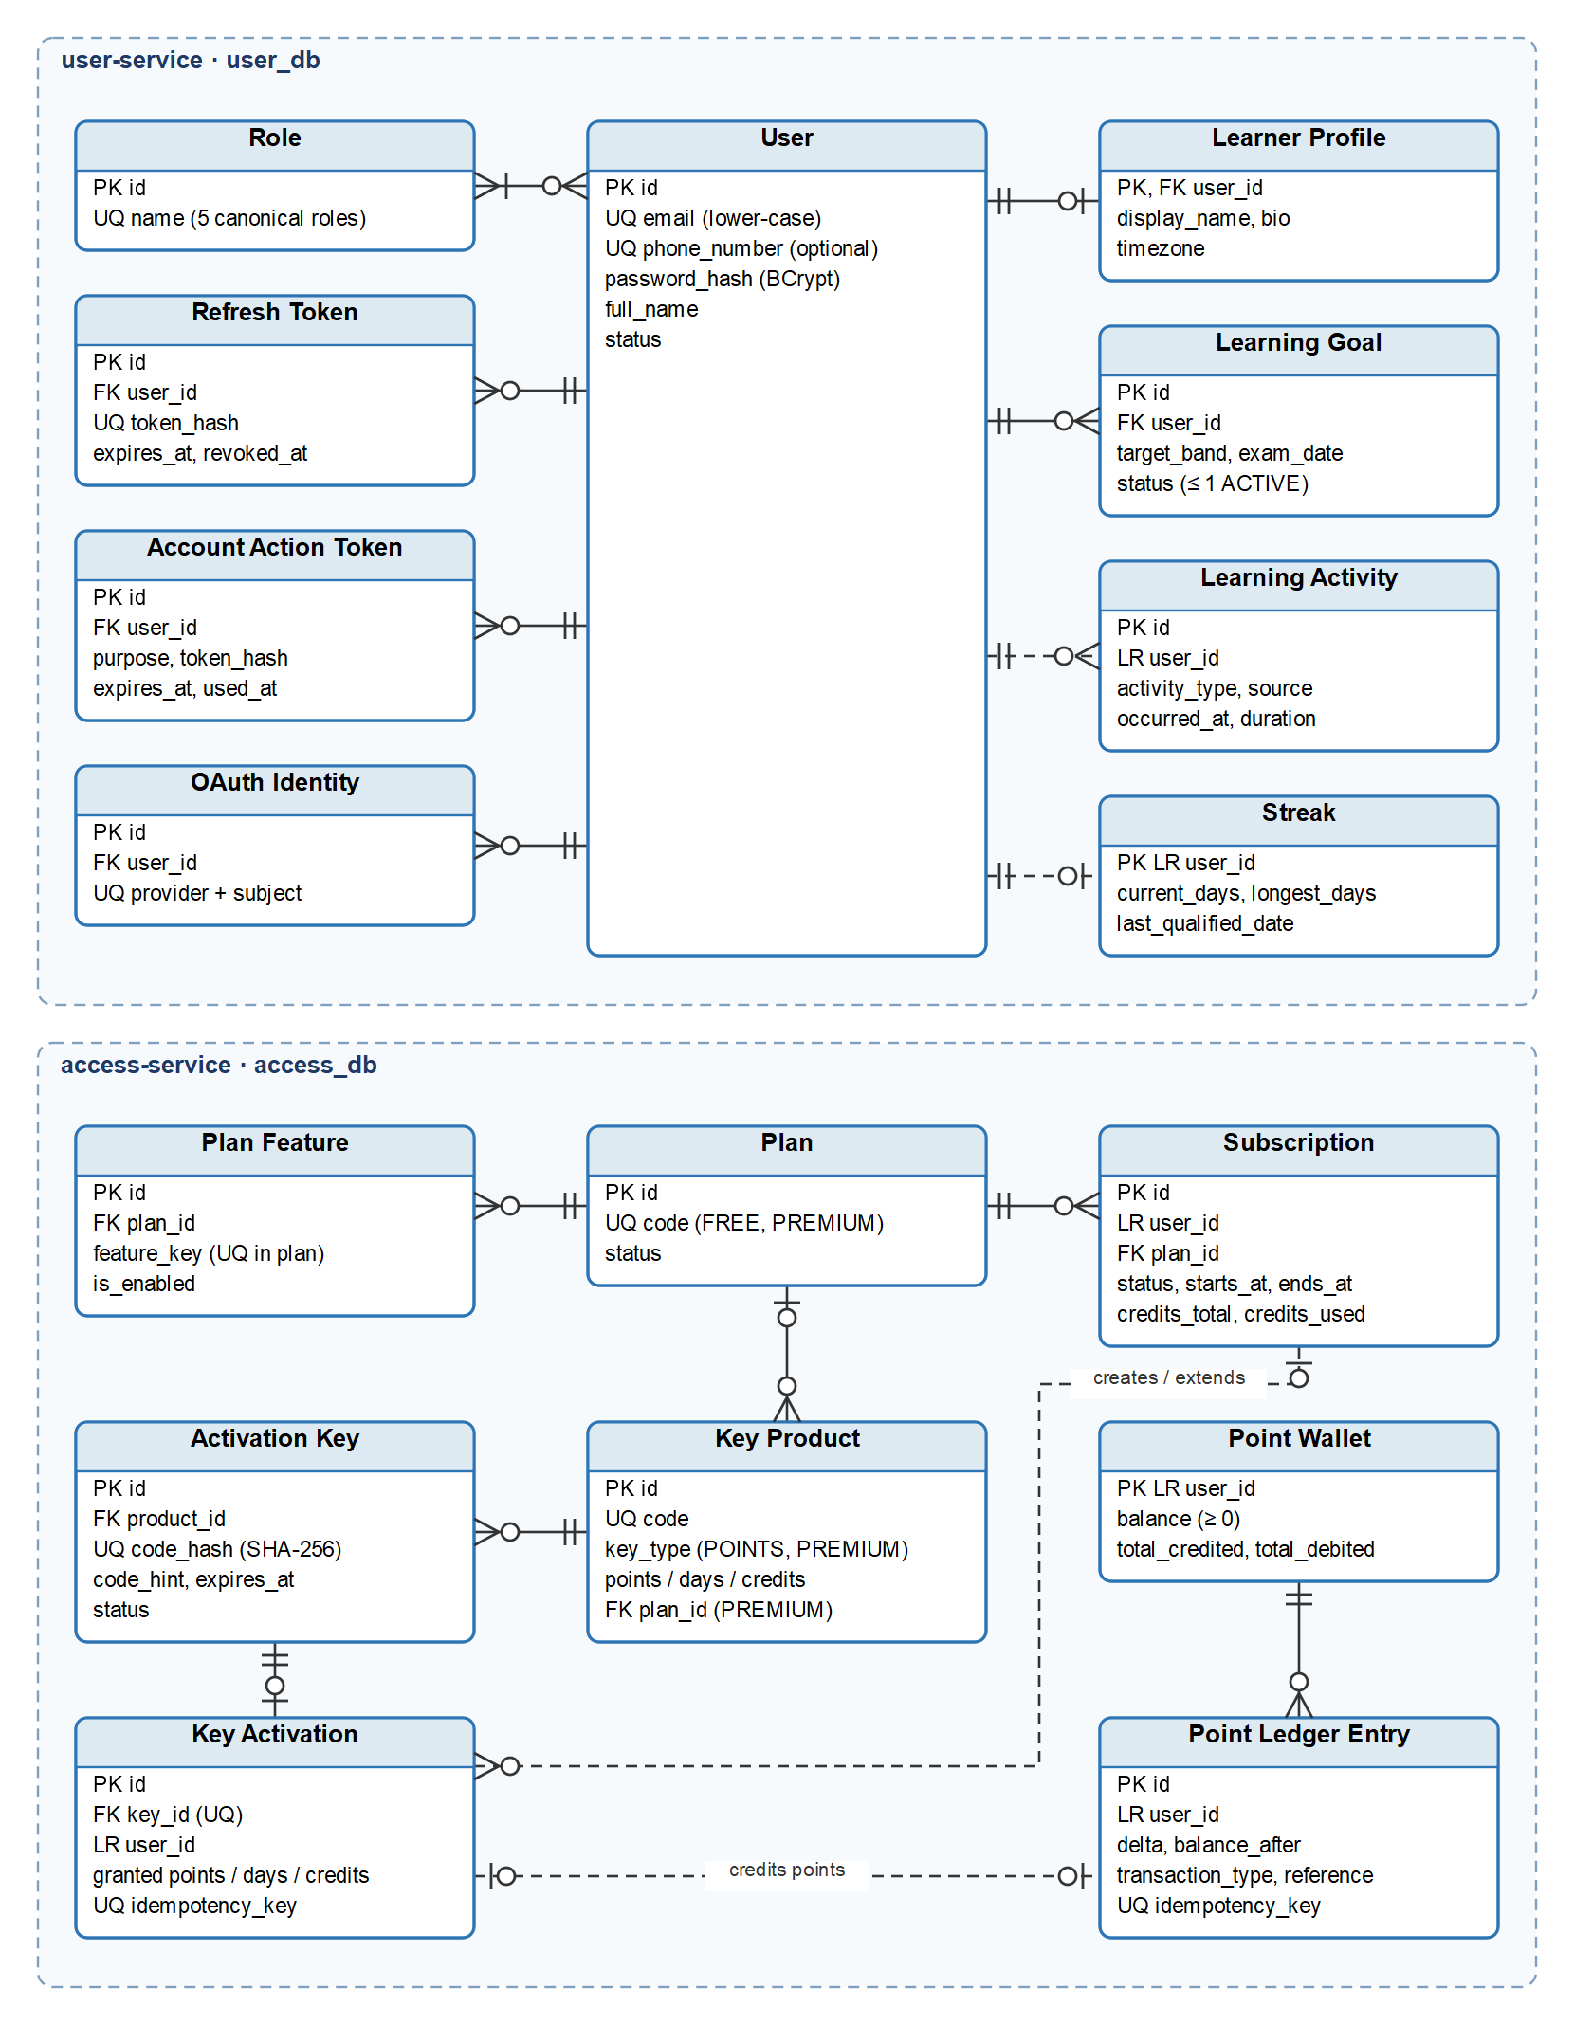
Figure 4.1a — Conceptual ERD (1/5): Identity and Access: user-service and access-service
Source: part4-diagrams/IELTSPath_ERD.drawio, page 1
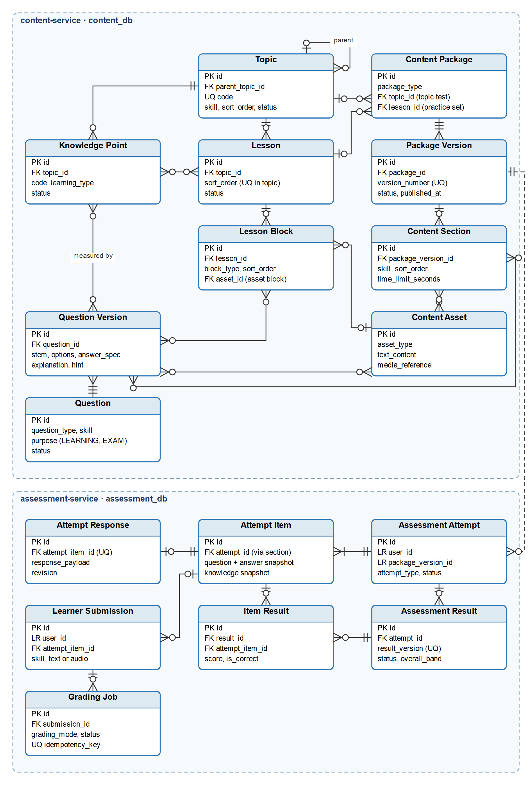
Figure 4.1b — Conceptual ERD (2/5): Content and Assessment: content-service and assessment-service
Source: part4-diagrams/IELTSPath_ERD.drawio, page 2
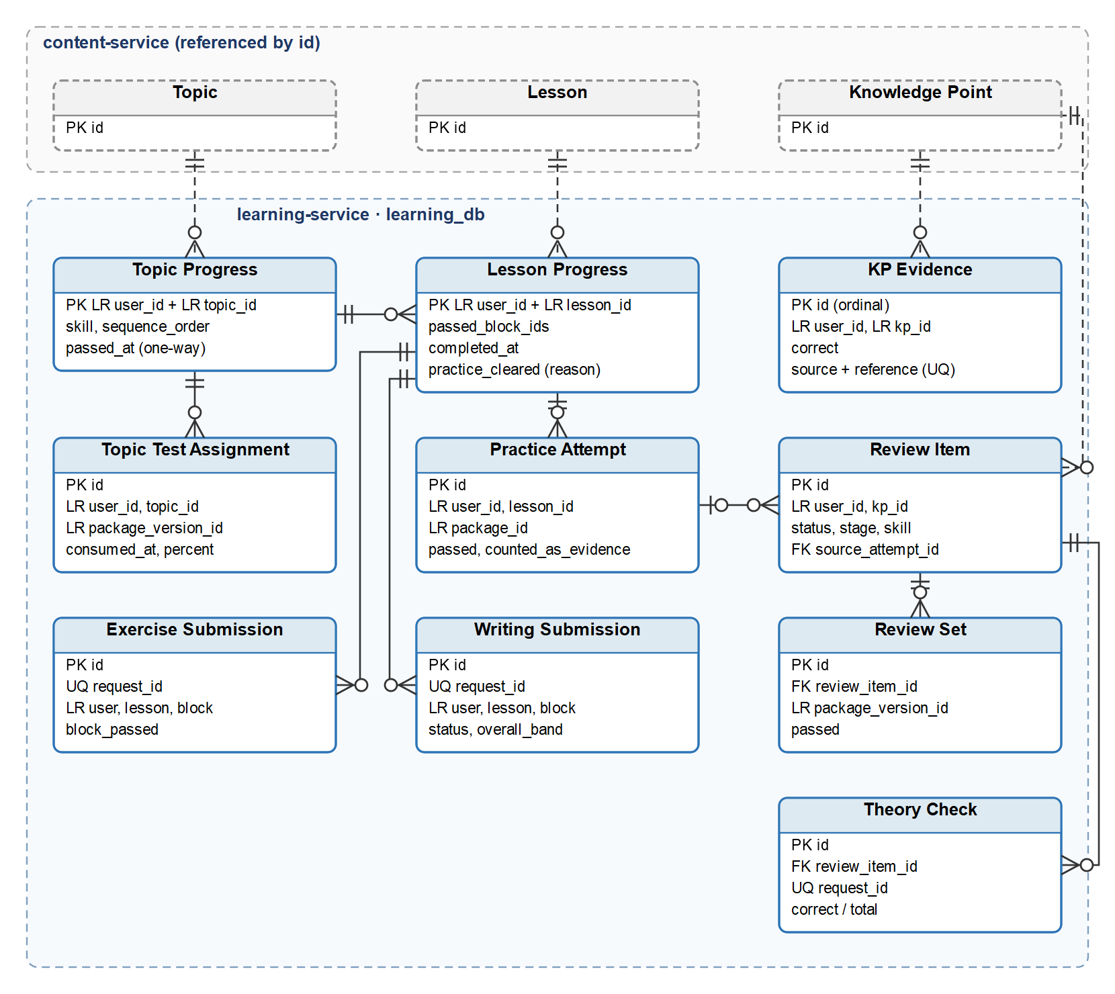
Figure 4.1c — Conceptual ERD (3/5): Learning progress and mastery: learning-service
Source: part4-diagrams/IELTSPath_ERD.drawio, page 3
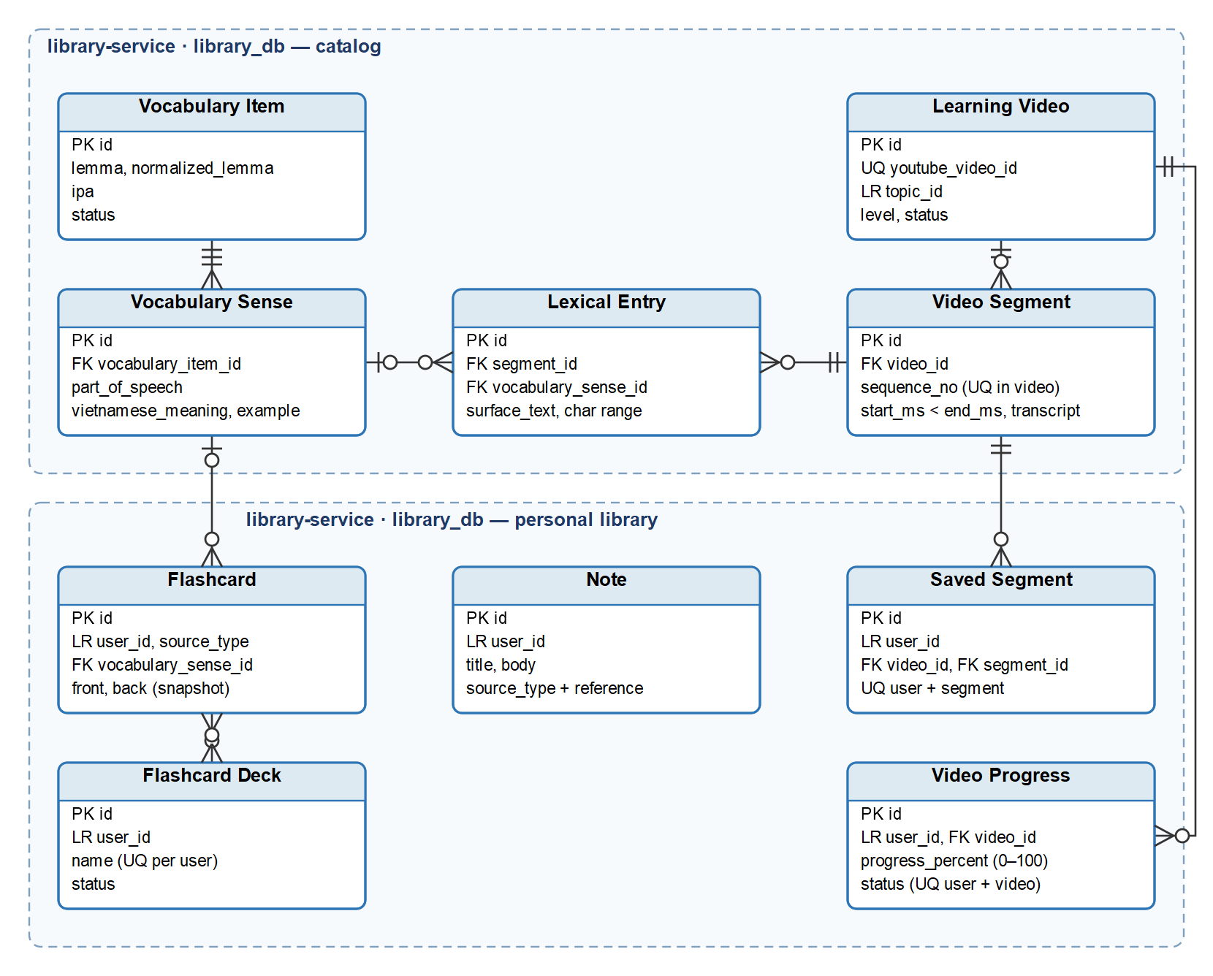
Figure 4.1d — Conceptual ERD (4/5): Library: vocabulary and video catalog, personal library
Source: part4-diagrams/IELTSPath_ERD.drawio, page 4
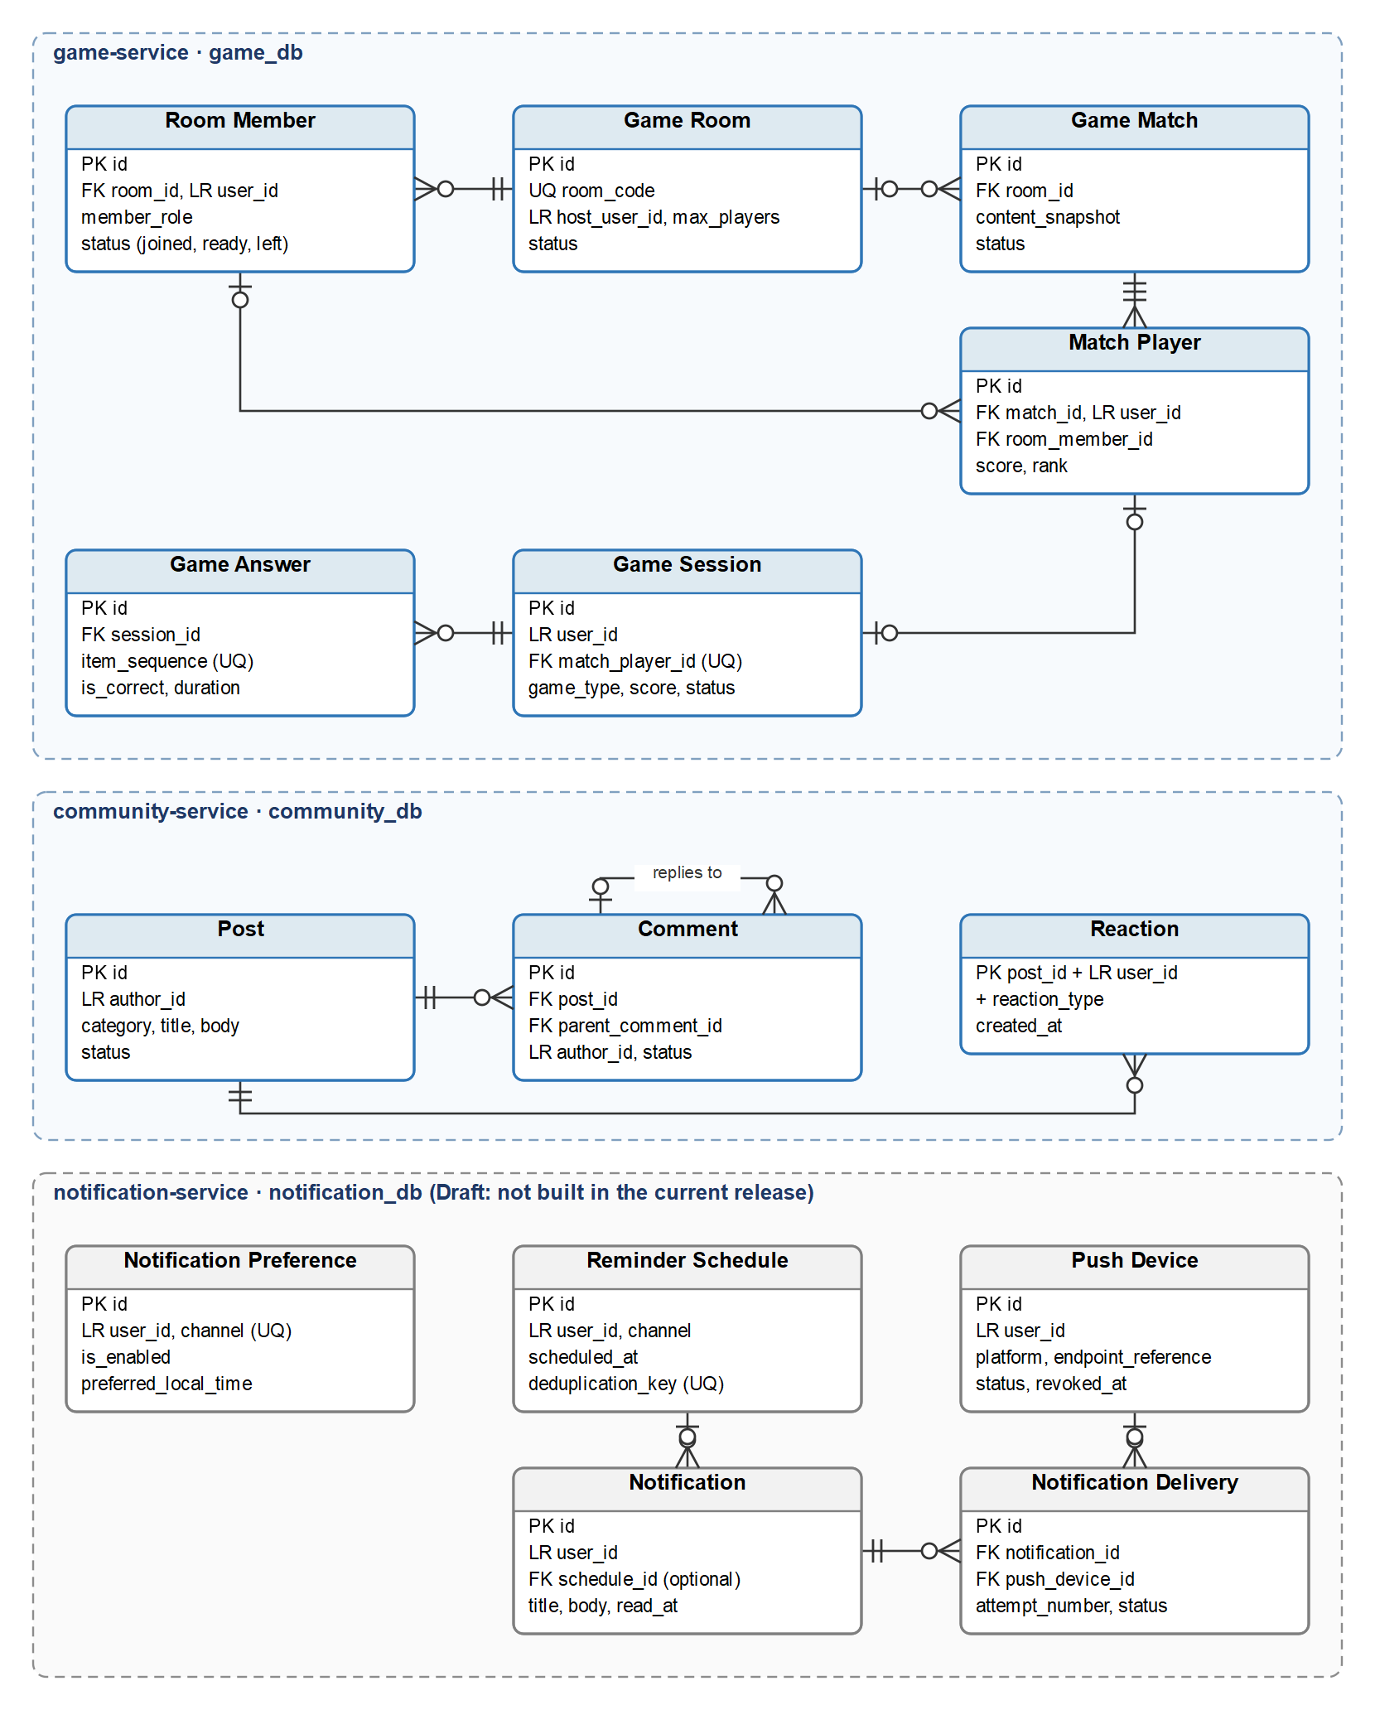
Figure 4.1e — Conceptual ERD (5/5): Game, Community and Notification
Source: part4-diagrams/IELTSPath_ERD.drawio, page 5

Table 4.1 — Core entities by data owner
Entity | Purpose (one sentence) | Key Relationships | Full Attributes
Identity and profile — user-service (user_db), Figure 4.1a
User | An account that signs in, owns learner data or performs staff work. | User >--< Role; User --< Refresh Token, Account Action Token, OAuth Identity, Learning Goal | RTW Sheet 5
Role | One of the five canonical roles that control access. | Role >--< User | RTW Sheet 5
Refresh Token | A hashed, single-use token that keeps one sign-in session alive. | User --< Refresh Token | RTW Sheet 5
Account Action Token | A hashed, single-use token for a sensitive action such as a password reset. | User --< Account Action Token | RTW Sheet 5
OAuth Identity | A link between a user and an external identity provider account. | User --< OAuth Identity (UQ provider + subject) | RTW Sheet 5
Learner Profile | A learner's display name, biography and time zone. | User -- Learner Profile | RTW Sheet 5
Learning Goal | A learner's target band, exam date and daily study time, with at most one ACTIVE goal. | User --< Learning Goal | RTW Sheet 5
Learning Activity | A record of one study activity used for activity history and the streak. | User --< Learning Activity (LR) | RTW Sheet 5
Streak | A learner's current and longest run of qualified study days. | User -- Streak (LR) | RTW Sheet 5
Plans, keys and points — access-service (access_db), Figure 4.1a
Plan | An access level, FREE or PREMIUM. | Plan --< Plan Feature; Plan --< Subscription; Plan --< Key Product | RTW Sheet 5
Plan Feature | A feature key that a plan enables, such as PREMIUM_CONTENT. | Plan --< Plan Feature | RTW Sheet 5
Subscription | A learner's Premium access for a period, with examiner grading credits. | Plan --< Subscription; User --< Subscription (LR); Key Activation --< Subscription (LR) | RTW Sheet 5
Key Product | What a key grants: points, or Premium days with grading credits. | Plan --< Key Product; Key Product --< Activation Key | RTW Sheet 5
Activation Key | One issued key, stored only as a hash and a hint, redeemable once. | Key Product --< Activation Key; Activation Key -- Key Activation | RTW Sheet 5
Key Activation | The record of a key redemption with a snapshot of what it granted. | Activation Key -- Key Activation; User --< Key Activation (LR) | RTW Sheet 5
Point Wallet | A learner's current point balance, never below 0. | User -- Point Wallet (LR); Point Wallet --< Point Ledger Entry | RTW Sheet 5
Point Ledger Entry | One append-only change of a point balance with its reason and idempotency key. | Point Wallet --< Point Ledger Entry; Key Activation -- Point Ledger Entry (LR) | RTW Sheet 5
Curriculum and question bank — content-service (content_db), Figure 4.1b
Topic | A curriculum unit of one skill, ordered in the learning path. | Topic --< Topic (parent); Topic --< Knowledge Point, Lesson; Topic --< Content Package (topic test) | RTW Sheet 5
Knowledge Point | A unit of knowledge or skill that mastery is measured on. | Topic --< Knowledge Point; Knowledge Point >--< Lesson; Knowledge Point >--< Question Version | RTW Sheet 5
Lesson | An ordered learning unit of a topic. | Topic --< Lesson; Lesson --< Lesson Block; Lesson --< Content Package (practice set) | RTW Sheet 5
Lesson Block | One ordered part of a lesson: text, asset, vocabulary or exercise. | Lesson --< Lesson Block; Lesson Block >--< Question Version; Content Asset --< Lesson Block | RTW Sheet 5
Question | The stable identity of a question, with its purpose LEARNING or EXAM. | Question --< Question Version | RTW Sheet 5
Question Version | The content of one question version: stem, options, answer specification, explanation and hint. | Question --< Question Version; Question Version >--< Content Section, Knowledge Point | RTW Sheet 5
Content Package | A practice set, topic test, mock test, placement test or quiz. | Content Package --< Package Version | RTW Sheet 5
Package Version | One numbered version of a package; a published version is not edited. | Package Version --< Content Section; Package Version --< Assessment Attempt (LR) | RTW Sheet 5
Content Section | An ordered section of a package version that holds its questions. | Content Section >--< Question Version; Content Section >--< Content Asset | RTW Sheet 5
Content Asset | A passage, image or audio file used by lessons, sections or questions. | Content Asset >--< Content Section, Question Version; Content Asset --< Lesson Block | RTW Sheet 5
Attempts and grading — assessment-service (assessment_db), Figure 4.1b
Assessment Attempt | One learner's sitting of a published package version. | Package Version --< Assessment Attempt (LR); Assessment Attempt --< Attempt Item, Assessment Result | RTW Sheet 5
Attempt Item | A question snapshot in an attempt, with its answer specification kept on the server. | Attempt Item -- Attempt Response; Attempt Item --< Item Result, Learner Submission | RTW Sheet 5
Attempt Response | The learner's latest saved answer to an attempt item, with a revision number. | Attempt Item -- Attempt Response | RTW Sheet 5
Assessment Result | One numbered result version of an attempt. | Assessment Attempt --< Assessment Result; Assessment Result --< Item Result | RTW Sheet 5
Item Result | The score and correctness of one item in a result version. | Assessment Result --< Item Result; Attempt Item --< Item Result | RTW Sheet 5
Learner Submission | A Writing text or Speaking audio sent for grading. | Attempt Item --< Learner Submission; Learner Submission --< Grading Job | RTW Sheet 5
Grading Job | A request to grade a submission by AI or by an examiner. | Learner Submission --< Grading Job | RTW Sheet 5
Learning progress and mastery — learning-service (learning_db), Figure 4.1c
Topic Progress | A learner's position in a topic and the time it was passed. | Topic --< Topic Progress (LR); Topic Progress --< Lesson Progress, Topic Test Assignment | RTW Sheet 5
Lesson Progress | A learner's passed blocks, lesson completion and practice clearance. | Lesson --< Lesson Progress (LR); Lesson Progress --< Exercise Submission, Writing Submission, Practice Attempt | RTW Sheet 5
Exercise Submission | One graded submission of a lesson exercise block, replayable by its request id. | Lesson Progress --< Exercise Submission | RTW Sheet 5
Writing Submission | One essay graded by the LLM, with its band, feedback and point charge. | Lesson Progress --< Writing Submission | RTW Sheet 5
Practice Attempt | One attempt at a lesson's practice set. | Lesson Progress --< Practice Attempt; Practice Attempt --< Review Item | RTW Sheet 5
Review Item | A pending or closed review of one weak knowledge point. | Knowledge Point --< Review Item (LR); Review Item --< Review Set, Theory Check | RTW Sheet 5
Review Set | A practice package version given to the learner inside a review. | Review Item --< Review Set | RTW Sheet 5
Theory Check | A quick-check submission at the theory stage of a review; it records no evidence. | Review Item --< Theory Check | RTW Sheet 5
Topic Test Assignment | A single-use topic final test code given to a learner. | Topic Progress --< Topic Test Assignment; consumed by one Assessment Attempt (LR) | RTW Sheet 5
KP Evidence | One correct or wrong outcome of a learner on a knowledge point, used to compute mastery. | Knowledge Point --< KP Evidence (LR); sources: exercise, practice, review set, essay, assessment result | RTW Sheet 5
Vocabulary, video and personal library — library-service (library_db), Figure 4.1d
Vocabulary Item | A word or phrase of the vocabulary catalog. | Vocabulary Item --< Vocabulary Sense | RTW Sheet 5
Vocabulary Sense | One meaning of a vocabulary item with its Vietnamese meaning and example. | Vocabulary Sense --< Lexical Entry, Flashcard | RTW Sheet 5
Learning Video | A YouTube video selected for learning; the video file is not stored. | Learning Video --< Video Segment, Video Progress; Topic --< Learning Video (LR) | RTW Sheet 5
Video Segment | A timed transcript segment of a learning video. | Learning Video --< Video Segment; Video Segment --< Lexical Entry, Saved Segment | RTW Sheet 5
Lexical Entry | A word or phrase marked in a segment transcript, optionally linked to a sense. | Video Segment --< Lexical Entry; Vocabulary Sense --< Lexical Entry | RTW Sheet 5
Video Progress | A learner's playback position and progress on one video. | Learning Video --< Video Progress | RTW Sheet 5
Saved Segment | A video segment a learner saved, with a transcript snapshot. | Video Segment --< Saved Segment | RTW Sheet 5
Note | A learner's personal note, optionally linked to a knowledge point or reading section. | User --< Note (LR) | RTW Sheet 5
Flashcard | A learner's study card with front and back stored as a snapshot. | Flashcard >--< Flashcard Deck; Vocabulary Sense --< Flashcard | RTW Sheet 5
Flashcard Deck | A learner's named group of flashcards. | Flashcard Deck >--< Flashcard | RTW Sheet 5
Games — game-service (game_db), Figure 4.1e
Game Room | A multiplayer lobby that players join by code before a match. | Game Room --< Room Member, Game Match | RTW Sheet 5
Room Member | A user's membership and readiness in a room. | Game Room --< Room Member; Room Member --< Match Player | RTW Sheet 5
Game Match | One multiplayer match played from a frozen content snapshot. | Game Room --< Game Match; Game Match --< Match Player | RTW Sheet 5
Match Player | One user's participation, score and rank in a match. | Game Match --< Match Player; Match Player -- Game Session | RTW Sheet 5
Game Session | One player's play of a game, single-player or in a match. | Game Session --< Game Answer | RTW Sheet 5
Game Answer | The answer to one item of a game session. | Game Session --< Game Answer | RTW Sheet 5
Community — community-service (community_db), Figure 4.1e
Post | A community post with a category and moderation status. | Post --< Comment, Reaction | RTW Sheet 5
Comment | A comment on a post, optionally a reply to another comment. | Post --< Comment; Comment --< Comment (reply) | RTW Sheet 5
Reaction | One user's LIKE or LOVE on a post. | Post --< Reaction (UQ post + user + type) | RTW Sheet 5
Notifications (Draft) — notification-service (notification_db), Figure 4.1e
Notification Preference | A learner's on/off choice and preferred time for one channel. | User --< Notification Preference (LR; UQ user + channel) | RTW Sheet 5
Push Device | A device that can receive push notifications. | Push Device --< Notification Delivery | RTW Sheet 5
Reminder Schedule | A planned study reminder, de-duplicated per learner. | Reminder Schedule --< Notification | RTW Sheet 5
Notification | The message a learner sees in the app, with its read time. | Notification --< Notification Delivery | RTW Sheet 5
Notification Delivery | One attempt to deliver a notification through an external channel. | Notification --< Notification Delivery; Push Device --< Notification Delivery | RTW Sheet 5

4.2 Data Constraints & Integrity Rules
Data constraints are integrity rules that IELTSPath enforces in the database or in the transaction that writes the data: uniqueness, valid ranges, immutability, atomic writes and references. They differ from the business rules in Part 5, which state policy; a constraint keeps the stored data consistent whatever the request. Each constraint names the features (FT-xx) or the state transition tables (Part 4.4) it supports, and its violation behaviour is the response returned through the API Gateway.
Where the current release does not yet enforce a constraint, the row says so after "Current release:".

ID | Constraint | Entities Affected | Violation Behaviour
DC-01 | A status changes only along the valid transitions of its entity's state transition table; a terminal state has no outgoing transition.  Supports: Part 4.4 | Learning Goal, Activation Key, Topic Progress, Review Item, Writing Submission, Assessment Attempt, Assessment Result | Rejected with the response listed in the entity's Invalid Transitions table in Part 4.4 (HTTP 400, 403 or 409); the stored status does not change.
DC-02 | An email belongs to at most one account: it is trimmed, stored in lower case and unique. A phone number, when given, is unique.  Supports: FT-01, FT-06 | User | HTTP 409; no account is created or changed.
DC-03 | Every user holds at least one role, each role is one of the five canonical roles, and a role appears at most once per user.  Supports: FT-07, FT-08 | User, Role | HTTP 400; the roles do not change.
DC-04 | Passwords, refresh tokens, account action tokens and activation keys are stored only as hashes (BCrypt for passwords, SHA-256 for keys). Token and key hashes are unique, and lookups are made by hash only.  Supports: FT-01 to FT-04, FT-11 | User, Refresh Token, Account Action Token, Activation Key | An unknown value is rejected (refresh HTTP 401, password reset HTTP 400, key activation HTTP 404); no raw value is stored, returned a second time or logged.
DC-05 | A refresh token or an account action token is consumed by one atomic conditional update that succeeds only while the token is unused and unexpired.  Supports: FT-03, FT-04 | Refresh Token, Account Action Token | Of two simultaneous uses exactly one succeeds; the other gets HTTP 401 (refresh) or HTTP 400 (reset).
DC-06 | A learner has at most one ACTIVE learning goal, enforced by a unique index on the learner's ACTIVE goal.  Supports: FT-09, Part 4.4 | Learning Goal | A simultaneous second activation gets HTTP 409; exactly one ACTIVE goal remains.
DC-07 | Learner Profile, Streak and Point Wallet have at most one record per user, keyed by the user id.  Supports: FT-06, FT-12, FT-45 | Learner Profile, Streak, Point Wallet | A second insert for the same user is refused by the database; the services update the existing record.
DC-08 | A point balance is a whole number never below 0. Every balance change is written in the same transaction as exactly one ledger entry whose balance after equals the new balance.  Supports: FT-12 | Point Wallet, Point Ledger Entry | A debit above the balance gets HTTP 402; the balance and the ledger do not change.
DC-09 | Idempotency keys are unique for key activations, point ledger entries and grading jobs.  Supports: FT-11, FT-12, FT-33 | Key Activation, Point Ledger Entry, Grading Job | A repeat with the same key returns the original record and grants or charges nothing again; reusing a key with a different user, amount or reference gets HTTP 409.
DC-10 | An activation key has at most one key activation. A redemption writes the key status, the key activation, the wallet and ledger change or the subscription change, and the outbox event in one transaction.  Supports: FT-11, Part 4.4 | Activation Key, Key Activation, Point Wallet, Point Ledger Entry, Subscription | A second redemption gets HTTP 400; if any step fails, nothing is granted.
DC-11 | A key activation keeps a snapshot of the points, Premium days and grading credits it granted; changing the key product later does not change past activations or subscriptions.  Supports: FT-10, FT-11 | Key Activation, Key Product | No API updates a key activation; past grants stay as recorded.
DC-12 | Subscription grading credits satisfy 0 ≤ used ≤ total, and consuming a credit is a versioned update of the subscription.  Supports: FT-14 | Subscription | With no credit left, HTTP 402 and nothing is consumed; a simultaneous stale update is rejected and consumes nothing.
DC-13 | Key product values match the key type: POINTS has more than 0 points; PREMIUM has more than 0 Premium days, a plan and at least 1 grading credit.  Supports: FT-10 | Key Product | HTTP 400; nothing is stored.
DC-14 | A published package version or question version is not edited: a change creates a new version with the next version number, unique per package or question, and an attempt keeps the snapshot taken when it started. Current release: sections can still be added to a published package version; attempts already started are not affected.  Supports: FT-16, FT-17, FT-30 | Package Version, Question Version, Assessment Attempt | The change is rejected and the published version stays as it is.
DC-15 | Publishing a package locks the questions involved in id order and checks one owner per question, the question purpose and the lesson skill; publishing is all or nothing.  Supports: FT-17 | Content Package, Package Version, Question | HTTP 422 QUESTION_ALREADY_USED, QUESTION_PURPOSE_MISMATCH or INVALID_PACKAGE_LESSON; nothing is saved or published.
DC-16 | Positions are unique within their parent: a lesson in its topic, a block in its lesson, a section in its package version, a question in its section and a segment in its video.  Supports: FT-17, FT-19, FT-37 | Lesson, Lesson Block, Content Section, Video Segment | A duplicate position is rejected and the existing order does not change.
DC-17 | A lesson block holds exactly the content of its type: TEXT has text only, ASSET has one asset only, VOCABULARY and EXERCISE have neither. An essay block holds exactly one essay question; a Task 1 essay also needs chart facts and an image.  Supports: FT-19, FT-25 | Lesson Block | The block is not stored, or INVALID_LESSON_BLOCK is returned and the lesson is not served.
DC-18 | A topic has one skill, LISTENING, READING, WRITING or SPEAKING, which cannot change once the topic has published lessons. Band limits lie between 0.0 and 9.0 in steps of 0.5, with the lower limit not above the upper one.  Supports: FT-15 | Topic | HTTP 409 TOPIC_SKILL_LOCKED or HTTP 400; the topic does not change.
DC-19 | A media reference is an https URL or, for audio, an ASCII key without a scheme, a leading "/" or ".."; an image may also be a PNG, JPEG or SVG data URI.  Supports: FT-18, FT-24 | Content Asset | INVALID_MEDIA_REFERENCE; the content is not served.
DC-20 | A vocabulary sense, video or segment that a learner's flashcard, progress or saved segment refers to cannot be deleted.  Supports: FT-36, FT-37, FT-38, FT-43 | Vocabulary Sense, Learning Video, Video Segment, Flashcard, Video Progress, Saved Segment | HTTP 400; the catalog record is kept.
DC-21 | Video data stays in range: a segment sequence of at least 1, a start of at least 0 and an end after the start; a lexical entry ends after it starts; progress lies between 0 and 100 and a position is not negative.  Supports: FT-37, FT-38 | Video Segment, Lexical Entry, Video Progress | HTTP 400; nothing is stored.
DC-22 | Personal library records are unique per learner: one progress per video, one saved segment per segment, one deck per name and one non-deleted flashcard per practice question.  Supports: FT-38, FT-43 | Video Progress, Saved Segment, Flashcard Deck, Flashcard | No duplicate is created: progress is updated in place and a repeated practice-question card returns the existing card; a duplicate saved segment or deck name gets HTTP 409.
DC-23 | A note's source type and source id are both given or both empty, and the source cannot change after the note is created.  Supports: FT-42 | Note | HTTP 400; nothing is stored.
DC-24 | An attempt stores snapshots of its sections, questions, answer specifications and knowledge points once, in the transaction that starts it. Grading uses only these snapshots, and answer snapshots are never returned to the learner.  Supports: FT-30, FT-31 | Assessment Attempt, Attempt Item | If the content module is unavailable at the start, HTTP 503 and no attempt is created.
DC-25 | An attempt item has at most one response, which is saved with the expected revision.  Supports: FT-30 | Attempt Response | A stale revision gets HTTP 409; the newer response is kept.
DC-26 | Result version numbers are unique and increasing per attempt, at most one version is DRAFT or PROCESSING at a time, and finalizing writes the result and its AssessmentCompleted.v2 outbox event in one transaction.  Supports: FT-31, FT-32, Part 4.4 | Assessment Result | Opening another version while one is being graded gets HTTP 400; finalizing again returns the version without a second event.
DC-27 | Item scores lie between 0 and the item's maximum, overall bands between 0.0 and 9.0, and knowledge-point judgments name only the knowledge points snapshotted on the item.  Supports: FT-32 | Item Result, Assessment Result | HTTP 400; no grading detail is saved.
DC-28 | Every learning-service write for a learner runs in one transaction that first locks that learner; progress, evidence and the stored response commit together or not at all.  Supports: FT-21, FT-22, FT-27, FT-28, FT-29 | Topic Progress, Lesson Progress, KP Evidence, Review Item, Practice Attempt, Topic Test Assignment | Simultaneous requests of the same learner are processed one at a time; a failure leaves no partial write.
DC-29 | Each learner submission carries a unique request id, and repeating it returns the stored response.  Supports: FT-22, FT-25, FT-27, FT-28 | Exercise Submission, Practice Attempt, Review Set, Theory Check, Writing Submission | The stored response is returned without grading or charging again; a request id already used for another lesson or block gets HTTP 409 REQUEST_CONFLICT.
DC-30 | Evidence is unique per learner, source and source reference, and each assessment result version is applied once per learner and attempt; a newer version replaces the evidence of the older one.  Supports: FT-26, FT-29 | KP Evidence | Duplicates and equal or older versions are ignored; evidence and mastery do not change.
DC-31 | At most one open record exists at a time: one PENDING review per learner and knowledge point, one unsubmitted set per review, one unused final test assignment per learner and topic, one unsubmitted practice attempt per learner and package, and one GRADING essay per learner and block.  Supports: FT-25, FT-27, FT-28, FT-29 | Review Item, Review Set, Topic Test Assignment, Practice Attempt, Writing Submission | The open record is returned instead of a new one; a second essay while one is grading gets HTTP 409 GRADING_IN_PROGRESS.
DC-32 | One-way markers are never cleared: a topic's passed time, a lesson's completion time and a lesson's practice clearance.  Supports: FT-20, FT-27, FT-29, Part 4.4 | Topic Progress, Lesson Progress | Later failures or new lessons leave the marker in place; a passed topic stays PASSED.
DC-33 | A learner's AI Writing grading count for a day (Vietnam time) never exceeds the daily limit of 10 and is increased atomically before the LLM is called.  Supports: FT-25 | Writing Submission (daily usage counter) | HTTP 429 DAILY_LIMIT_REACHED; no LLM call and no charge.
DC-34 | A Writing submission has 50 to 1,000 words and at most 10,000 characters. A GRADED submission always has a grade and a debit reference, and a PAYMENT_PENDING submission always has a grade.  Supports: FT-25, Part 4.4 | Writing Submission | HTTP 422 ESSAY_TOO_SHORT, ESSAY_TOO_LONG or ESSAY_EMPTY; a submission without a debit reference is never shown as graded.
DC-35 | No foreign key crosses two databases: a reference to another service's data is checked through that service's API when it is written.  Supports: FT-30, FT-37 | All LR references, for example Learning Video to Topic and Assessment Attempt to Package Version | An unknown id gets HTTP 404, or HTTP 422 for a package that cannot be attempted; an unreachable owner gets HTTP 503 and nothing is stored.
DC-36 | An integration event is stored in the outbox in the same transaction as the change that raises it; the consumer applies each event once and acknowledges it only after its own transaction commits. Current release: the access, content and game services write outbox events but do not relay them yet.  Supports: FT-29, FT-31 | Assessment Result, KP Evidence, Topic Test Assignment, Topic Progress | A failed message is retried every 30 seconds up to 5 deliveries and then moved to the dead-letter queue; a message that breaks the contract goes there at once.
DC-37 | A comment belongs to a visible post and may reply only to an ACTIVE comment of the same post; a reaction is unique per post, user and type; a post edit is a versioned update.  Supports: FT-49 | Post, Comment, Reaction | An invalid parent gets HTTP 400; a repeated reaction changes nothing; a simultaneous stale edit gets HTTP 409.
DC-38 | Posts, comments, notes, flashcards and decks are deleted softly: the record is marked DELETED and kept, and DELETED content is never returned.  Supports: FT-42, FT-43, FT-49 | Post, Comment, Note, Flashcard, Flashcard Deck | No API removes these records; deleted content leaves every list and read.
DC-39 | A room code is unique; a user has one membership per room and one player record per match; a match player has at most one game session; active members never exceed the room maximum of 2 to 32.  Supports: FT-47 | Game Room, Room Member, Match Player, Game Session | HTTP 400; the room does not change.
DC-40 | A reminder is scheduled once per learner and deduplication key, a learner has one preference per channel, and each delivery attempt has a unique idempotency key. Current release: not built.  Supports: FT-51, FT-53, FT-54 | Reminder Schedule, Notification Preference, Notification Delivery | No second reminder, preference or delivery is created; a repeated preference updates the existing one.

4.3 Data Retention & Ownership Policy
Each service owns and stores its own data (Part 4.1); a learner owns the personal data that describes them or that they create. Personal data is kept only while it serves the learner's account, in line with the Law on Personal Data Protection No. 91/2025/QH15 (PDP Law), which took effect on 1 January 2026 and gives a data subject the right to request deletion. Records needed to audit key sales and point balances are kept for a fixed period instead. Periods marked Team policy were set by the team on 05/10/2026; anonymised data is no longer personal data under the PDP Law.
Account closure: a learner asks support to close the account; the learner cannot close it in the app. An Administrator sets the account to INACTIVE, which stops sign-in and session refresh at once (FT-08). Thirty days after closure, every service deletes the learner's personal data and anonymises the learning records it keeps for statistics, so that no record leads back to the person; the exceptions are the sales and point records below.
Current release: an Administrator can only set an account to INACTIVE; no deletion, anonymisation or clean-up job exists yet, so expired tokens and DELETED content stay stored. These jobs are required behaviour (Draft).

Data Type | Retention Period | Owner | Deletion Authority | Basis
Account and sign-in data: email, full name, phone number, password hash, roles, OAuth links | While the account exists; deleted 30 days after the account is closed. | Learner (user-service stores it) | Administrator, on the learner's request through support; then the closure job. | PDP Law
Sessions and one-time tokens: refresh tokens, password reset tokens | Until used, revoked or expired; deleted 30 days after that. | User (user-service) | Clean-up job; the user signs out, an Administrator revokes action tokens. | Security policy
Learner profile and learning goals | While the account exists; deleted 30 days after closure. | Learner | Learner (edits the profile, changes goal status); Administrator; the closure job. | PDP Law
Personal library and activity: notes, flashcards, decks, saved segments, video progress, learning activity, streak | While the account exists. Notes, flashcards and decks the learner deletes stay DELETED for 90 days and are then removed. Everything is deleted 30 days after closure. | Learner | Learner (own items); clean-up and closure jobs. | PDP Law
Learning progress and evidence: topic and lesson progress, exercise and practice submissions, reviews, final test assignments, knowledge-point evidence | While the account exists; anonymised 30 days after closure and kept for aggregate statistics. | Learner; IELTSPath once anonymised | Closure job only; single records are not deleted, so mastery and path status stay consistent (DC-30, DC-32). | PDP Law
Writing essays and AI feedback | While the account exists. 30 days after closure the essay text and feedback are deleted; the band and pass result are anonymised as above. | Learner | Closure job. | PDP Law
Test attempts and results: responses, Writing texts and Speaking audio references, results, examiner grading | While the account exists. 30 days after closure responses and audio references are deleted; scores and results are anonymised. | Learner; examiner grading notes belong to IELTSPath | Closure job. | PDP Law
Points and key redemptions: point wallet, point ledger entries, key activations | 5 years from the date each record is written; ledger entries and key activations are never edited. | IELTSPath (sales and point audit); the learner reads their own | Nobody before 5 years. Corrections are new ADMIN_ADJUSTMENT or AI_GRADING_REFUND entries; a job removes records older than 5 years. | Team policy
Activation keys and subscriptions: issued keys (hash and hint), subscriptions with their credits | Keys: 5 years after they are issued. Subscriptions: 5 years after they end. | IELTSPath (Sale and Administrator) | Administrator revokes keys; no deletion before 5 years. | Team policy
Community content: posts, comments, reactions | While visible. Content the author deletes stays DELETED for 90 days for moderation questions and is then removed. HIDDEN content stays until it is restored or deleted. The author's content is deleted 30 days after closure. | Author | Author (own content); Administrator hides and restores (FT-50); clean-up and closure jobs. | PDP Law; moderation
Game data: rooms, matches, players, sessions, answers | While the account exists; anonymised 30 days after closure. | Player | Closure job. | PDP Law
Curriculum and catalog: topics, knowledge points, lessons, questions, packages, assets, vocabulary, videos | For the life of the system. Published versions are kept while any attempt or record refers to them; content is archived, not deleted. | IELTSPath (Content Author) | Content Author or Administrator archives; published content is not hard-deleted (DC-14, DC-20). | Content audit
Notifications (Draft): preferences, devices, notifications, delivery records | Preferences and devices: while the account exists, deleted 30 days after closure. Notifications and delivery records: [TBC]. | Learner | Learner (preferences, devices); clean-up and closure jobs. | PDP Law
Integration events: outbox events and dead-letter messages | [TBC] after the event is published or the dead-letter message is resolved. | The service that wrote the event | Clean-up job; an operator resolves dead-letter messages. | [TBC]

4.4 State Transition Tables
Six entities have a lifecycle with several steps: Learning Goal, Activation Key, Topic Progress, Review Item, Writing Submission, and Assessment Attempt with its Result Version. For each one, the valid transitions give the trigger, the guard that must hold and what the system does; the invalid transitions list the changes that must be rejected (DC-01). Each valid row maps to one or two positive tests and each invalid row to one negative test.
In the state machine figures a black dot is the start, a rounded box is a state, a shaded box with a thick border is a terminal state (no outgoing transition), and a dashed grey box is a state of a Draft feature. Arrows are labelled event [guard]. The figure sources are the pages of part4-diagrams/IELTSPath_StateMachines.drawio.

4.4.1 Learning Goal
Applies to: FT-09; BR-05; DC-01, DC-06
Valid State Transitions:
From State | Trigger Event | Guard Condition | To State | System Action
— | Learner saves a goal | Target band 1.0–9.0, exam date in the future when given, at least 5 minutes per day; the learner has no ACTIVE goal (otherwise the next row applies) | ACTIVE | Stores the goal with its start time.
ACTIVE | Learner changes the target band, exam date or daily minutes | Values valid as above | ACTIVE | Updates the same goal; no second goal is created. Current release: creates a new ACTIVE goal and moves the previous one to PAUSED.
ACTIVE | Learner pauses the goal | — | PAUSED | Keeps the goal; the learner has no ACTIVE goal until one is resumed or saved.
PAUSED | Learner resumes the goal | — | ACTIVE | Moves the learner's other ACTIVE goal, if any, to PAUSED in the same transaction.
ACTIVE or PAUSED | Learner marks the goal achieved | — | ACHIEVED | Records the end time.
ACTIVE or PAUSED | Learner marks the goal abandoned | — | ABANDONED | Records the end time.

Invalid Transitions (must be rejected — DC-01):
From State | Attempted Transition | Why Invalid | System Response
PAUSED | Pause | Only an ACTIVE goal can be paused | HTTP 400; the status does not change.
ACTIVE | Resume | Only a PAUSED goal can be resumed | HTTP 400; the status does not change.
ACHIEVED or ABANDONED | Resume or pause | Terminal state | HTTP 400; the status does not change.
ACHIEVED or ABANDONED | Change to the other end state | Terminal state. Current release: accepted | HTTP 400; the status does not change.
Any | A status other than ACTIVE, PAUSED, ACHIEVED or ABANDONED | Unknown status | HTTP 400.
— | A second goal saved at the same moment | Would leave two ACTIVE goals (DC-06) | HTTP 409; exactly one ACTIVE goal remains.
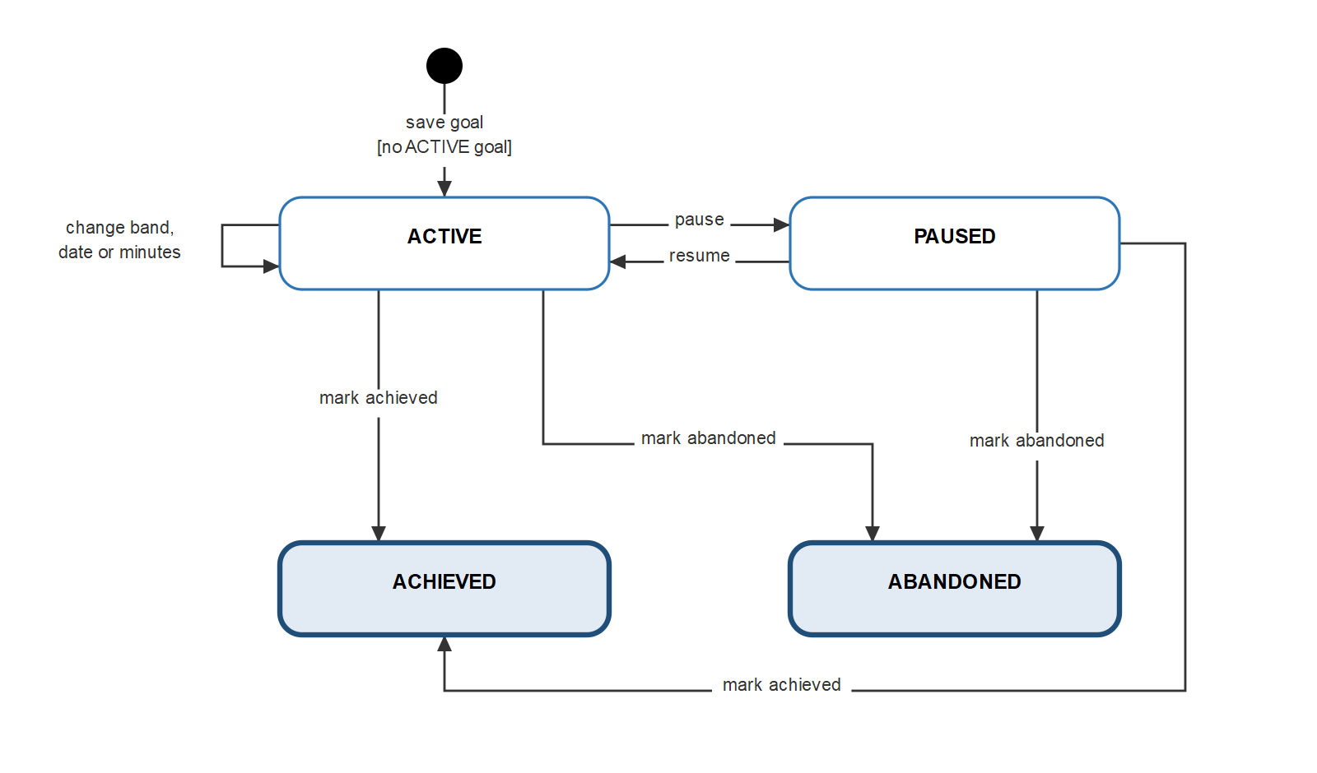
Figure 4.4.1 — State Machine: Learning Goal
Source: part4-diagrams/IELTSPath_StateMachines.drawio, page 1

4.4.2 Activation Key
Applies to: FT-10, FT-11, FT-12, FT-14; BR-07, BR-08; DC-04, DC-09, DC-10
Valid State Transitions:
From State | Trigger Event | Guard Condition | To State | System Action
— | Staff generate keys | Role ADMIN (SALES_STAFF: Draft); 1 to 1,000 keys for one key product | ACTIVE | Stores each key as a SHA-256 hash and a 4-character hint; returns every raw key once.
ACTIVE | Learner activates the key | The hash matches; the expiry time, if any, has not passed; the idempotency key is new | REDEEMED | In one transaction: records the key activation; a POINTS key credits the wallet with a ledger entry; a PREMIUM key creates or extends the subscription and adds its credits; writes the outbox event.
ACTIVE | Staff revoke the key | — | REVOKED | The key can no longer be activated.
ACTIVE | The expiry time passes | The key has an expiry time | EXPIRED | Activation is rejected. Current release: the stored status stays ACTIVE and expiry is checked from the expiry time at activation.
EXPIRED | Staff revoke the key | — | REVOKED | Makes the status explicit; nothing changes for learners.

Invalid Transitions (must be rejected — DC-01):
From State | Attempted Transition | Why Invalid | System Response
REDEEMED | Activate again with a new idempotency key | A key is redeemed once (BR-07) | HTTP 400; nothing is granted.
REDEEMED | Revoke | A redeemed key cannot be revoked | HTTP 400; the key stays REDEEMED.
REVOKED | Activate | Terminal state | HTTP 400; nothing is granted.
EXPIRED | Activate | The expiry time has passed | HTTP 400; nothing is granted.
— | Activate a key whose hash is unknown | No such key | HTTP 404.
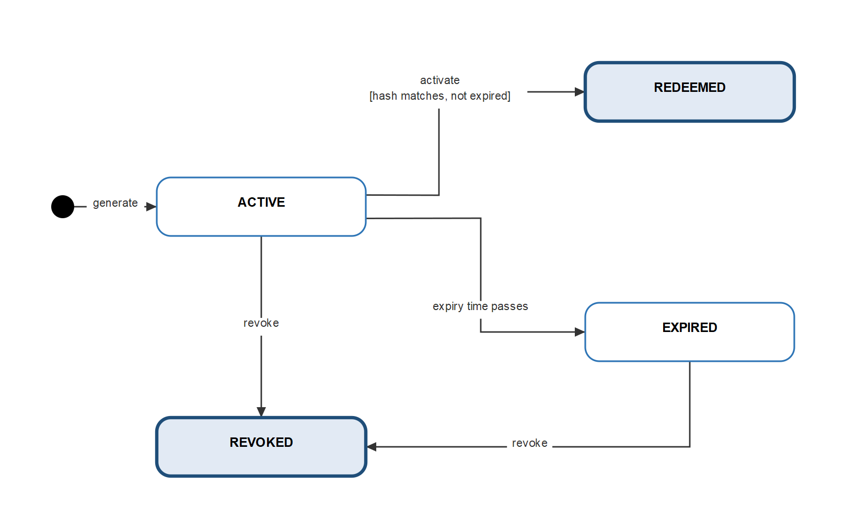
Figure 4.4.2 — State Machine: Activation Key
Source: part4-diagrams/IELTSPath_StateMachines.drawio, page 2

4.4.3 Topic Progress
Applies to: FT-20, FT-21, FT-29; BR-16, BR-22; DC-30, DC-32
Valid State Transitions:
From State | Trigger Event | Guard Condition | To State | System Action
— | The topic enters the learner's path | It is the first topic of its skill not yet passed (free topics before Premium topics, then curriculum order) | IN_PROGRESS | Creates the progress record; the lessons open in order.
— | The topic enters the learner's path | An earlier topic of the same skill is not passed | LOCKED | Lessons and the final test stay closed.
LOCKED | The previous unpassed topic of the skill is passed or leaves the curriculum | — | IN_PROGRESS | Derived when the path is next read.
IN_PROGRESS | The result of the learner's final test arrives | An unused assignment exists for the same package version, issued before the result; score at least 70% | PASSED | In one transaction: sets the passed time once, consumes the assignment, records evidence and opens reviews for knowledge points with mastery below 0.6; the next topic of the skill becomes IN_PROGRESS.
IN_PROGRESS | The result of the learner's final test arrives | As above, score below 70% | IN_PROGRESS | Consumes the assignment, records evidence and opens reviews; the learner can request another test code.
IN_PROGRESS | The last lesson of the topic is completed | The topic has no final test | PASSED | Sets the passed time.

Invalid Transitions (must be rejected — DC-01):
From State | Attempted Transition | Why Invalid | System Response
PASSED | Back to IN_PROGRESS or LOCKED after a failed result, a new lesson or a new order | Passing is permanent (DC-32) | No change; a new lesson is shown as available, not required.
LOCKED | Open a lesson | The topic is locked | HTTP 403 TOPIC_LOCKED.
LOCKED or IN_PROGRESS | Request the final test while a lesson is not completed | The gate is not met | HTTP 403 TEST_LOCKED; no code is issued.
IN_PROGRESS | Request the final test while a lesson has not cleared practice, or a review of the skill is pending | The gate is not met | HTTP 409 PRACTICE_REQUIRED or HTTP 403 REVIEW_REQUIRED; no code is issued.
IN_PROGRESS | A result with no matching assignment, or an equal or older result version | Not the learner's assigned test, or already applied (DC-30) | The topic does not pass; a repeated version is ignored.
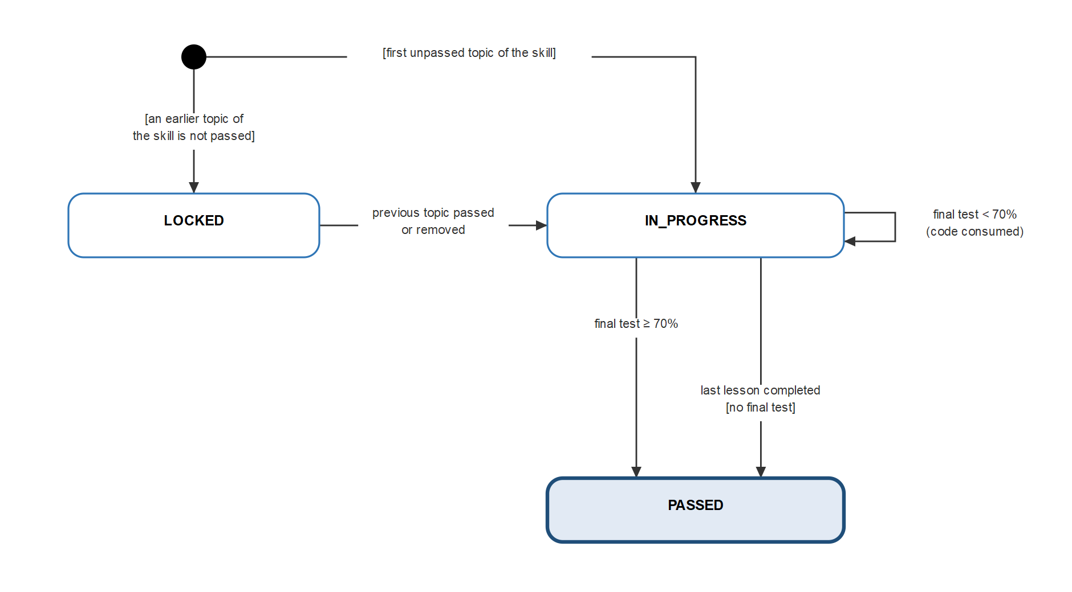
Figure 4.4.3 — State Machine: Topic Progress
Source: part4-diagrams/IELTSPath_StateMachines.drawio, page 3

4.4.4 Review Item
Applies to: FT-26, FT-27, FT-28; BR-20, BR-21; DC-30, DC-31
Valid State Transitions:
From State | Trigger Event | Guard Condition | To State | System Action
— | First practice submission below 70% for an unrevealed package, or an assessment result | The knowledge point scored at least 40% and was not wrong in the learner's first lesson submission; no PENDING review exists for it; an unseen set remains (practice) or mastery is below 0.6 (assessment) | PENDING · PRACTICE | Blocks the lessons, practice and final test of its skill.
— | As above | The knowledge point scored below 40% or was wrong in the first lesson submission | PENDING · THEORY | Same blocking; the theory of the knowledge point is shown first.
PENDING · PRACTICE | Learner opens the review | No open set | PENDING · PRACTICE | Gives one set from a package never given in a review and never revealed in practice, preferring the lesson's package.
PENDING · PRACTICE | Set submitted | Score at least 70% | DONE | Records evidence, returns solutions and transcripts; the skill is unblocked.
PENDING · PRACTICE | Set submitted | Score below 70%, first failed set | PENDING · THEORY | Records evidence and returns solutions.
PENDING · PRACTICE | Set submitted | Score below 70%, second failed set | SKIPPED | Records evidence; the skill is unblocked.
PENDING · PRACTICE | A set is needed | No unseen package remains | SKIPPED | The skill is unblocked.
PENDING · THEORY | Quick check submitted (up to 3 questions) | — | PENDING · PRACTICE | Returns the answers; records no evidence.

Invalid Transitions (must be rejected — DC-01):
From State | Attempted Transition | Why Invalid | System Response
PENDING · THEORY | Submit a set | The theory step comes first | HTTP 409 THEORY_REQUIRED.
PENDING · PRACTICE | Submit a quick check | Not at the theory step | HTTP 409 THEORY_NOT_REQUIRED.
PENDING | Submit a set that was already submitted | Each set is submitted once | HTTP 409 REVIEW_SET_CLOSED; the stored result is unchanged.
DONE or SKIPPED | Submit a set or a quick check | Terminal state | HTTP 409; the review does not change.
— | Open a second PENDING review for the same learner and knowledge point | One open review (DC-31) | No second review is created.
Any | Open or submit another learner's review | Not the owner | HTTP 404 NOT_FOUND.
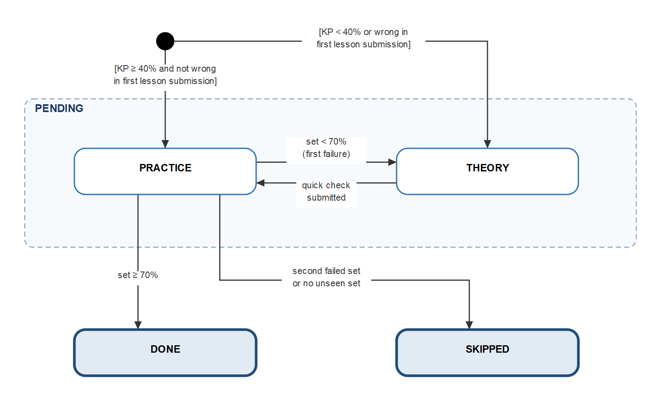
Figure 4.4.4 — State Machine: Review Item
Source: part4-diagrams/IELTSPath_StateMachines.drawio, page 4

4.4.5 Writing Submission
Applies to: FT-25; BR-10, BR-11, BR-30; DC-29, DC-31, DC-33, DC-34
Valid State Transitions:
From State | Trigger Event | Guard Condition | To State | System Action
— | Learner submits an essay with a request id | 50 to 1,000 words and at most 10,000 characters; balance at least 3 points; lesson gates met; fewer than 10 gradings today; no essay of the block GRADING for less than 120 s | GRADING | Stores the essay and the prompt snapshot, counts the daily usage and calls the LLM outside any database transaction (20 s limit, one retry for a malformed reply).
GRADING | The LLM returns a valid grade | Four criteria with bands 0–9 in steps of 0.5 | PAYMENT_PENDING | Stores the grade and computes the overall band; the grade is not shown yet.
GRADING | The LLM fails, times out or returns an invalid grade | — | FAILED | Stores the failure code; nothing is charged.
GRADING | A new essay for the block arrives | Grading started more than 120 s ago | FAILED | Stores GRADING_ABANDONED so the block can be graded again.
PAYMENT_PENDING | The debit succeeds | 3 points debited once, keyed by the submission | GRADED | In one transaction: stores the debit reference and records evidence; the grade, feedback and, when passed, the sample answer are shown.
PAYMENT_PENDING | The debit fails | — | PAYMENT_PENDING | Stores the reason and reports the failure; a resend retries only the debit, without a new LLM call.
FAILED | Learner resends the same request id | — | GRADING | Grades the essay first sent with that request id again.

Invalid Transitions (must be rejected — DC-01):
From State | Attempted Transition | Why Invalid | System Response
GRADED | Resend the same request id | Already graded | Returns the stored result; no LLM call and no charge.
GRADING | A second essay for the block within 120 s | One essay grading per block (DC-31) | HTTP 409 GRADING_IN_PROGRESS.
— | An essay with fewer than 50 or more than 1,000 words, or empty | Outside the limits (DC-34) | HTTP 422 ESSAY_TOO_SHORT, ESSAY_TOO_LONG or ESSAY_EMPTY; no LLM call.
— | The 11th grading of the day | Daily limit reached (DC-33) | HTTP 429 DAILY_LIMIT_REACHED; no LLM call and no charge.
PAYMENT_PENDING | Show the grade | Not paid yet | The grade is withheld until GRADED.
GRADED | Debit again | Charged once | No second debit.
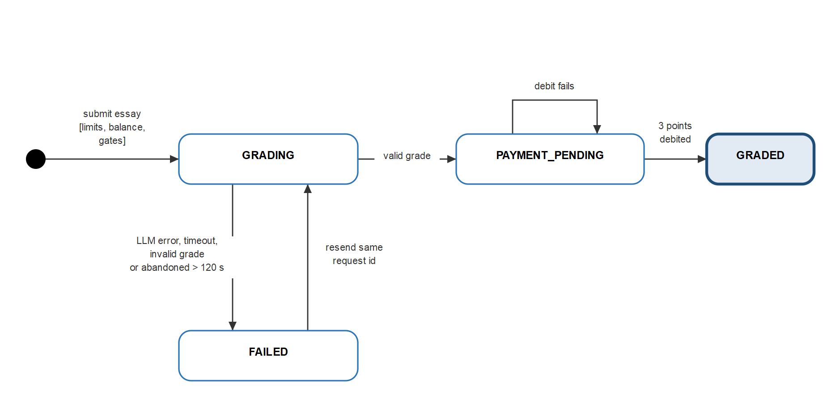
Figure 4.4.5 — State Machine: Writing Submission
Source: part4-diagrams/IELTSPath_StateMachines.drawio, page 5

4.4.6 Assessment Attempt and Result Version
Applies to: FT-30, FT-31, FT-32, FT-33; BR-24, BR-25, BR-26; DC-24 to DC-27
Valid State Transitions:
From State | Trigger Event | Guard Condition | To State | System Action
Attempt: — | Learner starts an attempt | A published TOPIC_TEST, MOCK_TEST, PLACEMENT_TEST or QUIZ version; the content module is reachable | IN_PROGRESS | Stores the snapshots in one transaction and derives the attempt type.
Attempt: IN_PROGRESS | Learner saves a response | The expected revision matches | IN_PROGRESS | Stores the response with the next revision.
Attempt: IN_PROGRESS | Learner submits | Before the expiry time, if any | SUBMITTED | When every item is auto-gradable, writes result version 1 as COMPLETED and the outbox event in the same transaction; otherwise the attempt waits for an examiner.
Attempt: IN_PROGRESS | Learner submits | At or after the expiry time | EXPIRED | Stores EXPIRED and returns HTTP 409 ATTEMPT_EXPIRED.
Result: — | Examiner opens a version | The attempt is SUBMITTED; the latest version is not DRAFT or PROCESSING | DRAFT | Creates the next version number.
Result: DRAFT | Examiner saves grading details | Scores within limits (DC-27) | DRAFT | The band saved last replaces the earlier one.
Result: DRAFT | Examiner finalizes | — | COMPLETED | Writes AssessmentCompleted.v2 to the outbox in the same transaction; the learning module applies it (Part 4.4.3).
Result: PROCESSING (Draft) | An AI grading job completes or fails | — | COMPLETED or FAILED | [TBC] with FT-33.

Invalid Transitions (must be rejected — DC-01):
From State | Attempted Transition | Why Invalid | System Response
Attempt: SUBMITTED | Submit again | Already submitted | No change; no second event.
Attempt: SUBMITTED or EXPIRED | Save a response | The attempt is closed | HTTP 400; nothing is saved.
Attempt: EXPIRED | Submit | The expiry time has passed | HTTP 409 ATTEMPT_EXPIRED.
Attempt: IN_PROGRESS | Examiner opens a result version | Not submitted yet | HTTP 400.
Result: DRAFT or PROCESSING | Open another version | One version graded at a time | HTTP 400.
Result: COMPLETED | Save grading details | A completed version is final | HTTP 400; nothing is saved.
Result: COMPLETED | Finalize again | Already final | Returns the version; no second event.
Any | A learner opens or changes a result version | Grading needs EXAMINER or ADMIN | HTTP 403.
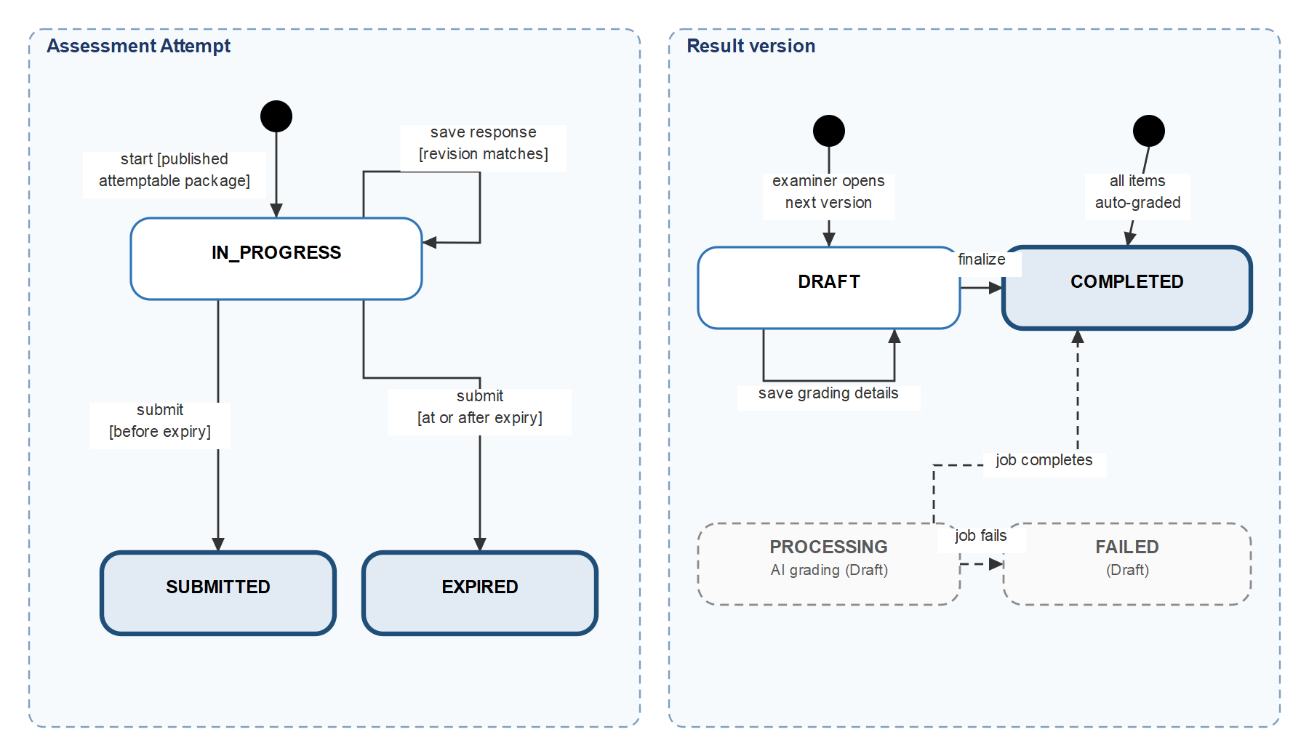
Figure 4.4.6 — State Machine: Assessment Attempt and Result Version
Source: part4-diagrams/IELTSPath_StateMachines.drawio, page 6

Part 5 — Business Rules
The table below lists every business rule of the current scope with the features that apply it. IELTSPath_RTW.xlsx Sheet 6 remains the master register and holds each rule's full text, trigger conditions, exceptions and source; Part 3 cites rules by ID only, so a rule is changed in one place.

ID | Business Rule | Applied in
BR-01 | Public registration creates an ACTIVE account with role CUSTOMER only; an email belongs to one account. | FT-01, FT-05
BR-02 | Passwords have 6 to 72 characters at registration (at least 6 at reset) and are stored only as BCrypt hashes. | FT-01, FT-04
BR-03 | A password reset token is single-use and expires 15 minutes after creation. | FT-04
BR-04 | Access tokens last 3,600 seconds; refresh tokens last 604,800 seconds and are consumed on each use. | FT-02, FT-03, FT-05
BR-05 | A learner has at most one ACTIVE learning goal; changing the goal updates the ACTIVE goal instead of adding a second one. | FT-09
BR-06 | Access is controlled by the five canonical roles; only ADMIN manages users and roles. | FT-02, FT-07, FT-08
BR-07 | An activation key is redeemed at most once; REDEEMED, REVOKED or expired keys are rejected; a redeemed key cannot be revoked. | FT-11
BR-08 | A Premium key extends the active subscription by the product's days, or starts a new subscription when none is active. | FT-10, FT-11
BR-09 | A point balance never goes below 0 and every change writes a ledger entry with an idempotency key. | FT-12, FT-33
BR-10 | AI grading of a Writing essay costs 3 points, debited once and only after a successful grade. | FT-12, FT-25
BR-11 | A learner can start at most 10 AI Writing gradings per calendar day in Vietnam time (Asia/Ho_Chi_Minh). | FT-25
BR-12 | A topic belongs to exactly one skill; the skill cannot change once the topic has published lessons. | FT-15, FT-19
BR-13 | A question has at most one owner: one lesson, or one practice set, topic test, mock test or placement test. | FT-17, FT-19
BR-14 | A question's purpose is fixed: LEARNING for lessons, practice and topic tests; EXAM for mock and placement tests. | FT-16, FT-17, FT-34, FT-35
BR-15 | The pass mark is 70% for lesson exercise blocks, practice sets, review sets and topic final tests. | FT-20, FT-22, FT-27, FT-28, FT-29
BR-16 | In each skill the first unpassed topic is IN_PROGRESS and later topics are LOCKED; free topics come before Premium topics; passing is permanent. | FT-13, FT-20
BR-17 | Lessons open in order; a pending review blocks the lessons, practice and final test of its own skill only. | FT-21, FT-27, FT-28, FT-29
BR-18 | Only the first submission of each lesson block, and the first submission of an unrevealed practice set, records evidence. | FT-22, FT-26, FT-27
BR-19 | Answers and explanations stay hidden until the block or set is passed or submitted; hints appear only after a wrong answer in an unpassed block; transcripts appear only after completion. | FT-18, FT-21, FT-22, FT-23, FT-24, FT-25
BR-20 | A practice package whose answers a learner has seen is never given to that learner again as a review set. | FT-27, FT-28
BR-21 | A review runs set → theory with up to 3 quick-check questions (no evidence) → set; 70% makes it DONE; a second failed set or no unseen set makes it SKIPPED. | FT-27, FT-28
BR-22 | A final test needs every lesson completed and practice-cleared; a test code is single-use and consumed even on failure; codes rotate to the least recently used test. | FT-29
BR-23 | Mastery uses the latest 5 outcomes with weights 0.5, 0.7, 0.85, 0.95, 1.0 (cap 0.5 with one outcome, 0.8 with two); an assessment opens reviews for mastery below 0.6. | FT-26, FT-29, FT-34
BR-24 | Test solutions and transcripts are shown only when the result is 70% or more. | FT-24, FT-31, FT-34
BR-25 | Each result version is applied once; a newer version replaces the evidence of the older; equal or older versions are ignored. | FT-26, FT-29, FT-31, FT-32, FT-34, FT-35
BR-26 | Only EXAMINER and ADMIN grade and finalize results; finalizing twice has no further effect. | FT-32
BR-27 | Personal data (library, activity, streak, attempts, reviews, notifications) is visible only to its owner; catalog writes need ADMIN or CONTENT_AUTHOR. | FT-06, FT-30, FT-36, FT-37, FT-38, FT-39, FT-40, FT-41, FT-42, FT-43, FT-44, FT-45, FT-51, FT-52, FT-53, FT-54
BR-28 | Users edit and delete only their own active community content; deletion is soft; ADMIN hides and restores non-deleted content. | FT-49, FT-50
BR-29 | A game gives 1 point per correct answer; a room holds 2 to 32 players and only the host starts it once at least 2 members are ready. | FT-46, FT-47, FT-48
BR-30 | Resending a request with the same request id or idempotency key returns the original result and never grades or charges twice. | FT-11, FT-12, FT-22, FT-25, FT-27, FT-31, FT-33, FT-39, FT-40
BR-31 | Sending an attempt for examiner grading consumes 1 credit from the learner's ACTIVE subscription; with no credit left the request is rejected. | FT-14
BR-32 | A learner has one notification preference per channel; a reminder is scheduled at most once per deduplication key, and a learner receives at most one study reminder per day. | FT-51, FT-52, FT-53, FT-54
BR-33 | Mock test skill scores convert to bands from 0 to 9 in steps of 0.5 by [TBC: the conversion table]; the overall band is the mean of the four skill bands rounded to the nearest half band. | FT-34
BR-34 | Only a learner whose ACTIVE subscription includes a content's required feature key can open Premium lessons and practice sets. | FT-13

Part 6 — Non-Functional Requirements (NFR)
Each row states what the system must achieve and under which condition. The Notes column gives the current release where it falls short, and each such gap is an open issue in IELTSPath_RTW.xlsx Sheet 8: Open Issues. Numbers marked MVP target are set for the first release and are confirmed or revised after a load test; [TBC] marks a value not decided yet. Test method, tool, measured result and status are tracked in Sheet 7: NFR Tracker.

6.1 Performance
ID | Requirement | Condition | Priority | Notes
NFR-P01 | A request that does not call the LLM gets its response within 2 seconds. | 95% of requests; 100 concurrent learners; one instance of each service. MVP target. | Medium | Not measured yet; confirmed or revised after a load test.
NFR-P02 | A synchronous call from one service to another has a 1-second limit to connect and a 3-second limit to get the response. When either limit is passed, the caller stops and returns HTTP 503 with a code naming the service, such as CONTENT_UNAVAILABLE. A GET is retried at most once; a write is retried only when it carries a request id or idempotency key (NFR-A03). A client request takes at most 5 seconds in total, retry included, except Writing grading (NFR-P03). | Every synchronous call between services (Part 1.2 Integrations). | High | Current release: connect 2 s, read 5 s, no retry. Open issue.
NFR-P03 | The learner gets the Writing grade, or HTTP 503 GRADING_UNAVAILABLE, within 45 seconds of submitting. Each LLM call stops after 20 seconds (configurable up to 25), and one more call is made only when the first reply cannot be used. No points are taken when grading fails. | One essay; LLM provider configured; default settings. | High | The 25-second ceiling keeps two LLM calls and the point debit inside the 60-second life of the internal token that is forwarded to access-service.
NFR-P04 | A list request returns one page of at most 100 items (20 by default); filtering, sorting and paging run in the database. | Every list endpoint. | High | Current release: enforced for posts, comments, notes, learning activity, reviews and point history.
NFR-P05 | A finished test result reaches Learning Service within 5 seconds of being saved. | 95% of results; RabbitMQ and Learning Service running. | Medium | The outbox relay checks every 2 seconds and sends up to 50 events per run.

6.2 Scalability
ID | Requirement | Notes
NFR-S01 | Every business service, game-service included, can run 2 or more instances without wrong results. A service keeps no user state in memory: data that instances must share (WebSocket tickets, messages of a game room) is kept in a shared store, or all connections of one room are routed to the same instance. | Current release: game-service runs as one instance because tickets and WebSocket sessions are held in memory. Possible fix: keep tickets in the database with a used flag and route connections by roomId (sticky); Redis is an alternative but is new infrastructure and needs approval. Open issue.
NFR-S02 | One game-service instance handles at least [TBC: N] rooms and [TBC: M] concurrent players. | Numbers set after a load test.
NFR-S03 | Each service owns its database, so the data of one service can grow or be moved without changing another service. | Part 4.1; no service reads another service's database.
NFR-S04 | The system supports 200 concurrent learners on one instance of each service, with no request failing because of load. MVP target. | Not measured yet; hosting is not decided (Part 1.2).

6.3 Availability & Reliability
ID | Requirement | Notes
NFR-A01 | Every event written to an outbox, in any service, is published to RabbitMQ after its transaction commits; a failed send is retried, up to 20 attempts, so no event is lost. | Current release: only assessment-service has an outbox relay; outbox events of access, content and game are stored but not sent. Open issue.
NFR-A02 | Learning Service retries a failed AssessmentCompleted.v2 message after 30 seconds, up to 5 deliveries, then moves it to a dead-letter queue; a message that breaks the contract goes there at once. A message is acknowledged only after its transaction commits. | Applying the same result version again has no effect (BR-25).
NFR-A03 | Resending a request with the same request id or idempotency key returns the first result and never grades or charges twice. | BR-30: key activation, point changes, lesson and practice submissions, essay grading, test results.
NFR-A04 | All writes of one learner in Learning Service run in one transaction that first takes a lock on that learner, so parallel requests from two tabs or devices cannot leave progress half-written. | PostgreSQL advisory lock per learner.
NFR-A05 | If the LLM is not configured or does not answer, only Writing grading stops (HTTP 503); every other feature keeps working and no points are taken. | BR-10; NFR-P03.
NFR-A06 | Each service exposes a health endpoint (/actuator/health) for monitoring and container checks. | Open without a token; returns the service status only.
NFR-A07 | Uptime is at least 99% per month, excluding announced maintenance. MVP target. | Measured once deployed; hosting is not decided (Part 1.2).
NFR-A08 | Every service database is backed up daily: at most 24 hours of data can be lost (RPO 24 h), and the service is restored within 4 hours (RTO 4 h). | Current release: no backup is set up; hosting is not decided (Part 1.2). Open issue.
NFR-A09 | Each service exports metrics for request count, error count and response time. An alert is raised when a dead-letter queue holds a message or when more than 5% of requests fail within 5 minutes. | Current release: only health and info endpoints; no metrics or alerts. Open issue.

6.4 Security
ID | Requirement | Notes
NFR-SEC01 | All client traffic uses HTTPS (TLS 1.2 or later) in deployed environments. | Local development uses HTTP; where TLS ends is decided with hosting [TBC].
NFR-SEC02 | Every request needs a valid access token except registration, sign-in, token refresh, sign-out, password reset, health checks and API docs. The Gateway checks the token and forwards a new internal token that is valid for 60 seconds. | Both tokens are HMAC-SHA256 JWTs. The game WebSocket uses a single-use ticket that expires after 30 seconds instead of a token.
NFR-SEC03 | Services accept only the internal token (right issuer, user id, expiry and a canonical role) and never trust identity headers sent by the client. | Shared security library used by every business service.
NFR-SEC04 | A password has at least 6 characters and at most 72 bytes (the BCrypt input limit) at both registration and reset, and is stored only as a BCrypt hash. Refresh tokens, password reset tokens and activation keys are stored only as SHA-256 hashes. | BR-02; FT-11. Current release: registration checks 72 characters rather than bytes, and reset has no upper limit. Open issue.
NFR-SEC05 | Access tokens last 1 hour; refresh tokens last 7 days and are replaced at each use; a password reset token is single-use and lasts 15 minutes. | BR-03, BR-04.
NFR-SEC06 | Access follows the five canonical roles: a learner reaches only their own personal data, and catalog writes need ADMIN or CONTENT_AUTHOR. | BR-06, BR-27.
NFR-SEC07 | Learners never receive answer keys or chart facts; explanations, solutions and transcripts are shown only when BR-19 and BR-24 allow. | Protects lesson, practice and test answers.
NFR-SEC08 | Secrets (JWT secrets, database and broker passwords, LLM API key) come from environment variables and never appear in code, logs or documents; the external and internal JWT secrets are different Base64 values of at least 32 bytes. | Current release: Config Server files still hold fallback JWT secrets; they must be removed before deployment. Open issue.
NFR-SEC09 | Browsers may call the API only from the configured frontend origin, and the game WebSocket only from its allowed origins. | FRONTEND_ORIGIN, GAME_WEBSOCKET_ALLOWED_ORIGINS. API docs are turned off outside local development (API_DOCS_ENABLED=false).
NFR-SEC10 | Logs hold ids, event types and error codes only, never passwords, tokens, API keys, prompts or essay text; each request keeps its X-Correlation-Id across services. | Lets a request be traced across services without personal content.
NFR-SEC11 | Sign-in allows at most 5 failed attempts per account and IP address in 15 minutes, and password reset at most 3 requests per email per hour; further requests get HTTP 429 until the window ends. | Current release: no rate limit on sign-in or password reset. Open issue.
NFR-SEC12 | Password reset returns the same response whether or not the email is registered, so the API never reveals which emails have an account. | Current release: an unknown email gets HTTP 404 with the email in the message. Open issue.
NFR-SEC13 | AI Writing grading is limited to 10 gradings per learner per calendar day in Vietnam time, and each grading costs 3 points, which caps LLM cost. | BR-10, BR-11. Both values are configurable.

6.5 Usability
The web frontend is outside this technical scope (Part 1.2); the rows below cover the API behaviour the frontend relies on.
ID | Requirement | Notes
NFR-U01 | Every service returns errors in one JSON format: timestamp, status, error, message, request path and details. | Current release: learning-service uses its own body (detail, code). Open issue.
NFR-U02 | A validation error lists each invalid field with its reason in details, so the client can show the message next to the input. | Current release: learning-service answers HTTP 422 "Invalid request" without the field list. Open issue.

6.6 Maintainability
ID | Requirement | Notes
NFR-M01 | Each Java service keeps the layers api → application → domain, with infrastructure outside; domain code does not depend on Spring, JPA or HTTP. | Checked in code review; no automated architecture test yet.
NFR-M02 | Database changes are made only through new Flyway migrations, which run when the service starts; an applied migration is never edited. | One migration history per service database.
NFR-M03 | HTTP and event contracts are written down in docs/contracts; event names carry a version (AssessmentCompleted.v2), and every consumer is checked before a contract changes. | Controllers remain the reference for the exact API paths.
NFR-M04 | Runtime settings live in Config Server with one file per service; secrets come from the environment. | infra/config-server/config-repo.
NFR-M05 | Each change ships with focused tests: Mockito for use cases, @WebMvcTest for controllers and security, Testcontainers PostgreSQL for persistence. | Current release: no CI pipeline or coverage gate yet.
NFR-M06 | The main learner APIs (user, access, assessment, learning) are described with OpenAPI and viewable in Swagger UI through the Gateway. | /swagger-ui.html; internal endpoints are not included.

6.7 Compliance
ID | Requirement | Regulatory Basis | Notes
NFR-C01 | Thirty days after an account is closed, every service deletes the learner's personal data and anonymises the learning records it keeps (Part 4.3). | Law on Personal Data Protection No. 91/2025/QH15 (right to request deletion). | Current release: the closure job does not exist. Open issue. Due date [TBC].
NFR-C02 | Only the essay, the task question and, for Task 1, the chart facts are sent to the LLM provider; no name, email or account id is sent. | Team policy, in line with the PDP Law. | Met in learning-service.
NFR-C03 | A Writing essay and its AI feedback are visible only to the learner who wrote it; a Writing answer in a test attempt is also visible to the EXAMINER or ADMIN who grades it. Essays are kept while the account exists and deleted 30 days after closure (Part 4.3). | Law on Personal Data Protection No. 91/2025/QH15. | Access rules are met; deletion waits for the closure job (NFR-C01).
NFR-C04 | Point ledger entries, key activations, issued keys and subscriptions are kept for 5 years and never edited; a correction is a new entry. | Team policy for sales and point audit (Part 4.3). | Records are never edited; the job that removes them after 5 years is not built yet.
NFR-C05 | Code ported from DeepTutor keeps its source and licence notice; the DeepTutor copy in third_party is never built or shipped. | Apache License 2.0 (DeepTutor v1.6.9). | Met in learning-service.

Appendices

Appendix A — RTW.xlsx Reference
All tracking artefacts → [ProjectName]_RTW.xlsx
Sheet 1: Overview Dashboard Sheet 2: Use Case List
Sheet 3: Feature Traceability Sheet 4: Permission Matrix
Sheet 5: Data Dictionary Sheet 6: Business Rules Register
Sheet 7: NFR Tracker Sheet 8: Open Issues Log
Sheet 9: Change Log

Appendix B — Diagram Index
Guidance — Diagram Index
List every diagram referenced in this SRS.
For each: diagram type, where it is referenced, and the source draw.io filename.
When the diagram is created, export as PNG and embed at the placeholder location.

Diagram | Type | Referenced in | File Name
[Diagram name] | [Type: Context / UC / ERD / State Machine / Activity / Sequence] | [Part X.Y] | [ProjectName]_[Name].drawio
[Add rows]

— End of Template —

